Contents

Kaushik Tutorial 2

Some examples of common pointcut expressions are given below. 22

Durga Soft 24

Spring MVC 68

Spring Services 90

Spring WS Using JDOM 92

Spring French Tutorial 93

Spring Real time project 112

RealProject 2 126

JAVA Project Implementation - Mr Naveen 188

## Kaushik Tutorial

1. Understanding Dependency Injection
   1. The object that is created by a class is injected from a different class or configuration is called dependency injection
2. Spring Setup
   1. Spring jars
   2. Common logs
3. Spring bean Factory
   1. Spring is a container off managed bean
   2. Spring bean factory used to create new objects
   3. Spring .XML has the list of object that will be read by bean factory to create objects.
4. Sample application is created with Spring.xml and object created using the following statement
   1. BeanFactoryfactory = **new** XmlBeanFactory(**new**FileSystemResource("Spring.xml"));
   2. 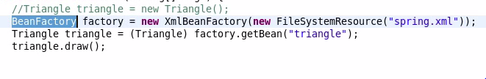
5. Application context(replacement for bean factory) and property initialization
   1. ApplicationContext can do all the function that bean factory does and more than that.
   2. 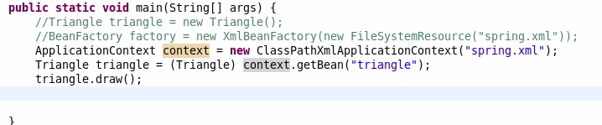
   3. Property initialization
   4. 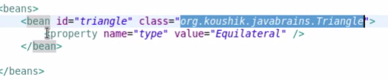
6. Constructor to inject the values
   1. 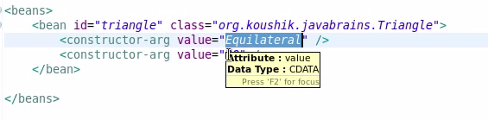
   2. Type and index are used to inject values if more than one parameter is used.
   3. 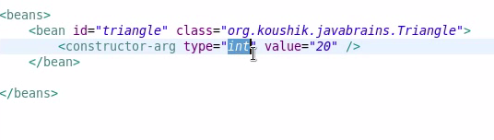
   4. Java.lang.String for string value.
   5. With index
   6. 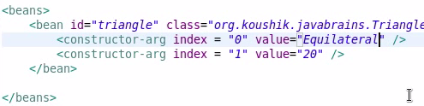
7. Injecting objects
   1. Create a separate bean to the objects and refer it in the parameter using ref attribute.
   2. 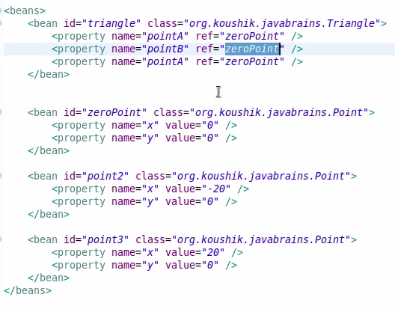
8. Inner bean, alias and Idref
   1. Innerbean – if an object bean is used only by bean then it can be nested inside the parent bean
   2. Alias – an alias name can be given to any of the bean and can be referred with the same in the application
   3. Idref– used to restrict the reference bean only to ID name of the bean rather than alias name

|  |  |
| --- | --- |
| **Ref** | **ID Ref** |
| It is a attribute | It is a tag |
| Can refer to ID, Name or alais | Can refer to Id alone |

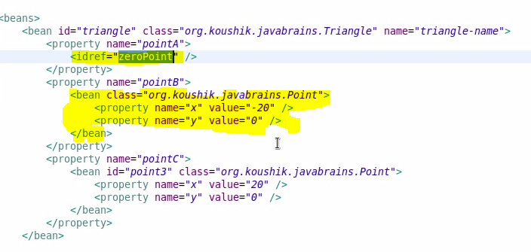



1. Initialize a collection
   1. List  -- using-- <list> - </list>
   2. 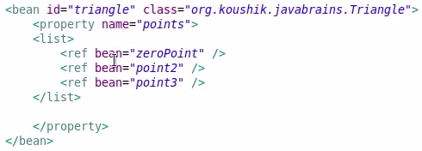
   3. Set   -- using-- <set> - </set>
   4. Map -- using-- <map> - </map>
   5. Properties --using-- <props> - </props>
2. Auto wiring
   1. By type
   2. By name
   3. Constructor
   4. 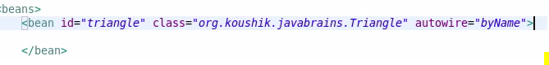
3. Understanding bean scopes
   1. Singleton – objects are created during applicationContext reads the Xml file
   2. Prototype – Objects are created during getbean. So new objects is created for each call.
   3. Web-Aware Scopes
      1. Request – new bean per servlet request
      2. Session – new bean per session
      3. Global – new bean per HTTP session
   4. Use “Scope” Attribute for setting the scopes.
   5. 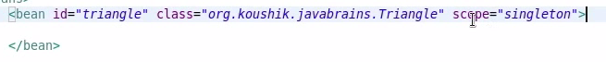
4. ApplicationContext Aware
   1. ApplicationContentaware – if the bean need the ApplicationContext Object, we need to use ApplicationContentAware.
      1. 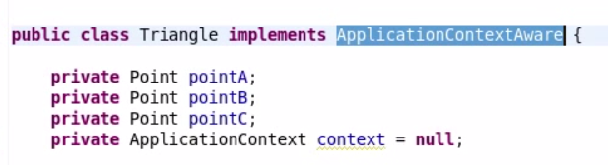
      2. 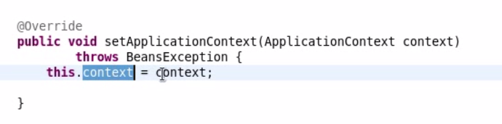
      3. Now when the ApplicationContext is loaded context will be passed for mail to the bean class
   2. beanNameAware
   3. 
   4. 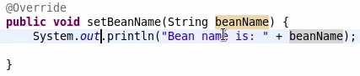
5. Bean definition inheritance
   1. Property of a parent bean can be inherited to the child bean
   2. 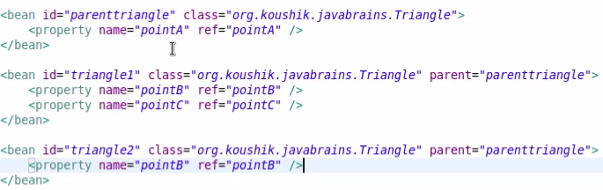
   3. Merge attribute – will merge the parent collection with the child’s collection
   4. 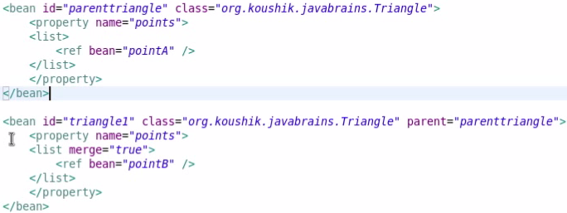
6. Life cycle callback
   1. For Desktop application spring need to Closed
   2. **AbstractApplicationContext** instead of ApplicationContext and register the context using context.registerShutDownHook()
   3. InitializingBean– afterPropertiesSet()
   4. DisposableBean – destroy()
   5. Init-method – attribute in bean tag used for specifying a init method for the bean
   6. Destroy-method – attribute in bean tag used for specifying a destroy method for bean
   7. Default-init-method – attribute in beans tag used for specifying a init method for the bean for all the beans
   8. Default -Destroy-method – attribute in beans tag used for specifying a destroy method for bean for all the beans
   9. 
   10. 
   11. The flow is shown in the following

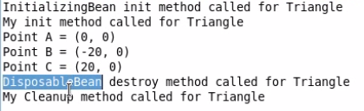

1. BeanPostProcesser
   1. This function will be called whenever any bean is created.
   2. This need to be registered in Spring.xml by creating a bean in pointing to this class.
   3. ImplementBeanPostProcesssor
   4. overriding method: PostProcessAfterInitilization(Object bean, String Bean name) and PostProcessBeforeInitilization(Object bean, String Bean name)
   5. 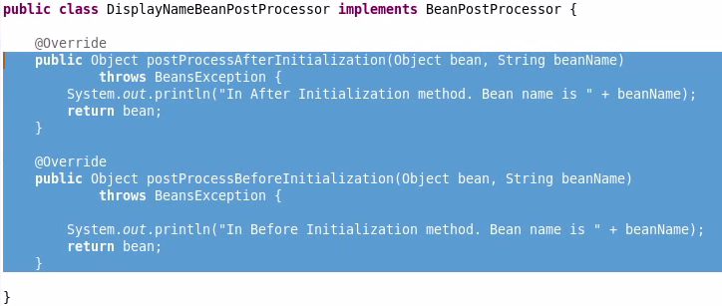
   6. 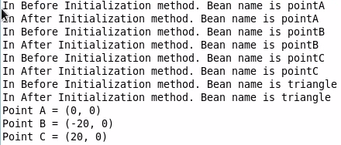
2. BeanFactoryPostprocesssor
   1. This method executed before the “Application Context “is loaded
   2. 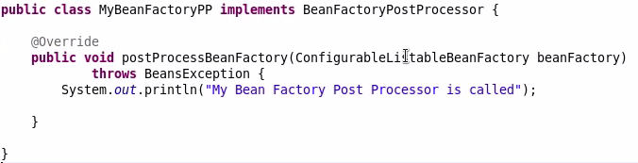
   3. 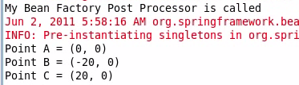
   4. Implement BeanFactoryPostProcesssor
   5. Overriding method postProcessBeanFaactory(ConfigurableListableactory)
   6. Add the following line in Spring.xml, to add property file to spring
   7. <beanclass=*"org.springframework.beans.factory.config.PropertyPlaceholderConfigurer"*>

<property name=*"location"* value=*"Sample.Properties"*></property> </bean>

1. Coding to interface
   1. Define an interface and implement it in a class.
   2. Then the interface can be casted to any of the implemented objects just by changing the getBeanName().
2. @required Annotiation
   1. Add @Required In the setter of the member variable
   2. Add a bean with the class name as “org.springframework.beans.factory.annotation.RequiredAnnotationBeanPostProcessor”.
   3. Now exception will be thrown while initializing the class
3. AutoWired Annotation
   1. Add @Autowired In the setter of the member variable
   2. Add a bean with the class name as “org.springframework.beans.factory.annotation.AutowiredAnnotationBeanPostProcessor”
   3. Autowired is used to assign the bean to the member variable automatically if any bean of the type is available
   4. If more than one bean is available it will check for the name of the bean which is matching the name of the member will be injected
   5. We can also use Qualifier annotation for the achieving this without matching names
   6. 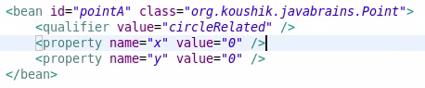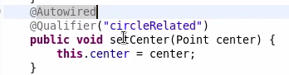
   7. <context:annotation-config/> can be used for all the postprocessor bean declaration in Spring.xml
4. JSR 250 annotations
   1. @Resource - from Javax.annotation. injection from xml to bean. If no name is given it takes the name of the variable itself

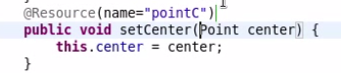

* 1. @PostConstruct – is called to initialize a bean (Both same as InitializingBeanandDisposableBean or init-method and destroy-method)
  2. @PreDestroy – is called before the bean is destroyed

1. Component and stereo type
   1. <context:component-scanbase-package=*"javaprojects.Spring.objects"*/>
   2. The above line is added in the spring.xml to indicated @component annotated classes are need to added as bean classes.
   3. 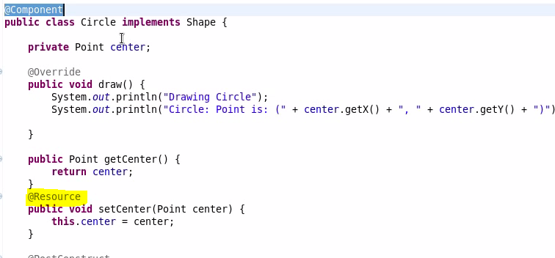
   4. @Resource will look for the bean in the XML.
   5. @service – for a service bean
      1. Still the loading of the center happens
   6. @repository - for a data bean
   7. @controller – for controller bean
2. Get the text from property file

<beanid=*"messageSource"*class=*"org.springframework.context.support.ResourceBundleMessageSource"*>

<propertyname=*"basenames"*>

<list>

<value>MyMessages</value>

</list>

</property>

</bean>

* 1. Paste the above tag in spring.xml and use the below line for invoking the messages
  2. Place the MyMessages.properties file also in the path.
  3. Context.getMessage("greeting", **null**,"Defaultgreeting",**null**)
  4. 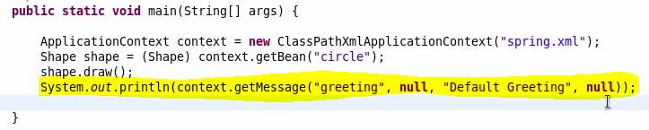
  5. 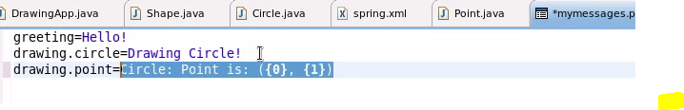
  6. 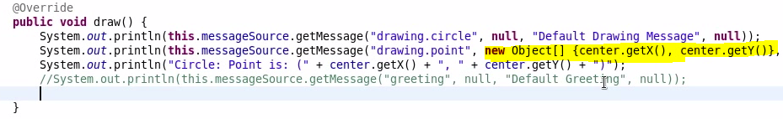

1. Event handler has three parts
   1. Event publisher, Event listener, Event
   2. ApplicationListener - class is used to listen for all the events in the class.
   3. ApplicationEvent –class implementing thishold the event to be published.
   4. ApplicationEventPublisher – is used to publish events in
   5. ApplicationEventPublisherAware – this is used to assign value to publisher to to publish events
   6. 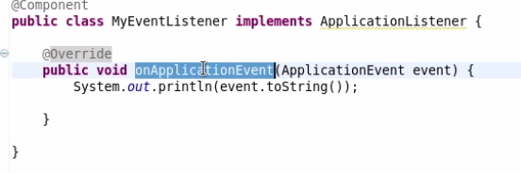
   7. 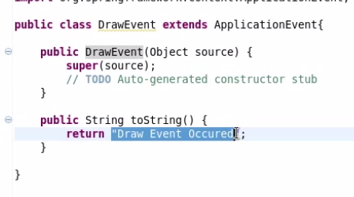
   8. 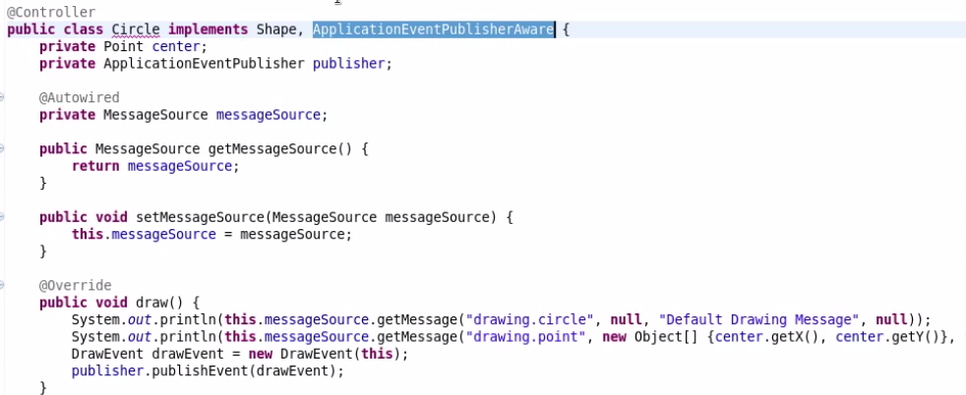
   9. 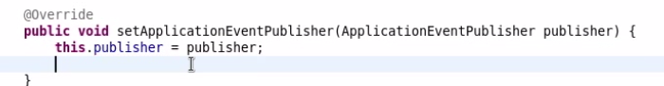
2. Aspect oriented Programming
   1. Function oriented programming
   2. Object oriented programming
   3. Cross cutting concerns (Logging, transcation and security)
3. Setup of spring Aspect library

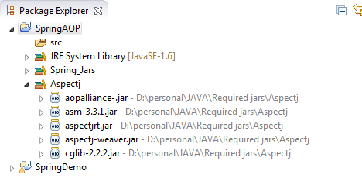

1. Create a sample class for Aspect programming
   1. Importing xmlns in spring.xml for AOP support
   2. getBean Overloads with two parameter (beanName, beanClass)
2. Aspect
   1. @Aspect annotation is used to indicate a method as Aspect
   2. @before , @after, @ method used to execute the methods for the particular type
      1. **Before Advice**: it executes before a join point.
      2. **After Returning Advice**: it executes after a joint point completes normally.
      3. **After Throwing Advice**: it executes if method exits by throwing an exception.
      4. **After (finally) Advice**: it executes after a join point regardless of join point exit whether normally or exceptional return.
      5. **Around Advice**: It executes before and after a join point.
3. Wild cards and Pointcuts
   1. Using * for all pattern in expression
   2. Pointcut are variables for expression defined in one place and referred wherever required
   3. 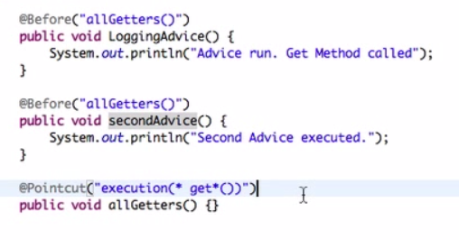
4. Few more on pointcuts
   1. @Pointcut(“Within(Class)”) – applies to all the Methods in the class
   2. @Pointcut(“args(Class)”)
   3. Using && operator in expression
5. Join points
   1. Joint point is passes as a parameter to an aspect method to get the info reg the method invoked the aspect.
   2. Gettarget() – gets the target object
   3. Print the parameter using AdviceArguments
6. Advice types
   1. @Before
   2. @after
   3. @afterreturning – if the method excutes successfully
   4. @afterthrowing – if the method throws exception
   5. @around
   6. pointcut,,returning, throwing
7. Around Advice method
   1. Method execute before and after the method
   2. ProceedingJoinPoint and ProceedingJoinPoint.proceed()
   3. Diff bet JoinPoint and Proceeding JoinPoint.(refer pt 30 for joinPoint)
8. Naming Conventions and Custom advice Annotations
   1. Using annotation for AOP
9. AOP XML Configuration

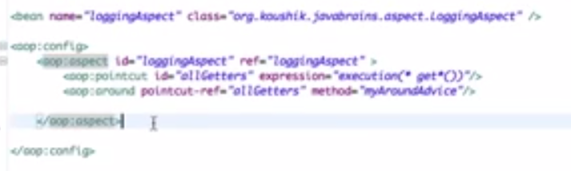

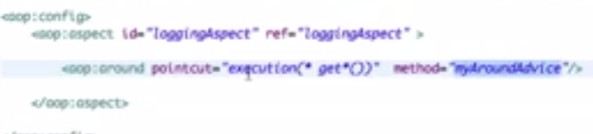

1. AOP Proxies – how the AOP works
2. Introduction to spring data and setup
   1. Install Derby
   2. Start a derby using below

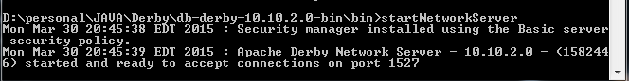

* 1. Using ij Client.
  2. Use the command: connect ‘jdbc:derby://localhost:1527/db;create=true’;

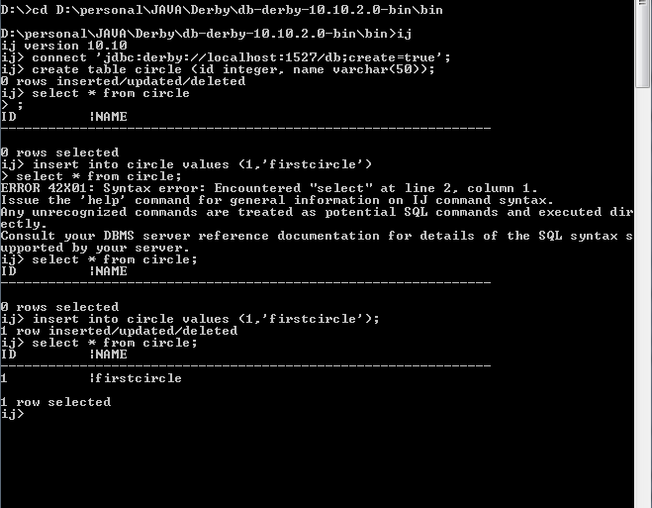

1. Using Database without Spring
2. Using Spring
   1. Add the following lines in Spring.xml to connect the database

<beanid=*"datasource"*class= *"org.springframework.jdbc.datasource.DriverManagerDataSource"*>

<propertyname=*"driverClassName"*value=*"org.apache.derby.jdbc.ClientDriver"*></property>

<propertyname=*"url"*value=*"jdbc:derby://localhost:1527/db"*></property>

</bean>

* 1. But using the above will not provide support to pool connection management.
  2. So we use DBCP jars to connect to databases
     1. commons-dbcp
     2. commons-pool-1.6
  3. Replace the above code with the below in spring.xml

<beanid=*"dataSource"*class=*"org.apache.commons.dbcp.BasicDataSource"*>

<propertyname=*"driverClassName"*value=*"org.apache.derby.jdbc.ClientDriver"*/>

<propertyname=*"url"*value=*"jdbc:derby://localhost:1527/db"*/>

<propertyname=*"initialSize"*value=*"2"*/>

<propertyname=*"maxActive"*value=*"5"*/>

</bean>

1. JDBCTemplate
   1. Create a local member JdbcTemplateTemplate= **new**JdbcTemplate();
   2. Refer the below method

**publicint**getCircleCounnt(){

String Sql="Select Count(*) from Circle";

Template.setDataSource(dataSource);

**return**Template.queryForInt(Sql);

}

* 1. 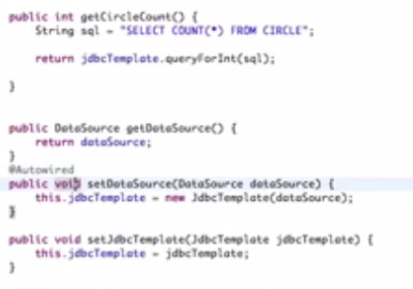
  2. 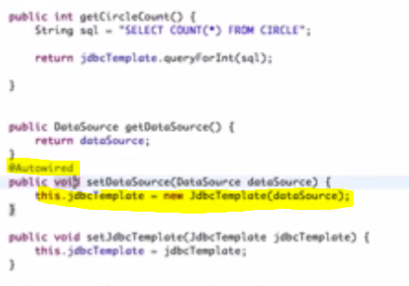

1. Return other datatypes
   1. 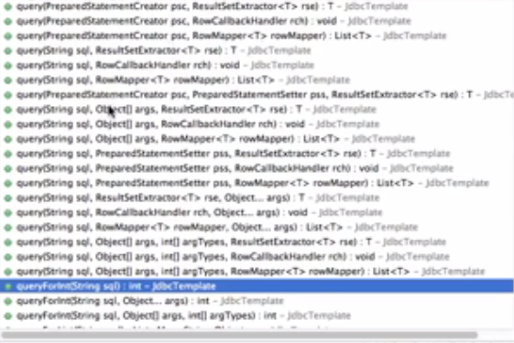
   2. 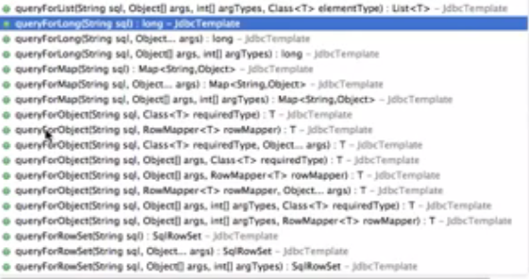
   3. 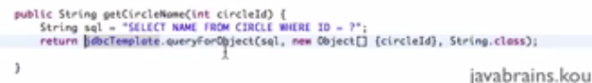
2. Row Mapper
   1. 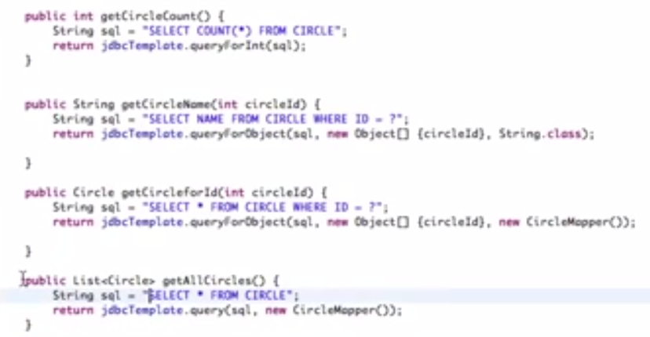
   2. 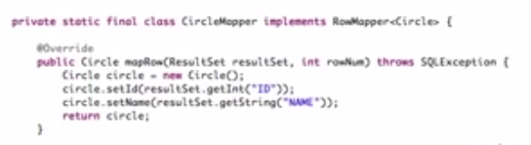
3. Performing write operation with JDBC Template
   1. 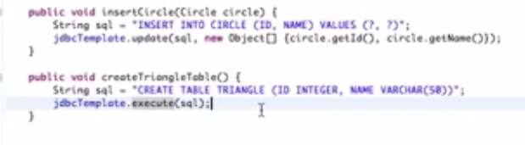
   2. Refer the above to insert and create a table
4. NamedParameterJDBCTemplate
   1. 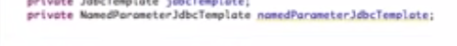
   2. 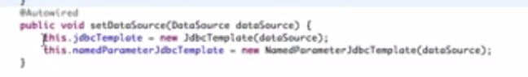
   3. 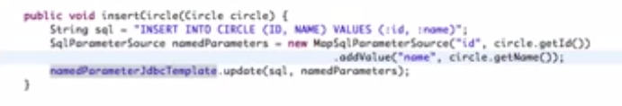
   4. Explore SimpleJdbcTemplate.
5. DAO Support classes
   1. 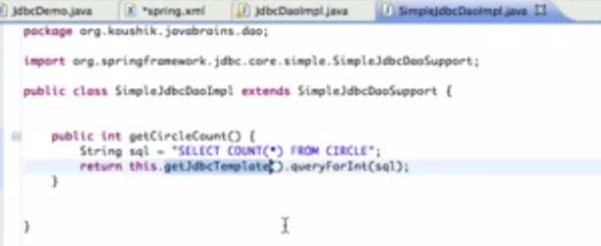
   2. 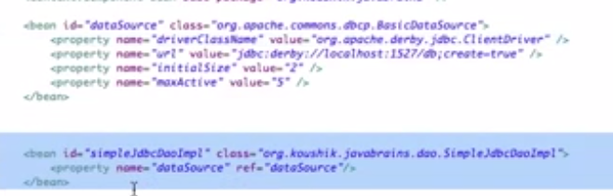
6. Hibernate Spring tutorial
   1. 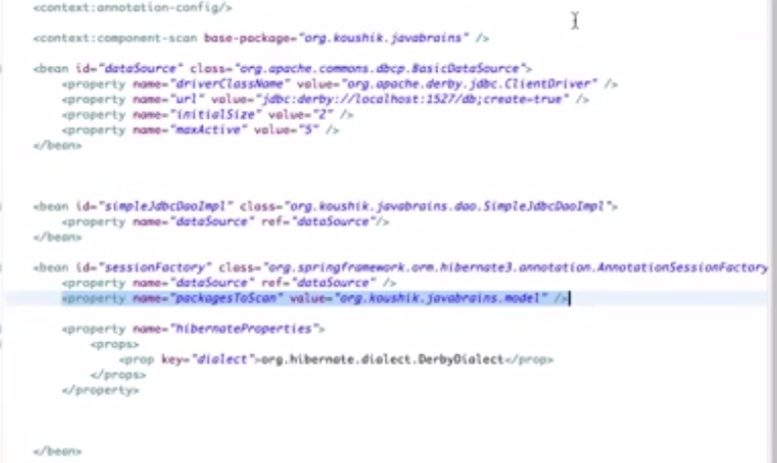
   2. 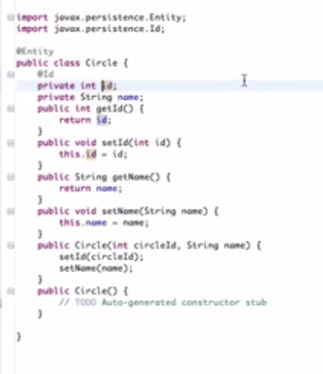
   3. 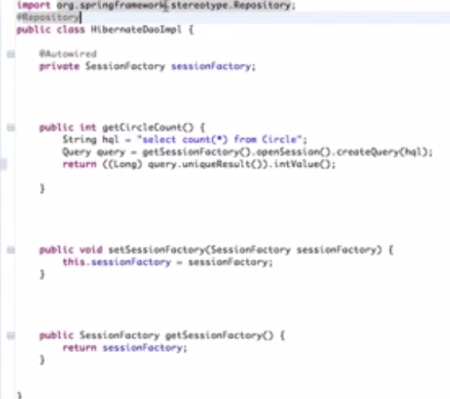
   4. 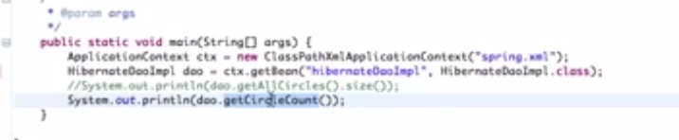

## Some [examples](http://www.dineshonjava.com/2012/11/pointcuts-and-wildcard-expressions.html) of common pointcut expressions are given below.

1. the execution of any public method:
   1. execution(public * *(..))
2. the execution of any method with a name beginning with "set":
   1. execution(* set*(..))
3. the execution of any method defined by the AccountService interface:
   1. execution(* com.xyz.service.AccountService.*(..))
4. the execution of any method defined in the service package:
   1. execution(* com.xyz.service.*.*(..))
5. the execution of any method defined in the [service package](http://www.dineshonjava.com/2012/11/pointcuts-and-wildcard-expressions.html) or a sub-package:
   1. execution(* com.xyz.service..*.*(..))
6. any join point (method execution only in Spring AOP) within the service package:
   1. within(com.xyz.service.*)
7. any join point (method execution only in Spring AOP) within the service package or a sub-package:
   1. within(com.xyz.service..*)
8. any join point (method execution only in Spring AOP) where the proxy implements the AccountService interface:
   1. this(com.xyz.service.AccountService)
   2. 'this' is more commonly used in a binding form :- see the following section on advice for how to make the proxy object available in the advice body.
9. any join point (method execution only in Spring AOP) where the target object implements the AccountService interface:
   1. target(com.xyz.service.AccountService)
   2. 'target' is more commonly used in a binding form :- see the following section on advice for how to make the target object available in the advice body.
   3. any join point (method execution only in Spring AOP) which takes a single parameter, and where the argument passed at runtime is Serializable:args(java.io.Serializable)
   4. 'args' is more commonly used in a binding form :- see the following section on advice for how to make the method arguments available in the advice body.
   5. Note that the pointcut given in this example is different to execution(* *(java.io.Serializable)): the args version matches if the argument passed at runtime is Serializable, the execution version matches if the method signature declares a single parameter of type Serializable.
10. any join point (method execution only in Spring AOP) where the target object has an @Transactional annotation:
    1. @target(org.springframework.transaction.annotation.Transactional)
    2. '@target' can also be used in a binding form :- see the following section on advice for how to make the annotation object available in the advice body.
11. any join point (method execution only in Spring AOP) where the declared type of the target object has an @Transactional annotation:
    1. @within(org.springframework.transaction.annotation.Transactional)
    2. '@within' can also be used in a binding form :- see the following section on advice for how to make the annotation object available in the advice body.
12. any join point (method execution only in Spring AOP) where the executing method has an @Transactional annotation:
    1. @annotation(org.springframework.transaction.annotation.Transactional)
    2. '@annotation' can also be used in a binding form :- see the following section on advice for how to make the annotation object available in the advice body.
13. any join point (method execution only in Spring AOP) which takes a single parameter, and where the runtime type of the argument passed has the @Classified annotation:
    1. @args(com.xyz.security.Classified)
    2. '@args' can also be used in a binding form :- see the following section on advice for how to make the annotation object(s) available in the advice body.
14. any join point (method execution only in Spring AOP) on a Spring bean named 'tradeService':
    1. bean(tradeService)
15. any join point (method execution only in Spring AOP) on Spring beans having names that match the wildcard expression '*Service':
    1. bean(*Service)
16. Use JoinPoint to to get the details of the method calling it
    1. jp.getSignature().getName() – get the method cane calling it
    2. jp.getSignature().getDeclaringType() - to get the full class name of the calling method
    3. jp.getArgs() - to get the args value of the calling method
17. **proceding join** point is used in Around advice to

## Durga Soft

1. Introduction Part 1
   1. Spring developed by Red Jhonson. Now it is taken by piovotal org.
   2. Its initial name is Interface 21. Later named as Spring.
   3. Spring came to replace EJB.
      1. EJB is heavy weight and tightly coupled. EJB are application server dependent.
      2. Spring is light weight and loosely coupled.No application server is needed.
2. Introduction Part 2
   1. Spring recommends to use Associated classes rather than inheritance.
   2. Spring is implemented using runtime Polymorphism and Has – A Relationship
   3. 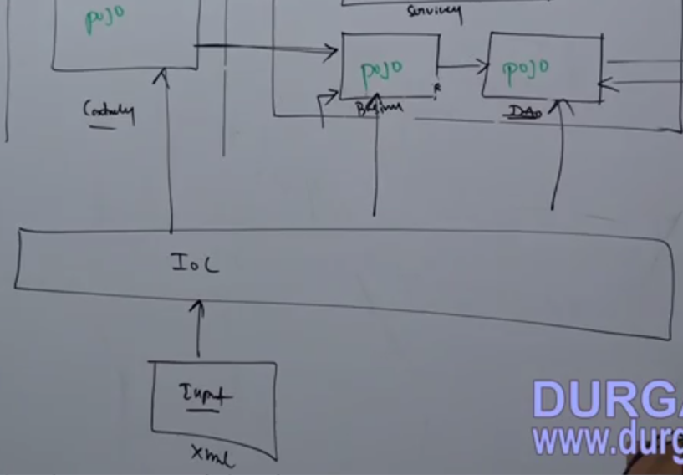
   4. IOC has two containers :
      1. Core Container (BeanFactory (I)(XmlBeanFactoryImpl))
      2. J2EE Container (ApplicationContext (I) ->ConfigurableApplicationContext (I) ->(ClasssPathApplicationContext)Impl)
   5. MVC container has one container
      1. Web (WebApplicationContext (I) ->(WebApplicationContextUtils) Impl)
   6. IOC containers
      1. Read XML
      2. Create instance of POJO classes
      3. Manage life cycles
      4. Dynamic parameter will be passed to POJO classes
      5. The Above Four points are the main points to dependency injection
3. Introduction Demo 3
   1. Dependency injection
   2. Hello world sample application
      1. POJO Class
      2. XML File
      3. Driver class
4. Introduction Demo 4
   1. Creating a sample application
   2. 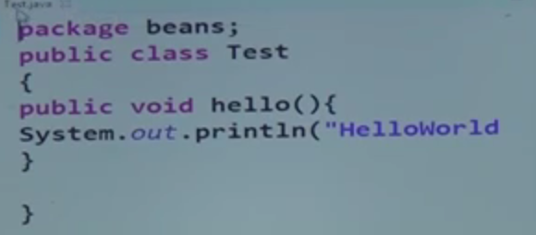
   3. 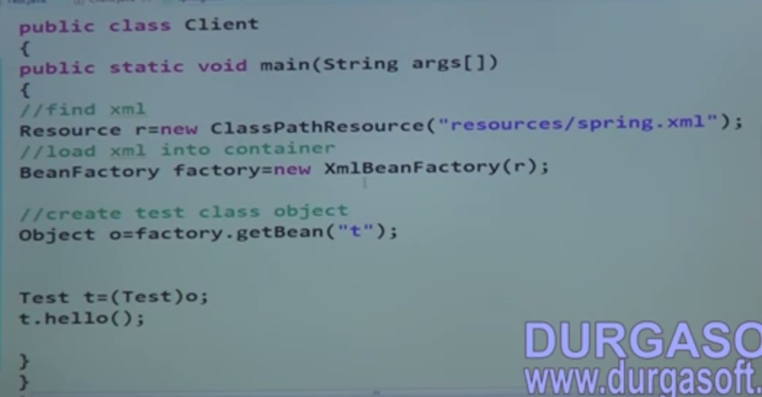
   4. 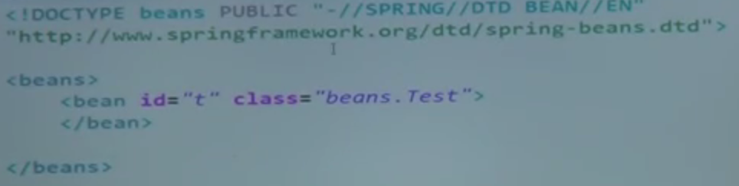
5. Introduction Demo 5
   1. The Scope attribute in set to indicate the **Singleton** object creation or **prototype** creation
   2. It can also be done thru “beantype” attribute which can be set to either “singleton” or “prototype”
   3. Diff Bet BeanFactory and ClasspathXMLApplication

|  |  |
| --- | --- |
| **BeanFactory** | **ApplicationContent** |
| Getbean method will create an object | Loading the XML will create the Objects. If the bean type is “prototype” Objects will be created only during getBean method |
| LazyLoading | EagerLoading (Recomended) |

1. IOC
   1. Two Containers
      1. Core Container – Bean Factory
      2. J2ee Container –ApplicationContext ->ConfigurableApplicationContext
   2. Containers can do the following
      1. Create instances for POJO classes
      2. Manage life cycles for POJO classes
      3. Dependency injection into POJO classes
   3. IOC use SAX parser it will read the spring.xml. It will check for the well-formed of the XML and validness of the document.
2. Program to find the diff bet Core Container and J2EE Container.
   1. 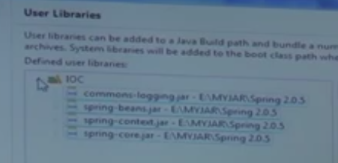
   2. Libraries
   3. 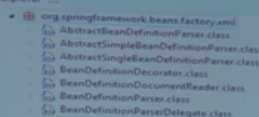Open this package.
   4. Navigate to Spring-beans-2.0.dtd and copy the following lines.
   5. 
   6. Using J2EE container
   7. ApplicationContext Ap=**new** ClassPathXmlApplicationContext("com/Resources/Spring.xml");
   8. Spring can initiate private constructors also
3. Program to access private constructor without spring
   1. 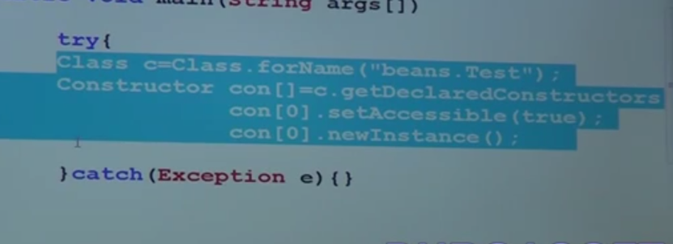
   2. Dependency Injection
      1. POJO instantiation
      2. Life cycle mgmt.
      3. Dependency injection
   3. Implementing complete MVC Application
      1. Dependency in case of DAO
         1. Drivers and Connection pools
         2. JDBCTemplate
         3. SessionFactory and Hibernate template
4. Continuation of MVC Application
   1. Dependency in case of Business
      1. DAO, Transaction, Mail, Security, etc
   2. Dependency in case of Controller
      1. Bussiness
   3. 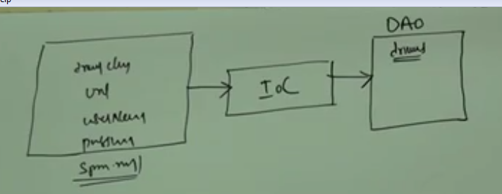
   4. Types of DI
      1. Setter
      2. Constructors
      3. lookup method
   5. Property tag is used to pass values to setters in DI
   6. Type of data injected using Spring
      1. Primitive
      2. Secondary
      3. Primitive Array
      4. Secondary array
      5. Collection
5. Injecting thru XML
   1. Using property tag (using name and value)
   2. Using Constructor-args (using value, type and Index)
   3. 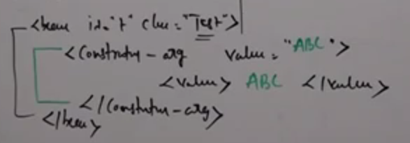
   4. For constructor overloading to avoid ambiguity, user type attribute in constructor.
   5. 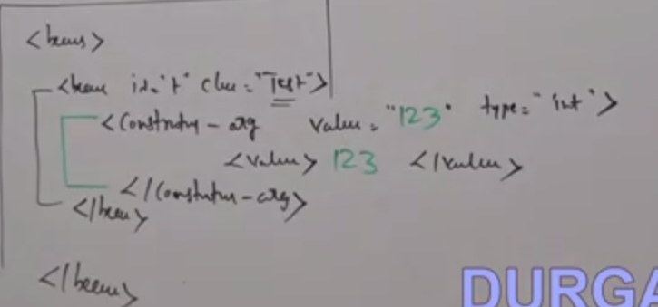
6. Continuation
   1. Type Attribute in constructor
   2. Index attribute in Constructor to set right parameter to the right constructor args
      1. If more than one constructor-args having the same index then the latest one will be assigned.
      2. In case of secondary data type we should use “ref”
7. Injecting secondary data type
   1. Using reference
   2. Using inner bean
   3. Loading multiple xml files into ApplicationContext. Use the below lines to load the array of xml files.

String files[]=**new** String[]{"Spring.xml","Engine.xml"};

ApplicationContext Context = **new**ClassPathXmlApplicationContext(files);

1. Injecting Primitive type Array
   1. Primitive type Array  -- using-- <list><value>value<value/></list>
   2. Secondary type Array  -- using-- <list><ref bean=”ref”/></list>
2. Injecting Primitive type collection
   1. List  -- using-- <list> - </list>
   2. Set   -- using-- <set> - </set>
   3. Map -- using-- <map><Entry key=”xx” value=”xx”/></map>
   4. Properties --using-- <props> - </props>
      1. The value should be passed between only prop tag. But in case of Map we can pass it as a attribute.
      2. To load the properties from a file use util class.
      3. 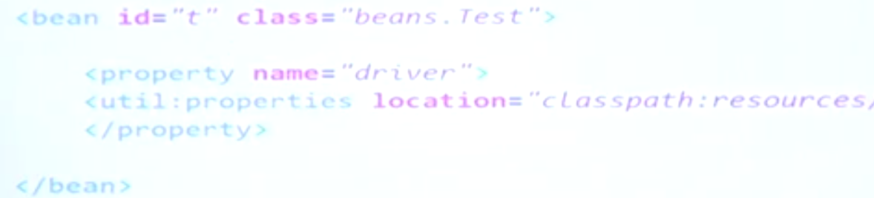
3. Injecting collection
   1. To load vector and other type of collection we need to use <util: > Class
   2. <util: > Class and its functionalities
   3. <util:list>, <util:set>,<util:map> and <util:property>
   4. Array or list of object injection
   5. 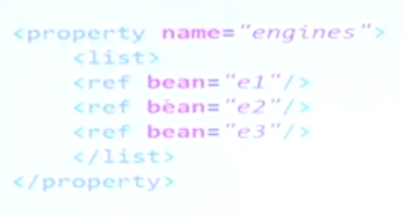
   6. Array or list of primitive type injection
   7. 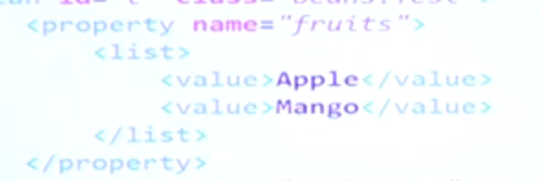
4. Continuation
   1. For Vector, set and map
      1. <util: >needs to be used for the above collections
      2. For list
      3. 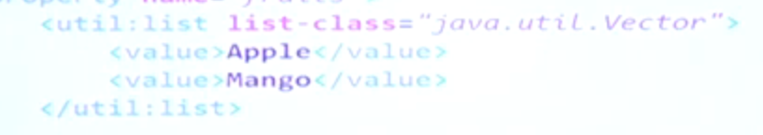
      4. For set
      5. 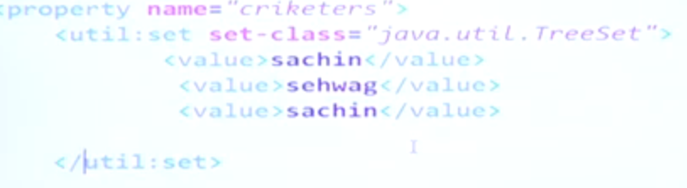
      6. For map
      7. 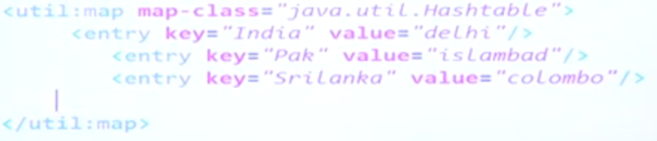
   2. Loading properties (Properties DI)
   3. 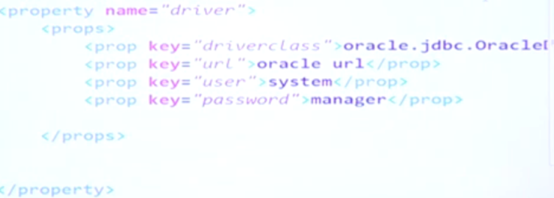
   4. From Properties file
   5. 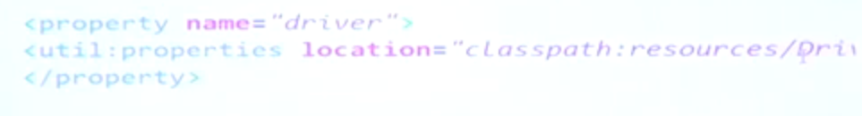
5. Dependency Injection
   1. Two types : setter and constructor

|  |  |
| --- | --- |
| **Setter** | **Constructor** |
| Not mandatory to pass value | Mandatory to pass the value |
| Injected using property tag | Injected using constructor-args tag |

* 1. Dependency checking
     1. To make setter DI mandatory
     2. Add the attribute “Dependency-Check” in bean tag values (None,Simple,Objects,all)
        1. None – No objects needs to be passed in the bean
        2. Simple – Mandatory pass all the primitives
        3. Objects – Mandatory pass all the Secondary
        4. All - Mandatory pass all the primitives and secondary
     3. Unsatisfactory DI exception will be thrown when mandatory values are not passed.

1. @Required annotation
   1. This annotation will be given to the setter method of all the required members
2. Sample program for Dependency check and @required
   1. To @required annotation to work we need to initiate “RequiredAnnotationBeanPostProcessor” From “org.springframework.beans.factory.annotation.RequiredAnnotationBeanPostProcessor”
3. Depends-on
   1. One class has dependency on other class we can use “Dependency-on”
   2. 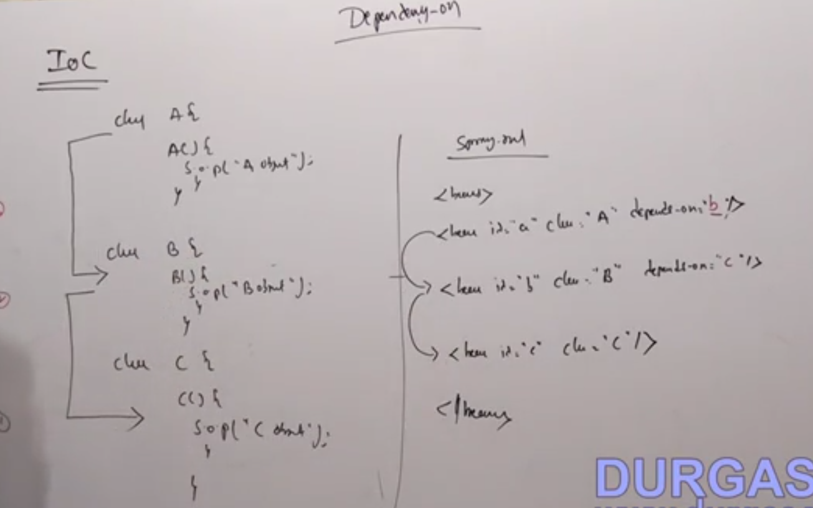
   3. Mutual dependency are not possible
   4. Setter and constructor DI Using P namespace for setter and C Namespace for constructor
      1. 
4. Continuation:
   1. Setter and constructor DI Using P namespace and C Namespace
      1. Add the following jars to the project
      2. 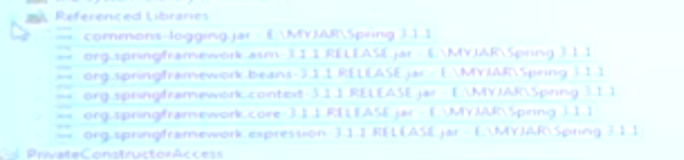
      3. 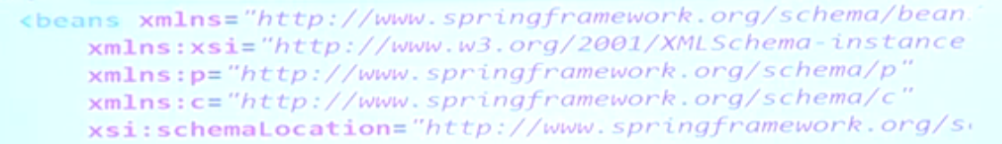
      4. 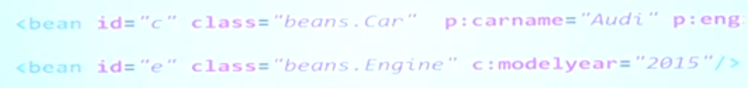
      5. 
5. AutoWiring
   1. Automatic DI
   2. Applicable only to Secondary types
   3. Bean Tag Attribute – Autowire {“ByName”, ”ByType”, ‘’Constructor”,”Autodetect”, “No”}
   4. Can use it in “bean” tag using “Autowire” attribute or in “beans” tag using “Default-Autowire” Attribute tag.
   5. Autowire types and it DI
      1. ByName - Setter
      2. ByType – Setter
      3. Constructor – Constructor
      4. Autodetect – both setter and Constructor
      5. No – Nothing
   6. ***Autowire-Candidate (true/false)*** attribute – in autowire by type, had more than one object qualifying for DI, beans object with this attribute indicate that it won’t participate in Autowiring. So for resolving the ambiguity this attribute is used.
6. Continuation of AutoWire
   1. ByName – Check for both type and ref name
   2. Constructor – use DI by type
7. Continuation of AutoWire
   1. Using @autowire Annotation
   2. To resolve the ambiguity in this annotation we need to use @qualifier annotation
      1. The @Qualifier tag does not need getter or setters
      2. The feature is supported only in Spring 3.
   3. For enabling annotation we need to instantiate the following class
   4. AutowiredAnnotationBeanPostProcessor
   5. Using autowire annotation without using setter or constructors we can use DI.
   6. @qualifier – is used to load the bean with the qualifying name mentioned in the @qualifier annotation.
8. Continutation
   1. 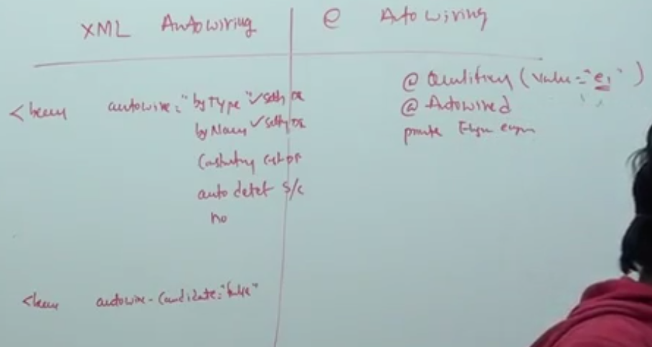
   2. Stereotype
      1. @controller – Controller
      2. @repository – DAO
      3. @service – Business
      4. @component – Non MVC
9. Continutaion
   1. <Content:annotation-config/> - will automatically initiate all the below annotation
      1. @required - requiredAnnotationBeanPostProcessor
      2. @autowire - AutowiredAnnotationBeanPostProcessor
      3. @postConstruct-CommonAnnotationBeanPostProcessor
      4. @preDestroy - CommonAnnotationBeanPostProcessor
10. Continuation
    1. Class having primitive type objects can only injected using bean. It cannot inject using @component.
    2. For Classes using @component, the objects can be created using “getbean(<ClassName>.class)”.
    3. 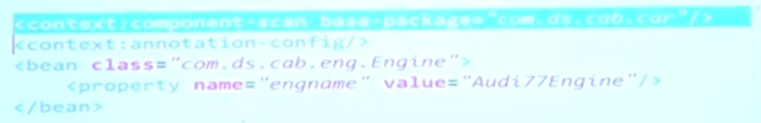
    4. Static variable DI – MethodInvokingFactoryBean.
    5. 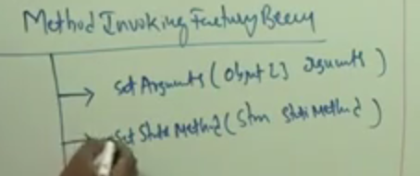
    6. 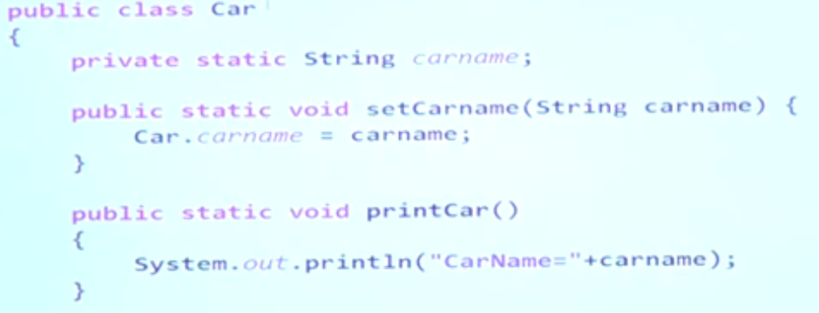

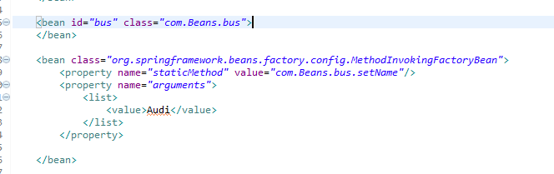

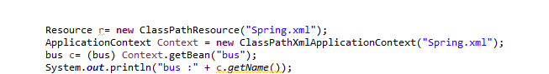

1. Singleton classes and factory classes
   1. Singleton
      1. Only one instance throughout the main class or application
      2. Returns the same class object
   2. Factory Class
      1. to create instance for singleton class
      2. It will return the other class object
2. Factory Methods
   1. Get the calendar object in spring
   2. Factory class is designed for returning instance of other classes(Singleton, factory class with static method and factory with instance method)
   3. 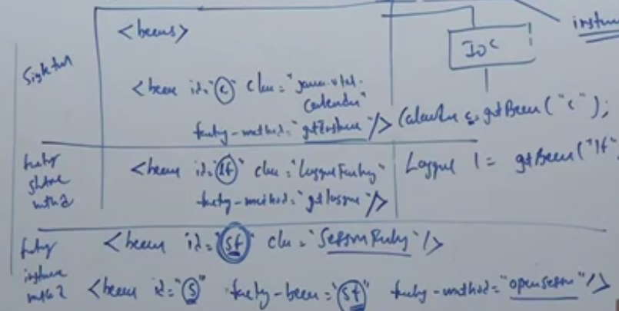
3. Continuation
   1. Factory main aim
      1. Make client independent
      2. Hide instantiation logic
   2. Example of Factory bean
   3. 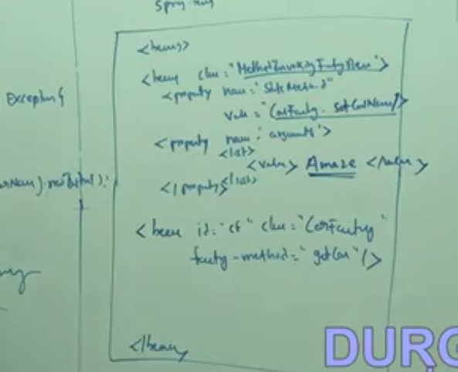
4. Continuation
   1. Factorybean interface
      1. To implement factories in spring we have three approaches
         1. Stat ic factory
            1. 
            2. getInstance() is the factory method.
            3. To make a normal class a static factory class
            4. Create static object of the same class

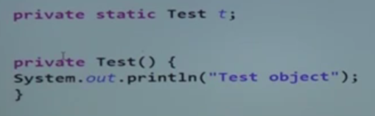

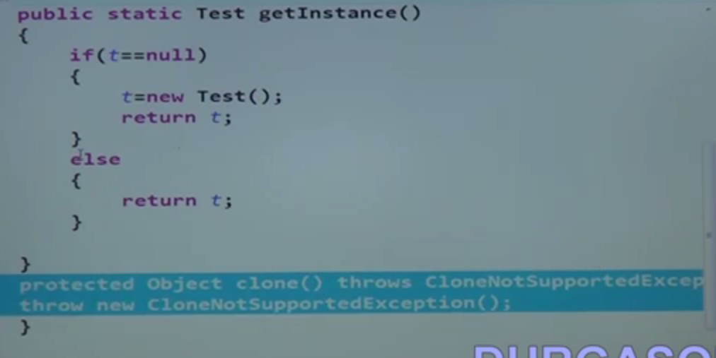

Code the above two methods

* + - * 1. MethodInvokingFactorybean is used to create object for other class

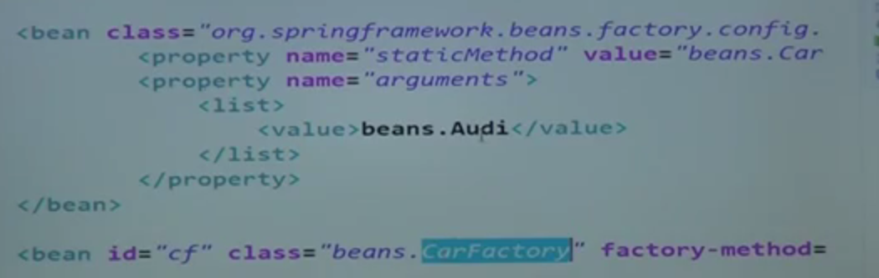

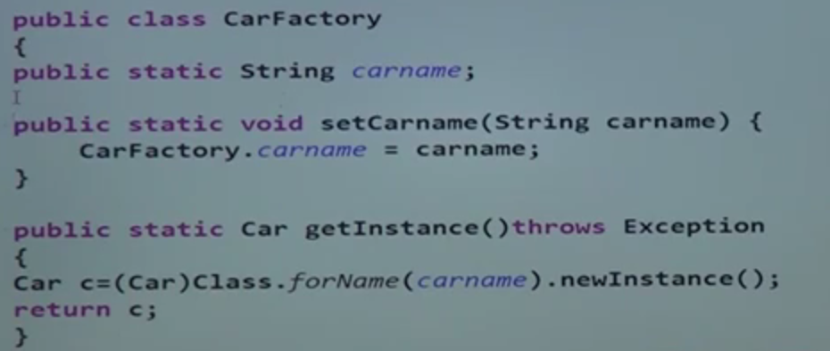

* + - 1. Instance factory
         1. 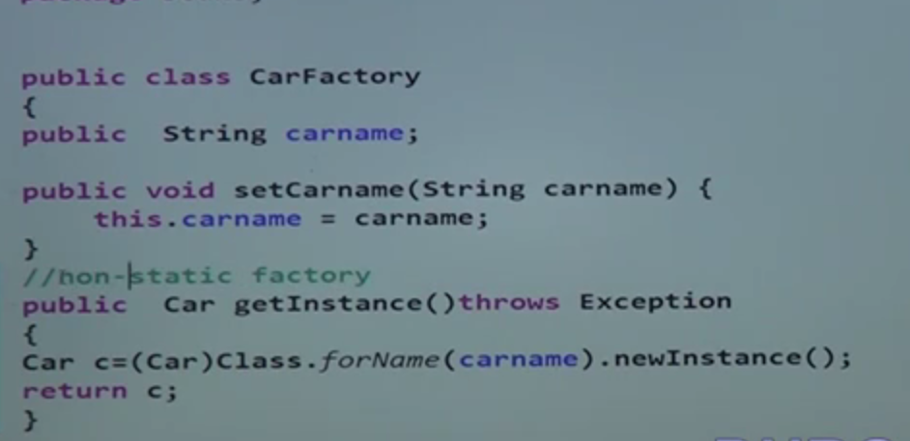
         2. Remove static variable and methods
         3. 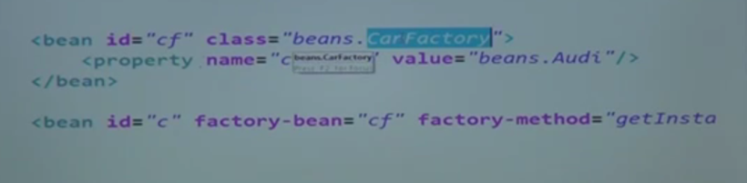
      2. Factory bean
         1. 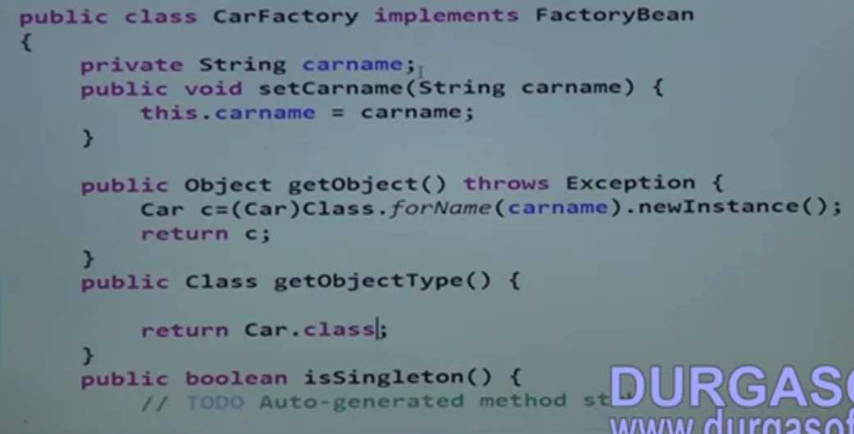
         2. 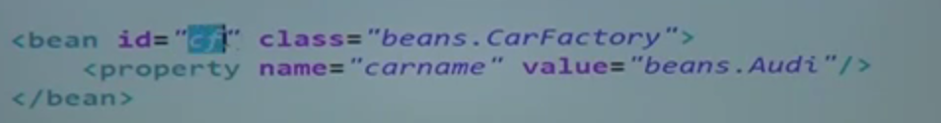
    1. Two programs
       1. MethodInvokingFactorybean
       2. Factory object.

1. Continuation
   1. Code for all the three approaches of factory class
      1. Static factory
      2. Instance factory
      3. Factory bean
         1. Implement FactoryBean
         2. Override the following method : getobject(), GetObjectType(), isSingleton()
2. Life cycle methods
   1. ConfigurableApplicationContext – we can manage lifecycle Spring beans
   2. Three Approach
      1. Programatic –implementingInitilizatingbean(override afterpropertiesSet), Disposable bean (override destroy).
         1. 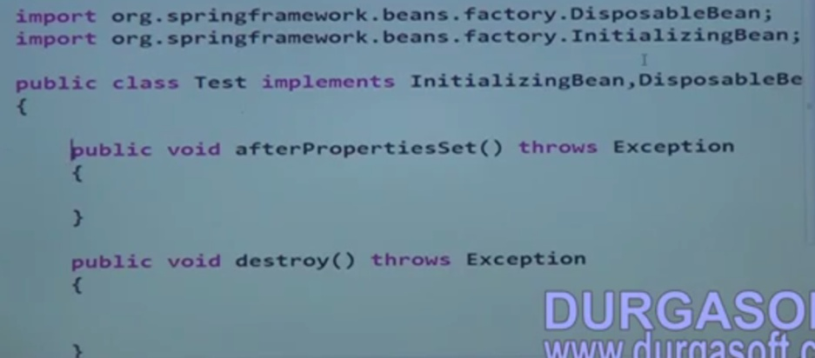
         2. 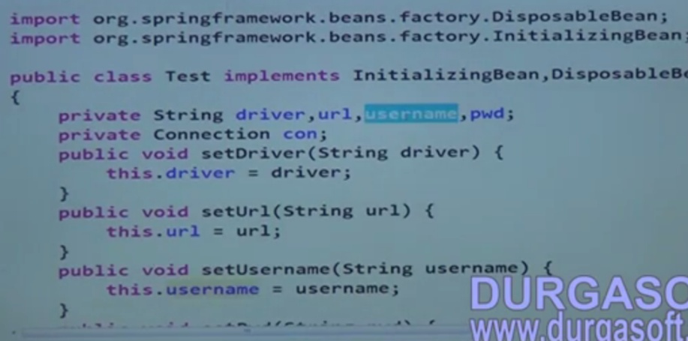
         3. 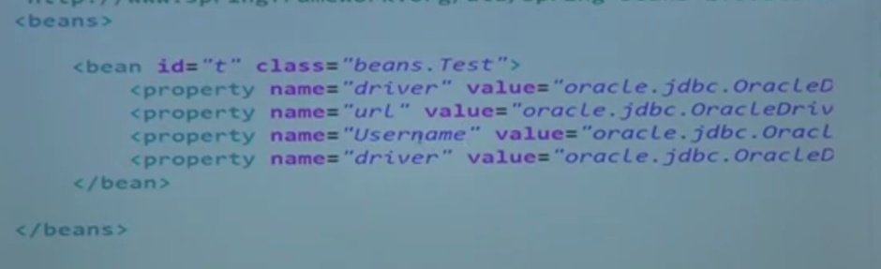
         4. 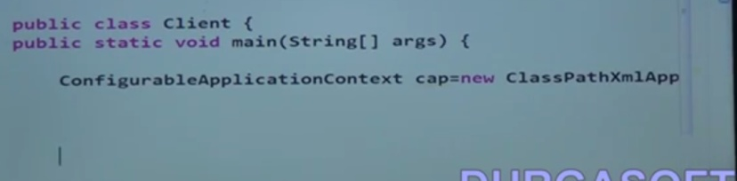
      2. XML approach – init-method, destroy-method
         1. 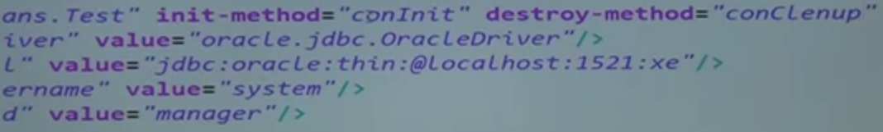
      3. Annotation - @postConstruct,@preDestroy
         1. Activate **CommonAnnotationBeanPostProcessor**
         2. 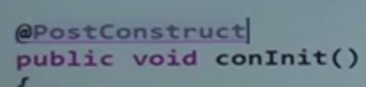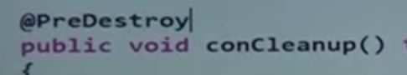
         3. 
      4. 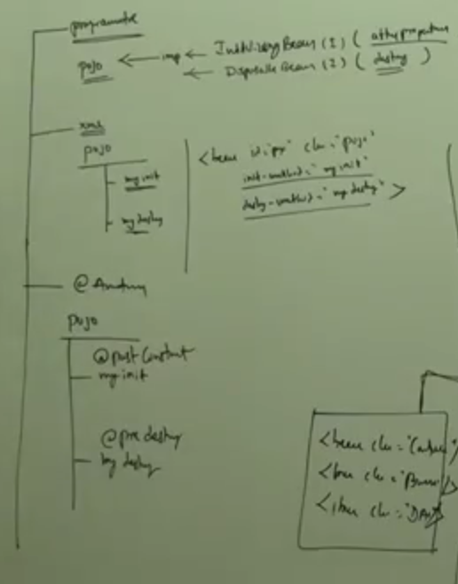
3. Continuation
4. Continuation
   1. Default-init-method and Default-destroy-method
   2. Dependency injection using lookup method is used to override interface, abstract and concrete methods
      1. If a method returning secondary type we can DI that method using lookup method.
      2. 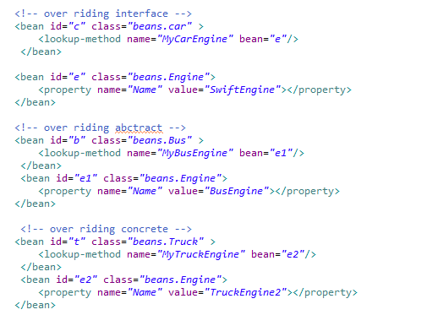
5. Continuation
   1. Example program
6. Method Replacer Tag
   1. MethodReplacer Implementation is used to re implement the existing method without changing the old method
   2. 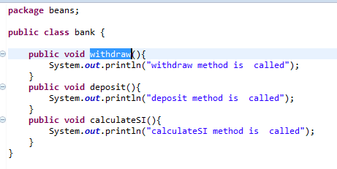
   3. 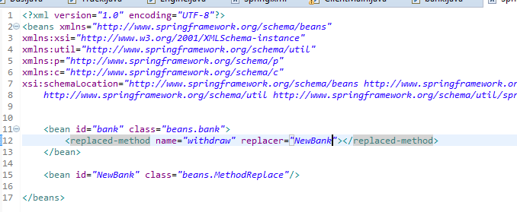
   4. 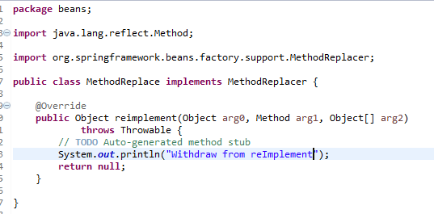
   5. 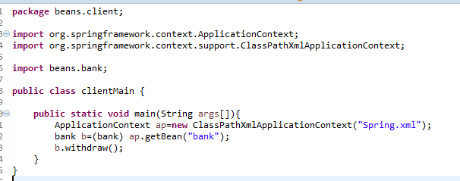
7. Revision
   1. JDK packages for Autowiring
      1. @Resource, @inject
      2. 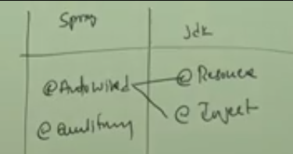
   2. @autowire and @inject use by type checking, and @resource use Byname and @qualifier can be coupled with any of the above.
   3. <context:annotation-config> need to be initiated to activate this annotations
8. Replacement for JDK packages annotation
   1. @component - @named
9. Loading Property file
   1. PropertyPlaceHolderConfigurer
   2. 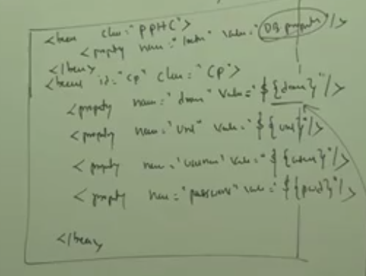
   3. 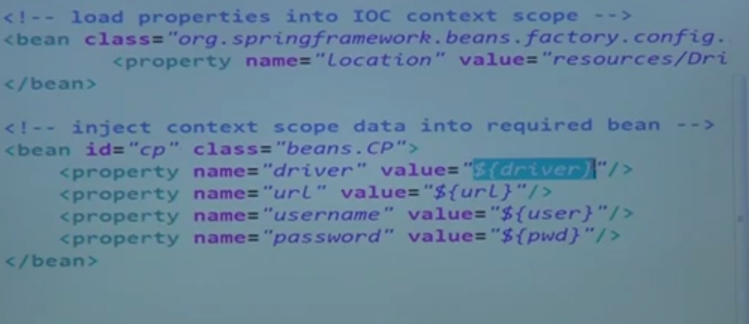
10. I18N
    1. I18N -Provide Language support
    2. L10N - Business support
11. L18 Demo program
    1. 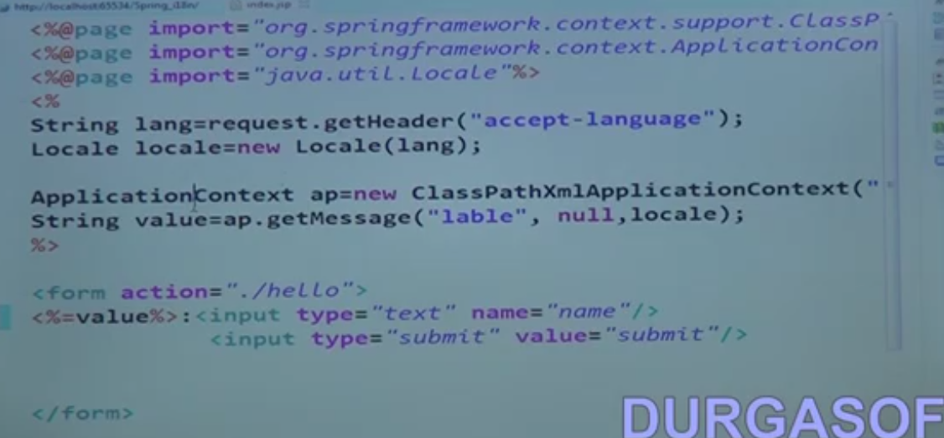
    2. 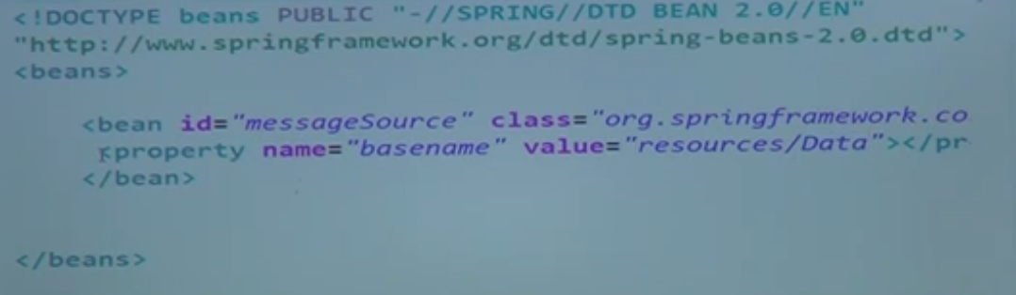
12. Event handler
    1. Four event : Start, stop, Close, refresh
    2. ApplicationListner<ContextStartEvent>,ApplicationListner<ContextStopperEvent>,ApplicationListner<ContextRefreshedEvent>,ApplicationListner<ContextClosedEvent>
    3. GO A DETAILED VIEW OF THIS
    4. 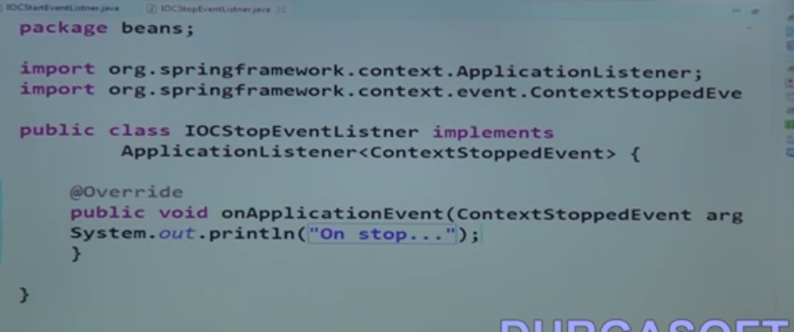
13. MVC (Model view Controller)
    1. Features
       1. Form backup support (Spring tag library)
       2. Controller support (Multi action controller, multi form controllers)
       3. Validation
       4. I18N
       5. Interceptors
       6. View Resolvers
       7. Exception Handling
    2. WebApplicationContext
    3. 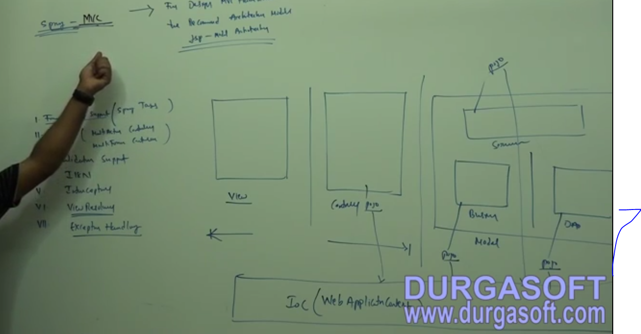
    4. 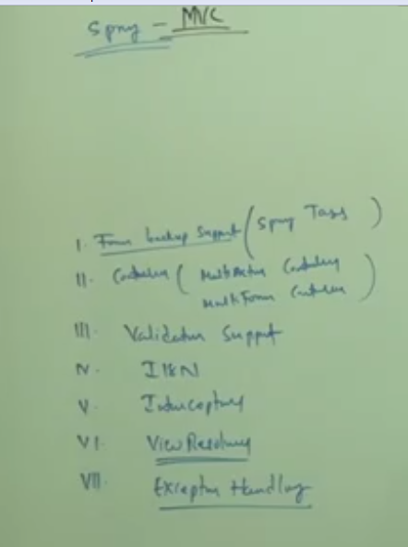
    5. 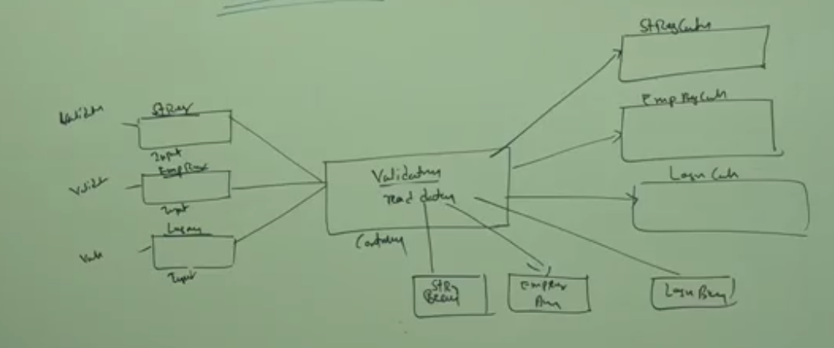
    6. 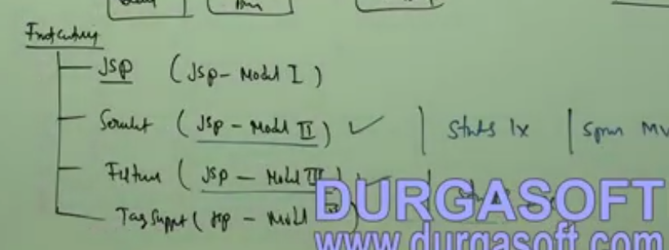
    7. JSP,Servlet,Filters,TagSupport
14. Continutaion
    1. Spring MVC the Front controller is Dispatcher servlet (org.springFramework.web.servlet.DispatchServlet)
    2. Strut 1.x-> Action servlet, JSF ->Facelet servlet, Struct 2.x ->Filter dispatcher and struct prepare and execute filter
    3. 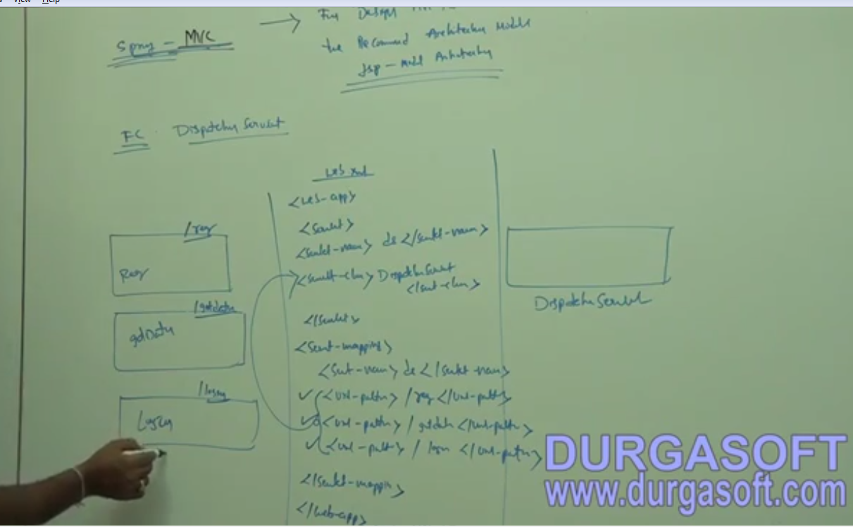
    4. 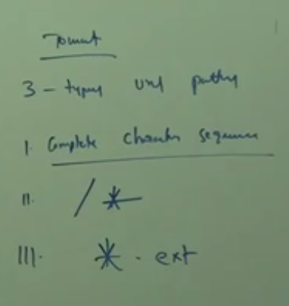
    5. 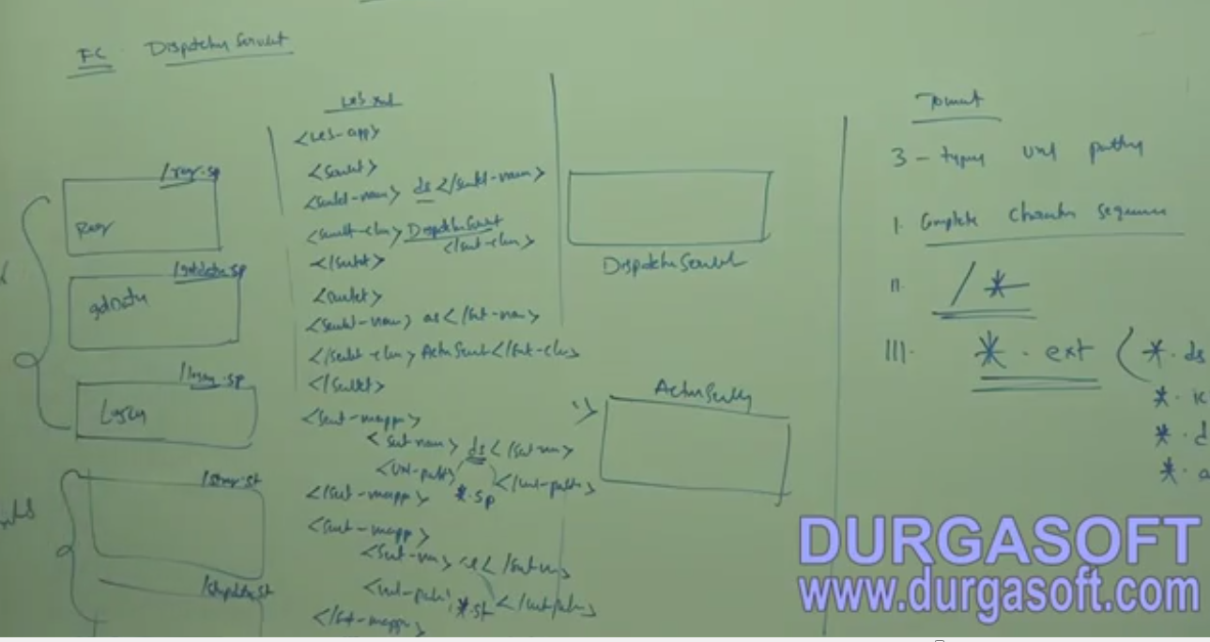
15. Continuation
    1. Work flow of Dispatcher servlet
       1. The input request from webpage goes to the servlet configured in web.xml.
       2. Multi controller can be mapped in web.xml to redirect the request from webpage to different controller ex: spring or struts etc.
       3. In Spring the controller will search for <ServletName>-Servlet.xml and there it will get the which controller to be executed.
       4. The controller class implements controller method and override “HandleRequest” and it return “ModelView”.
       5. ModelView object contain the map and the string for the redirect page.
       6. The map has the return values which will use the view Resolver class mentioned in <ServletName>-Servlet.xml.
       7. The Redirect page will be mentioned below bean class “InternalResourceViewResolver” with two setters prefix and suffix in <ServletName>-Servlet.xml. The page <Prefix><returnStringFromModelView><Suffix>
       8. Using ${key} – we can read the map and display the message in the result page.
16. Controllers
    1. Abstract Controllers
       1. View controller
          1. Parameterasible view controller
          2. URLFileName View Controller
       2. ThrowAway Controller
       3. BaseCommand Controller
          1. Abstract command controller
          2. Abstract form controller
             1. SimpleFormController
             2. AbstractWizardController
       4. MultiAction Controller
    2. 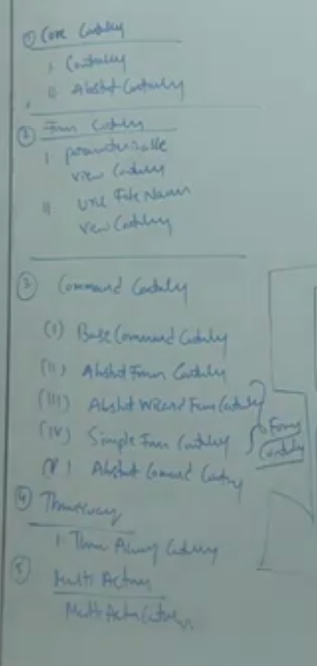
    3. Handlers Classes
       1. BeanNameURLHandlerMappping (Default)
          1. <beanname=*"/hello.ds"*class=*"controller.HelloController"*/>
       2. SimpleURLHandlerURLMapping
          1. 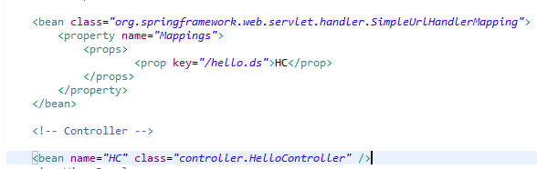
       3. ControllerClassNameHandlerMapping
          1. 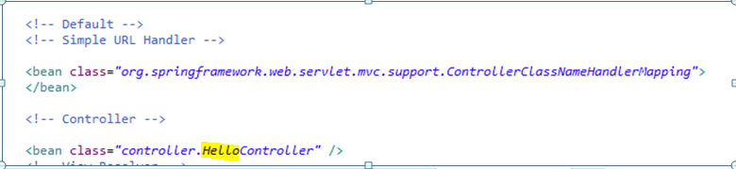
          2. 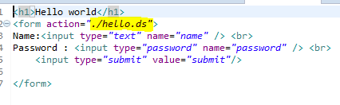
       4. CommonsPathMapHandlerMapping
    4. ViewResolver
       1. InternalresourceViewResolver
       2. TilesViewResolver
    5. 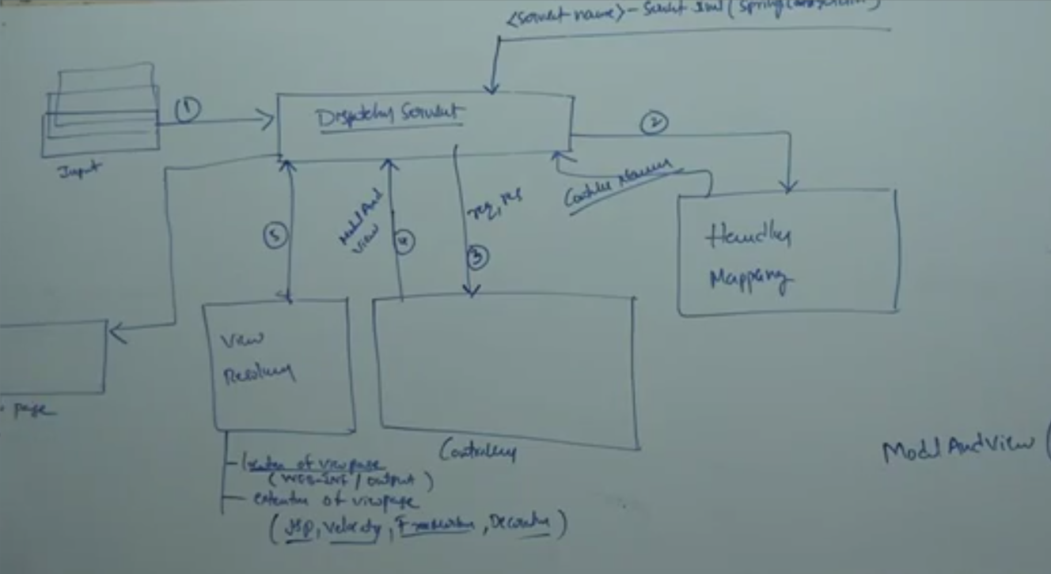
    6. 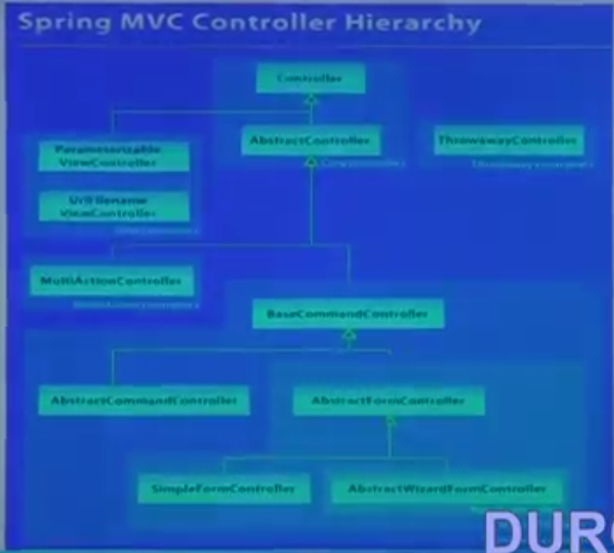
17. Continuation
18. Hello World Example
    1. 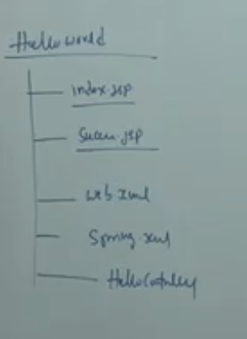
    2. 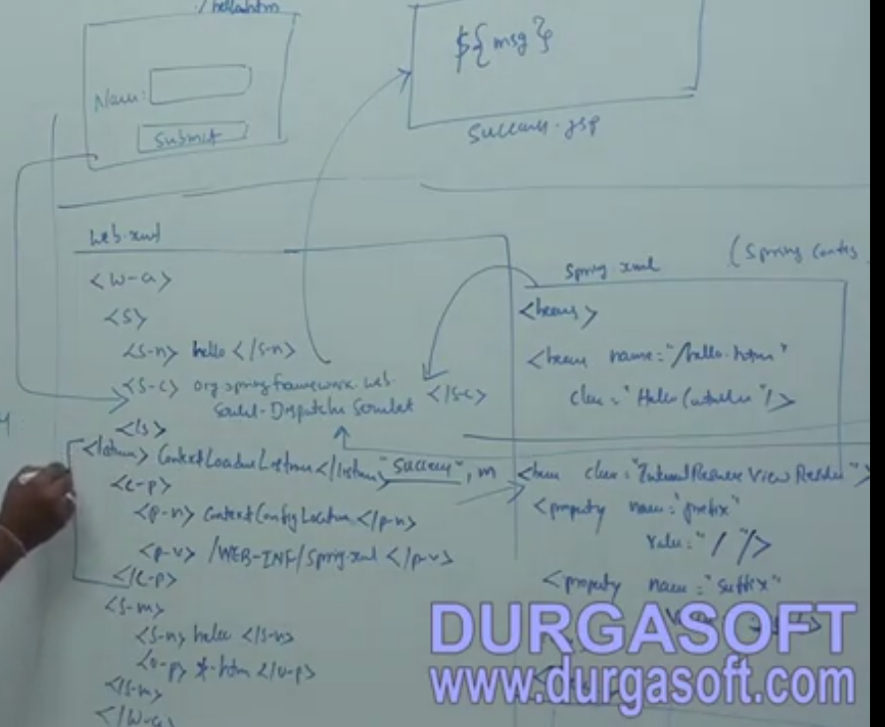
19. Sample Hello world application in MVC
    1. 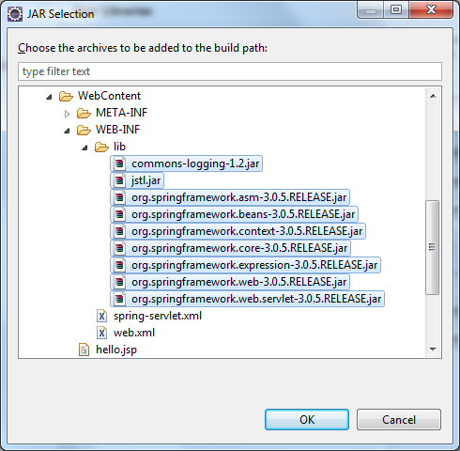
    2. Refer “MVC_HelloWorld” Application
    3. Steps
       1. Create a “Dynamic web application”.
       2. Add the above jar in project and Web-inf folder
       3. Open web.xml and add servlet configuration.
       4. 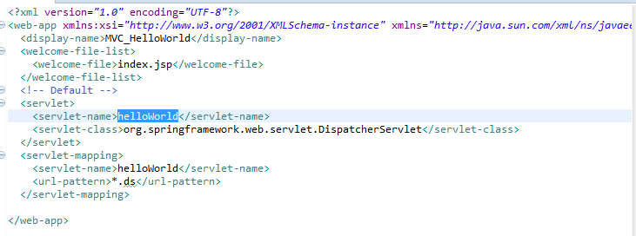
       5. Create a new xml file named in : <Servlet name>-servlet.xml
       6. 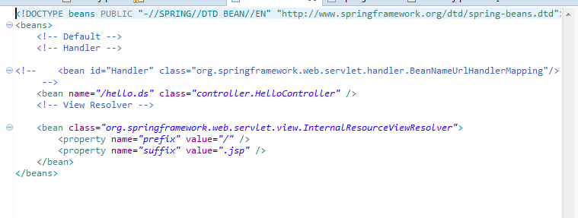
       7. Create two JSP Index and success.
       8. 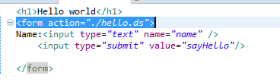
       9. 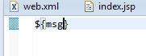
       10. Create a java class as shown below
       11. 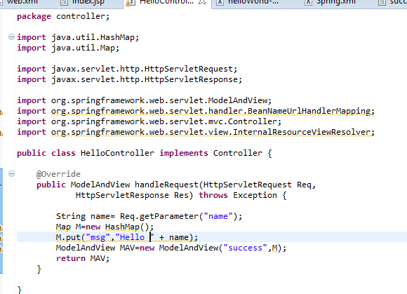
       12. Run the index file
    4. Flow

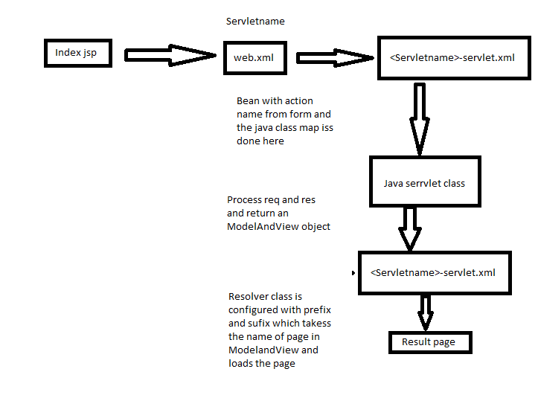

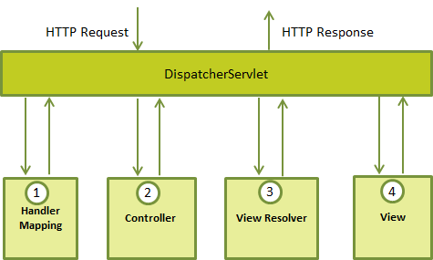

1. Controllers
   1. Discussion on the below five controllers
   2. 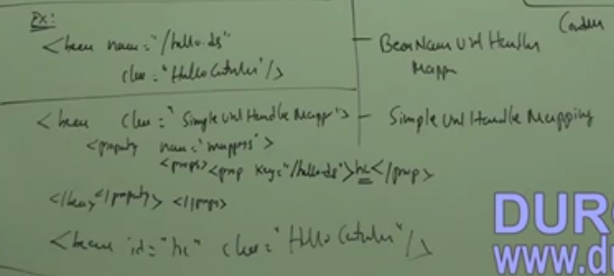
   3. 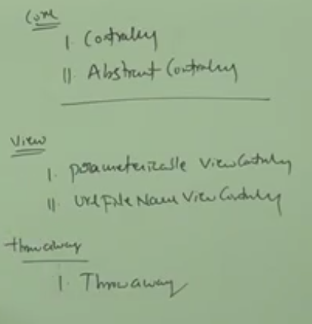
   4. 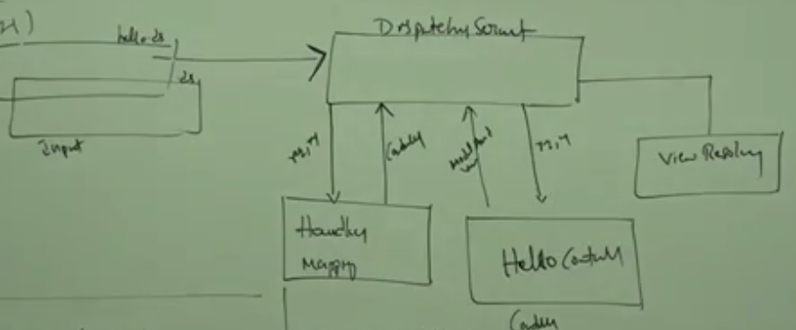
   5. SimpleURLHandlerMapping
      1. 
      2. 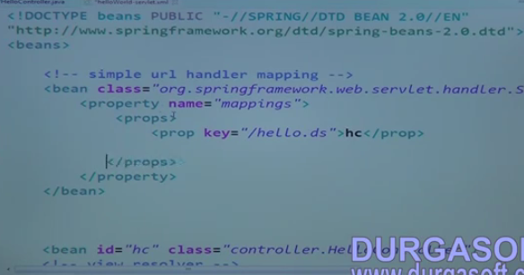
      3. In the above example in <Servlet name>-servlet.xml change the configuration as shown in the above diagram.
   6. ControllerClassNameHandlerMapping
      1. 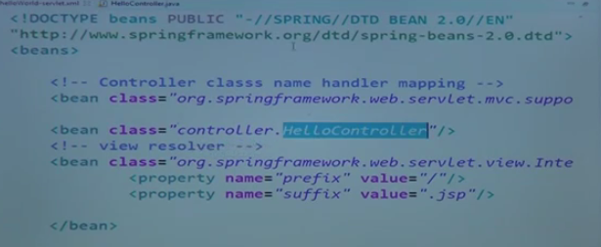
      2. The name of the action class in the webpage should be same as java class name. Then the above configuration will automatically work.
2. Continuation
   1. Configuration Parameters
   2. <Init-Parameter>, <Context-Parameters> - we can load the more than one servlet xml in different location in web.xml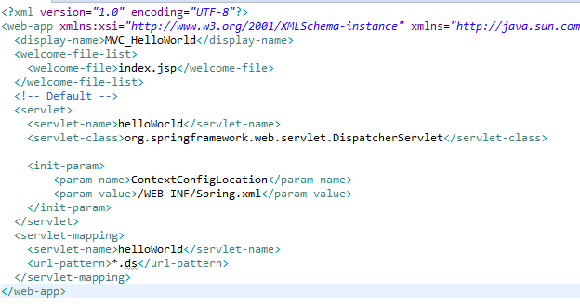
   3. We can also use import statement to achieve the above
   4. 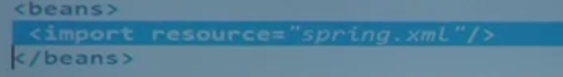
3. Continuation
   1. Abstract controller
      1. Override handleRequestInternal instead of handleRequest.
   2. Parameterizable View Controller
      1. Override handleRequestInternal instead of handleRequest.
      2. SetViewNamein the XML file and getViewName in the ModelAndViewController.
      3. 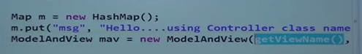
      4. Should extends ParameterizableViewController
      5. 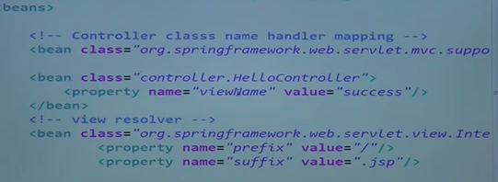
   3. URLFilenameController
      1. Override handleRequestInternal instead of handleRequest.
      2. Append the action name to the modelAndView object and send the object. i.e if "hello.ds" is submitted it will load "hello.jsp".
      3. 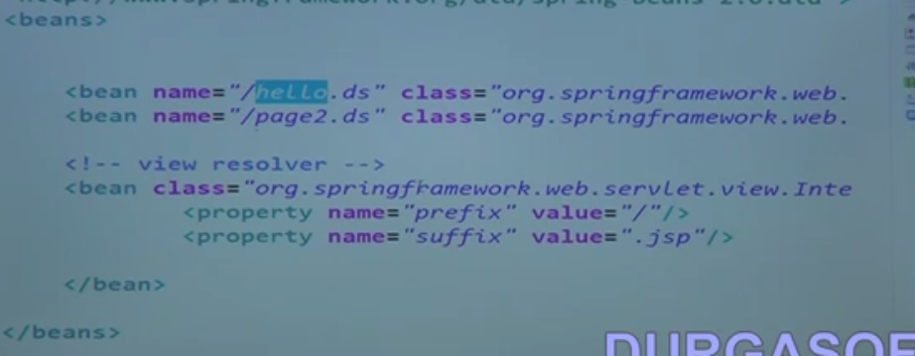
      4. This hello.ds will be returned as hello.jsp
4. Continuation
   1. Implement Controller – HandleRequest
   2. EntendsAbstractController–HandleRequest ,HandleRequestInternal
   3. There is no much difference bet controller and abstractController except the overriding method name
   4. ParameterisiableViewContrller- HandleRequest ,HandleRequestInternal, getViewName,SetViewName (viewName is @required Annotated)
   5. URLFileNameController - HandleRequest ,HandleRequestInternal
   6. ThrowAwayController - Execute this controller according to its bean properties.(Same as struct2 or JSF)
5. Continuation
   1. MultiActionController
      1. Should not override HandleRequest and HandleRequestInternal
      2. Custom methods with handle request signature
      3. Method name equal to action name
      4. useSimpleUrlhandlerMapping.
      5. If we want different method name then use methodNameResolver
         1. InternalPathMethoNameResolver

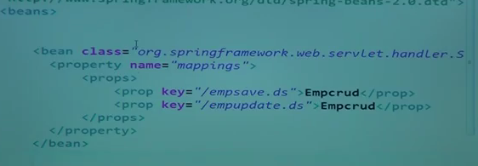



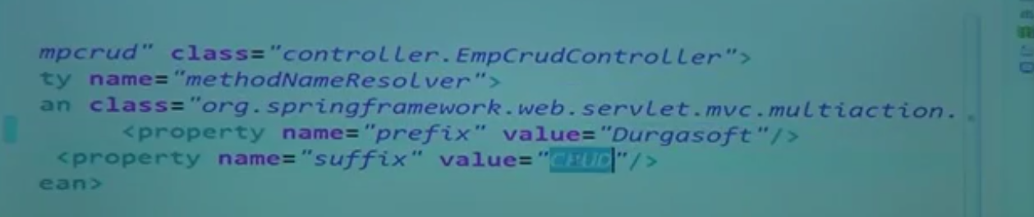

1. Continuation
   1. Example to do the InternalPathMethoNameResolver
   2. SetmethodNameResolver to be set in xml
   3. 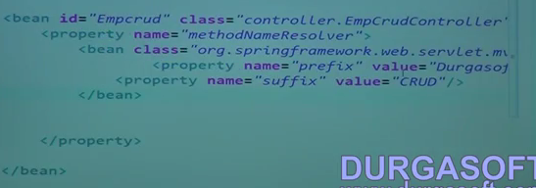
   4. 
   5. 
2. Command Controller
   1. BaseCommandController
   2. ThrowAwayController
3. Data Access Object (DAO)
   1. JDBC - Database
   2. JAX-P, JAX-B – XML
   3. ORM (JJPA, Hibernate) – For Database
   4. OGM – NonSQL
   5. Spring-JDBC
   6. SpringORM
   7. 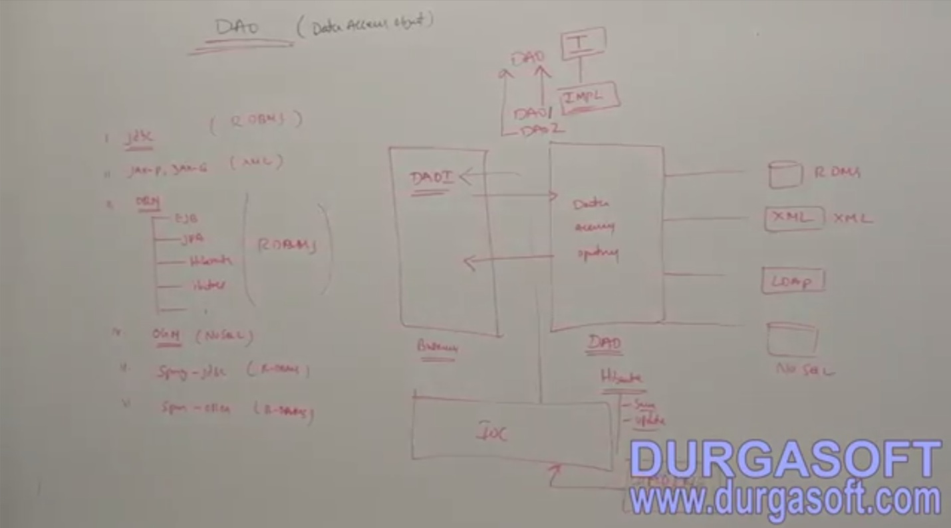
   8. Before Implementing a DAO, create an Interface so that the object will be loosely coupled with the business layer
4. Continuation
   1. Model objects
5. Continuation
   1. Connection Pool
6. Continuation
   1. Connection pool implementation
7. Continuation
   1. JDBC Template
      1. No compile time exception
      2. No open or close connection

|  |  |
| --- | --- |
| **JDBC** | **Spring JDBC** |
| Compile Time Exception (SQL Exception) | Run Time Exception (Data access exception) |
| Exception belongs to Java.sql | Exception belongs to Spring-Dao.jar |
| Need to close connection | No need to close any connection |
| Prepared statement is type safe | All JDBCC templates are type safe |
| Select returns only Int | Generic return values are returned |

1. Implementation of JDBC
2. Hibernate Template DEMO
   1. 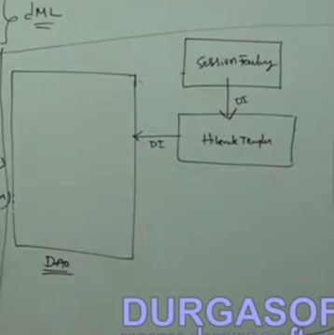
   2. 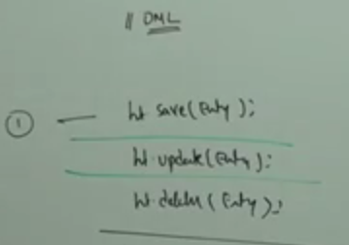
   3. 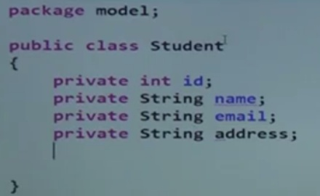Generate Getters and setters for this
   4. 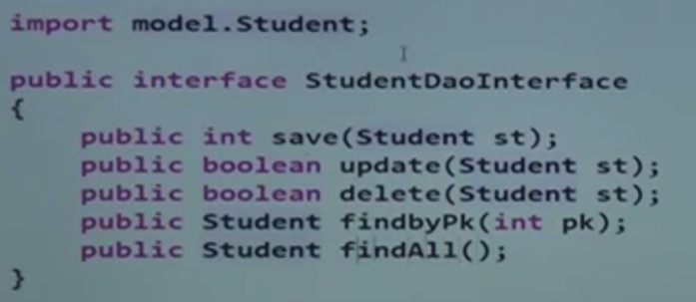
   5. Implement this interface
   6. 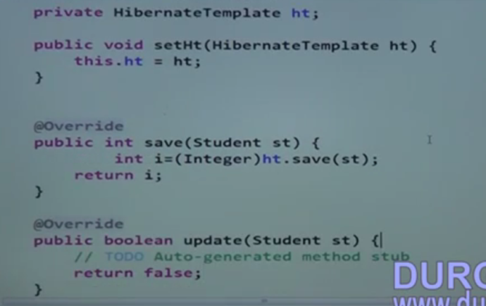
   7. 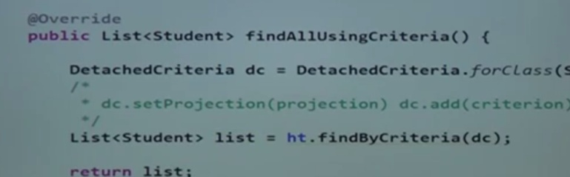sample method where Ht is the hibernate template.
   8. 
   9. 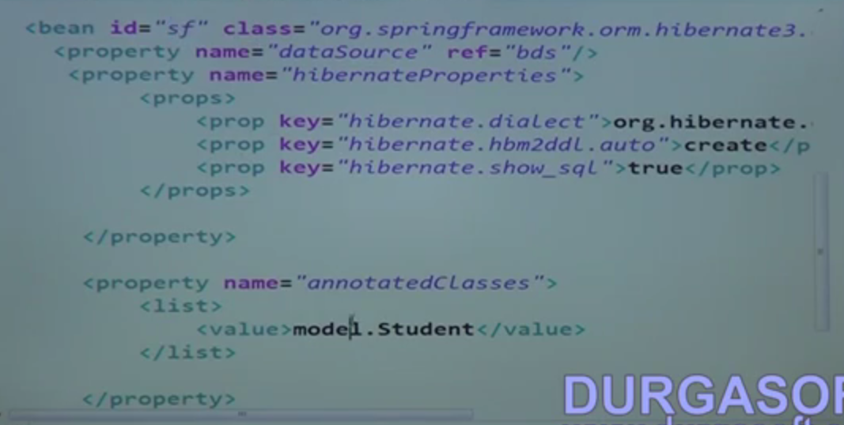
   10. 
   11. 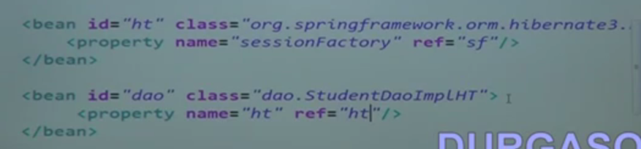
   12. 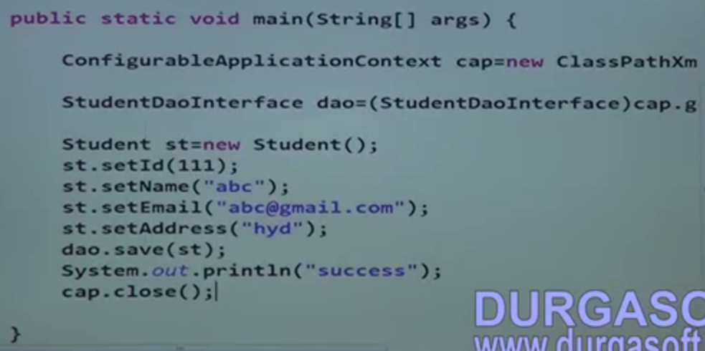
3. DTO in Spring
   1. 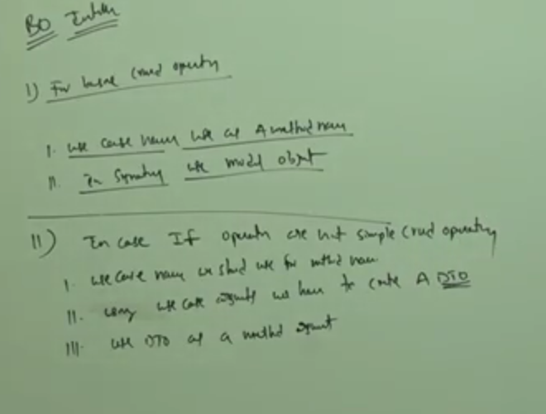
4. Continuation
5. AOP
   1. MethodBeforeAdvice
   2. AfterReutuningAdvice
   3. methodInterceptor
   4. ThrowsAdvice

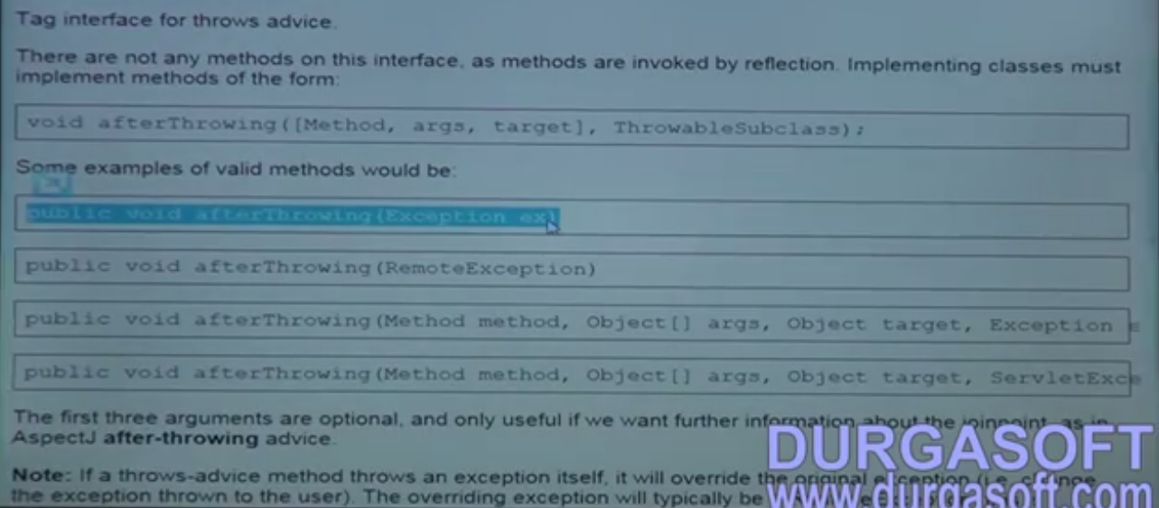

## Spring MVC

1. Introduction to MVC
   1. 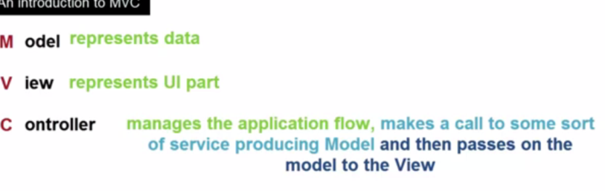
   2. 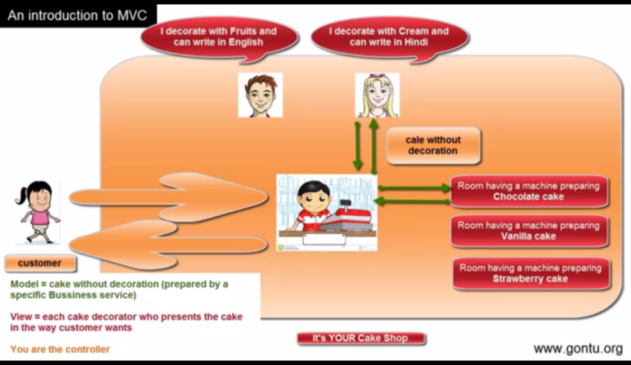
2. Spring MVC
   1. 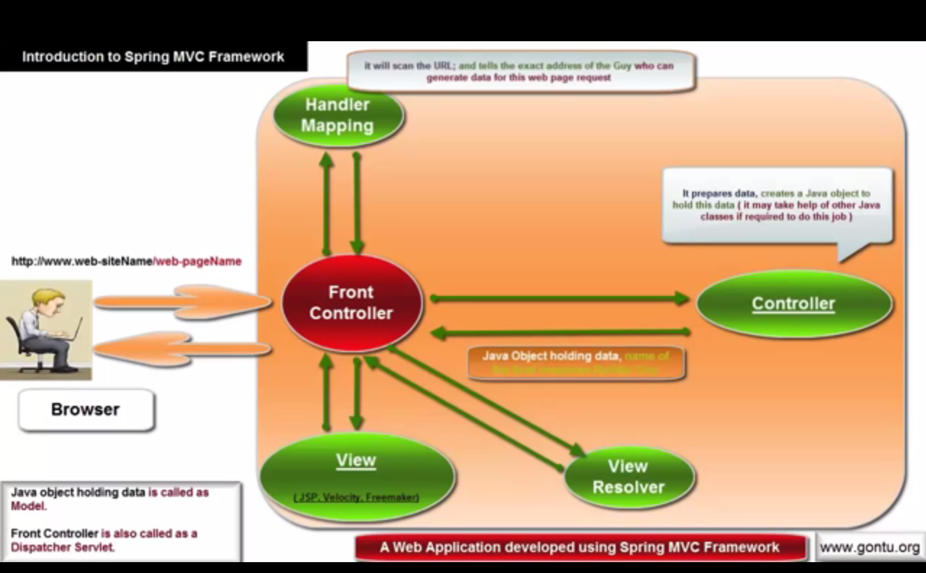
3. Installation and Setup using an Eclipse IDE
   1. Create a new Dynamic web project and add the dependent libraries
4. Integrating Tomcat Apache server with an Eclipse IDE
5. Creating first Spring MVC Web Application using Eclipse IDE (01)
   1. 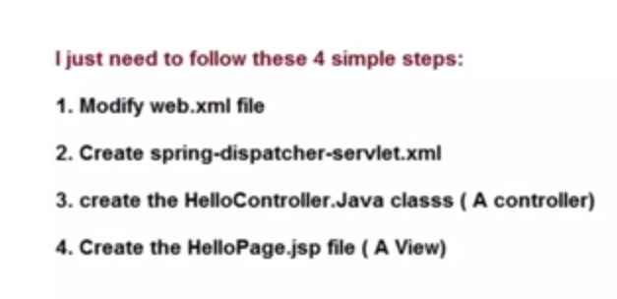
   2. 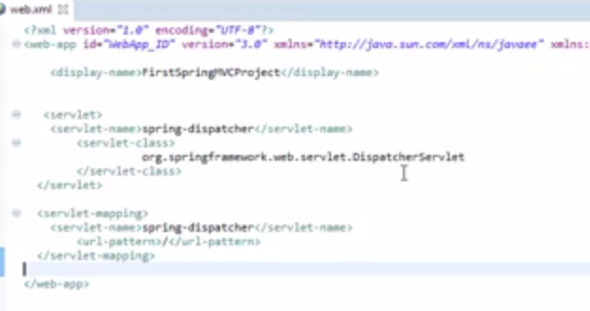
   3. 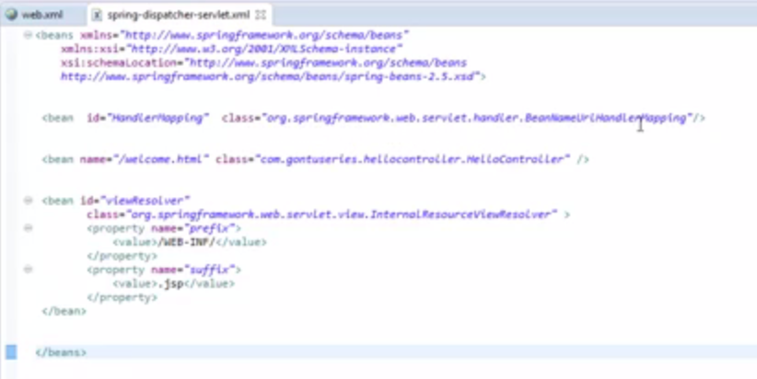
6. Creating first Spring MVC Web Application using Eclipse IDE (02)
   1. 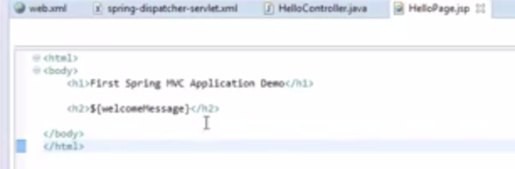
   2. 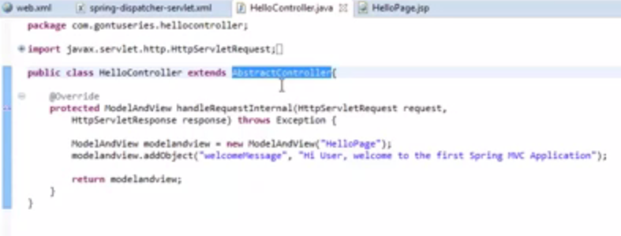
7. writing an annotation based controller class -@Controller, @RequestMapping
   1. Same java class with equivalent annotation is as below.
   2. 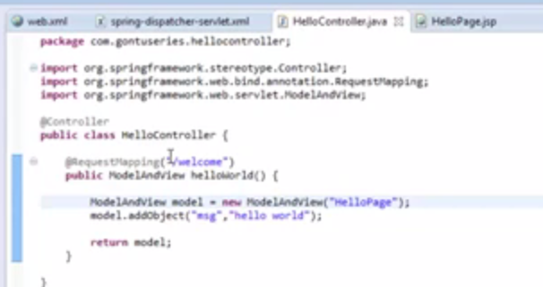
   3. 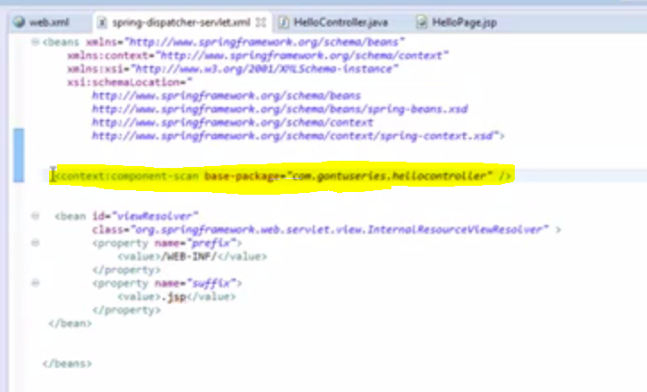
8. MultiAction Controller class, @RequestMapping annotation at class level
   1. 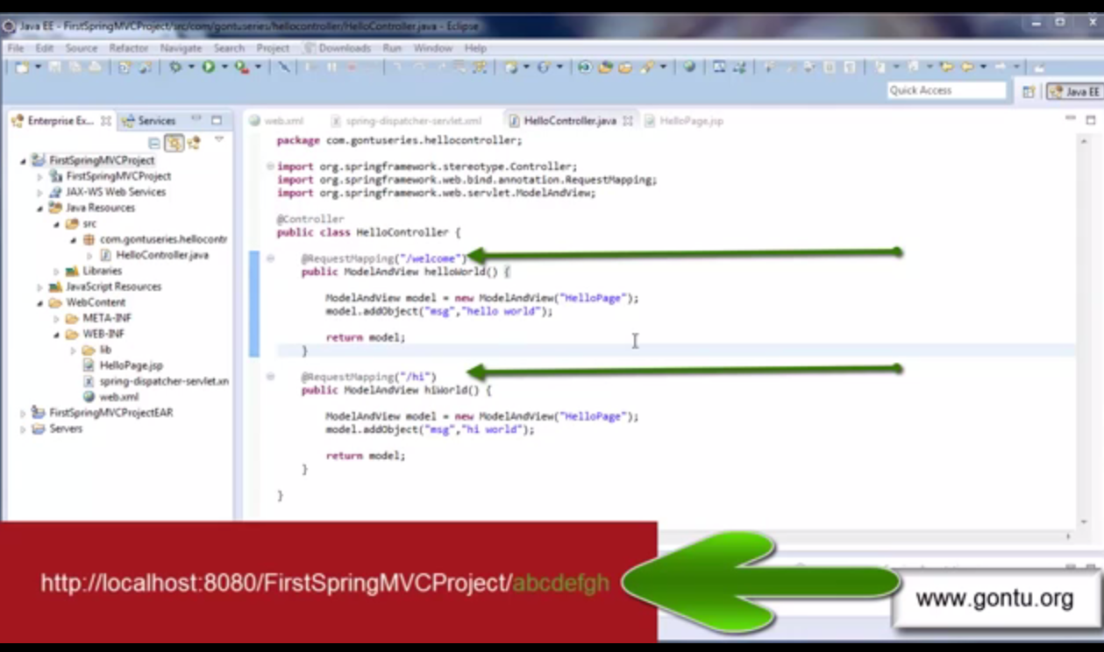
   2. If the request does not match with any of the value in @requestMapping then we will get a 404
   3. 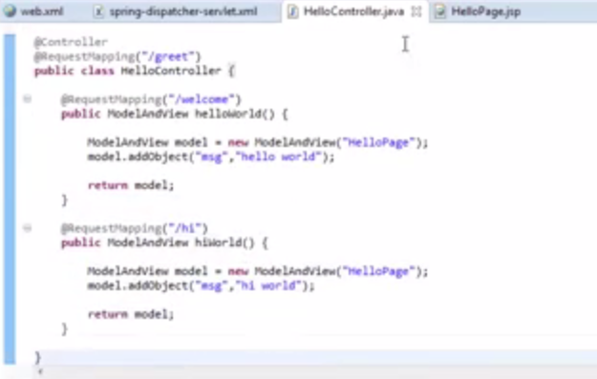
   4. 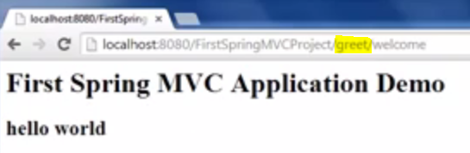
9. @PathVariable annotation in detail (A URI-Template concept )
   1. 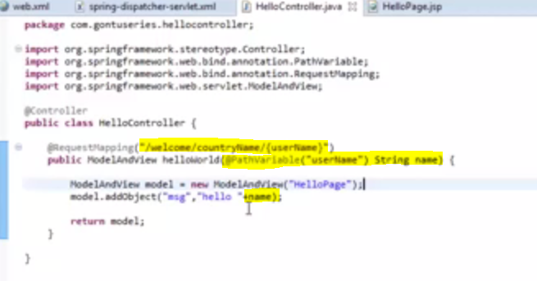
   2. Use @PathVariable to bind the values in the request to a variable.
   3. It can also done thru the following
   4. 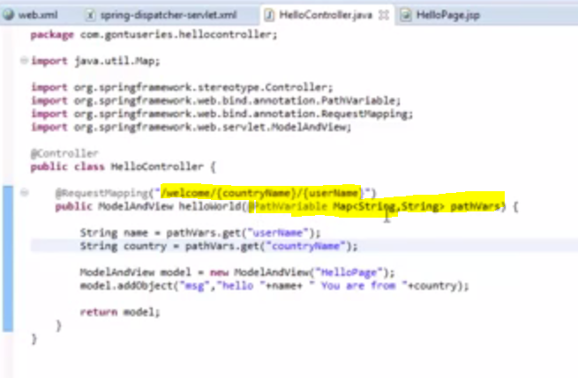
   5. To do so need to place the highlighted tag in xml
   6. 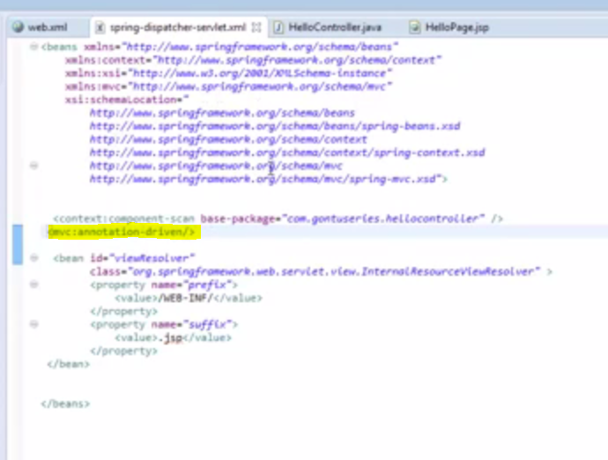
10. Handling an HTML form using @RequestParam annotation
    1. 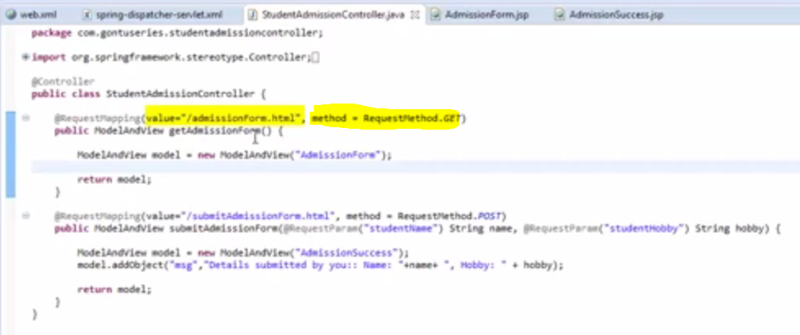
    2. 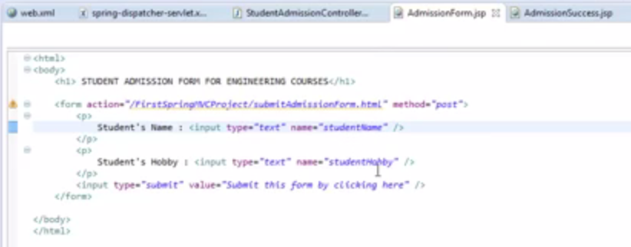
    3. 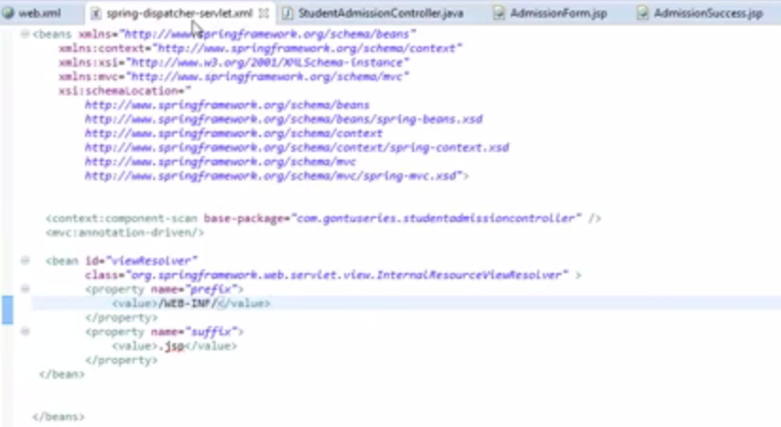
    4. 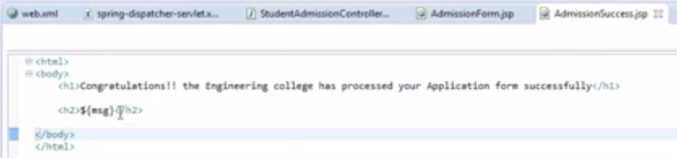
    5. Default value will be used if no values is provided
    6. 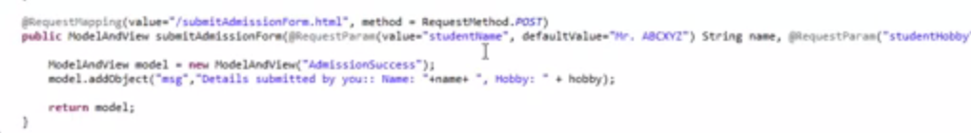
11. Understanding @ModelAttribute Annotation 01 (using on a method argument)
    1. Create a model object
    2. 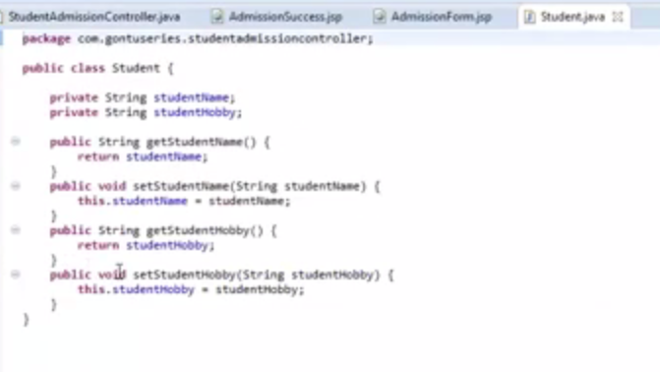
    3. 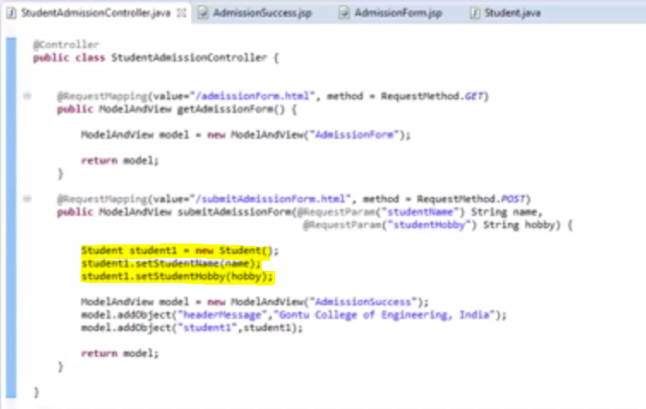
    4. 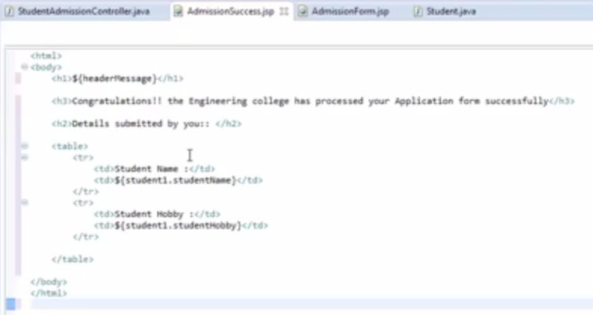
    5. Using @ModelAttribute
    6. 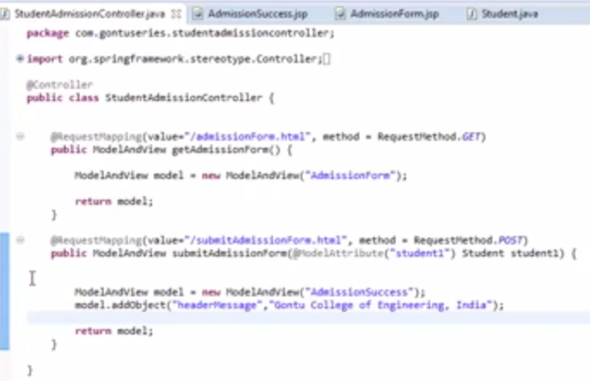
    7. Name of member variables with the name of the form elements should be the same.
12. Understanding @ModelAttribute annotation 02 ( using at a method level )
    1. 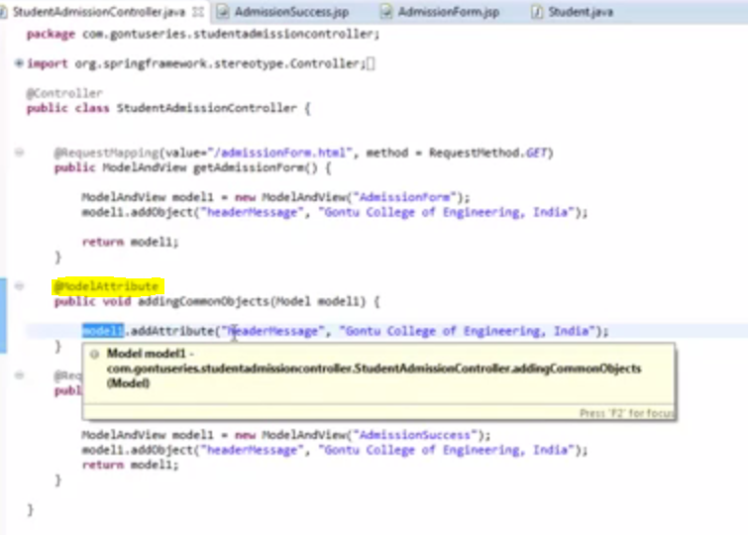
    2. @ModelAttribute on a method will append all the objects in that method to all the models in the class.
13. Data Binding with Date, Collection (Arraylist), Long etc
    1. 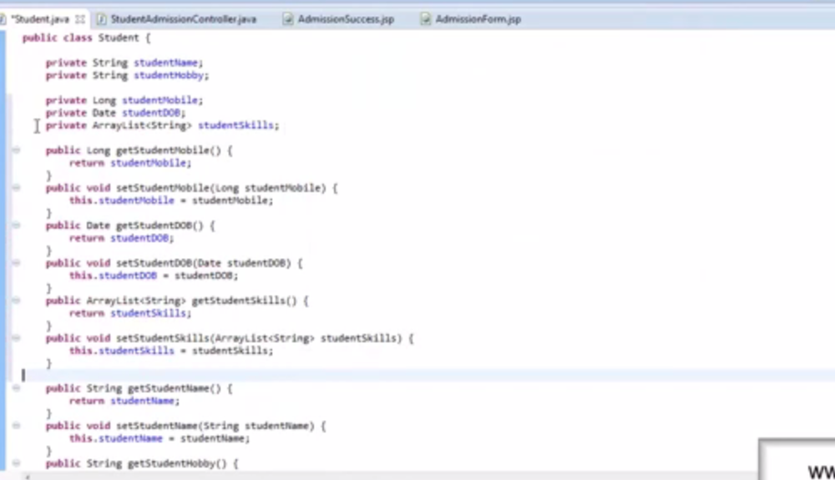
    2. For processing the student class with the above mentioned records
    3. 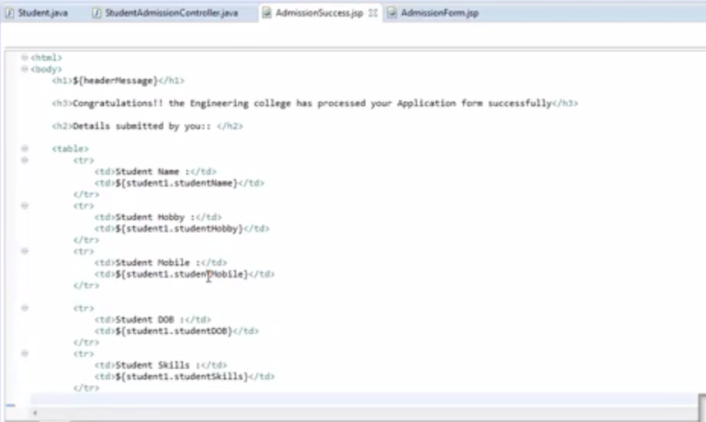
    4. 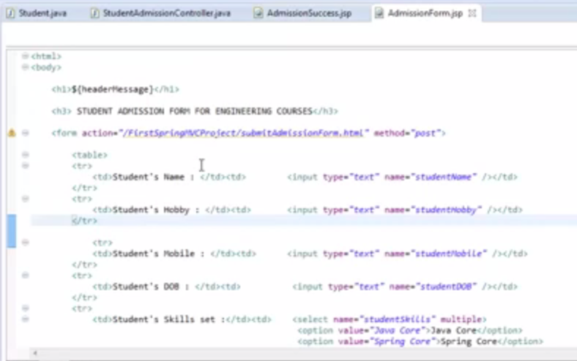
    5. That the end. The model object will automatically bind to the values to the members
14. Data Binding with a User-Defined Type, BindingResult (concept)
    1. 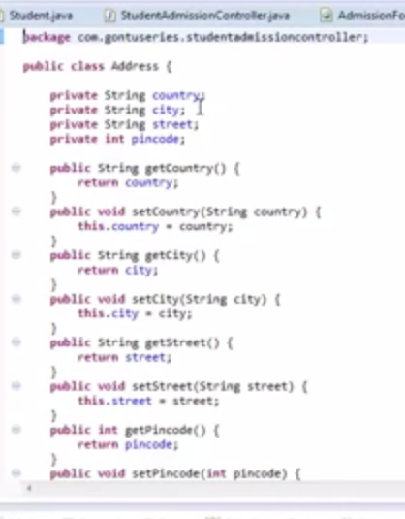
    2. 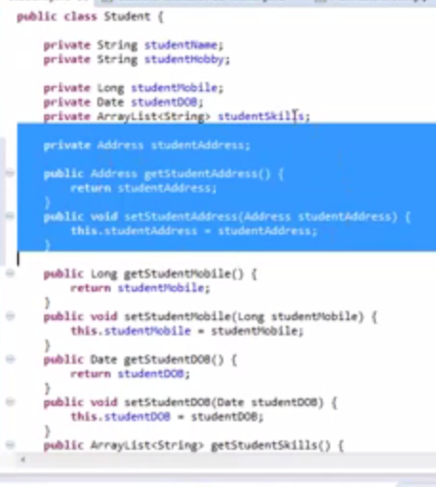
    3. 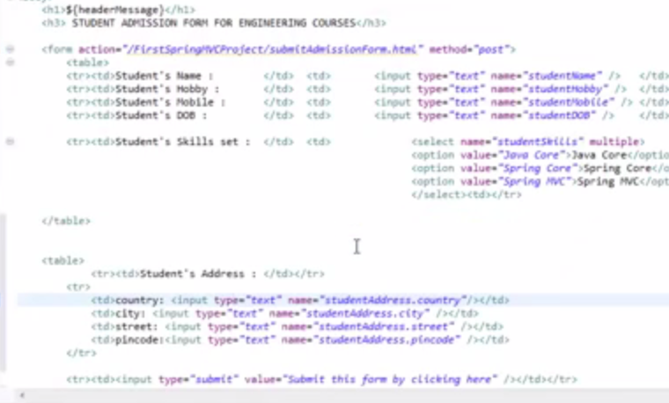
    4. 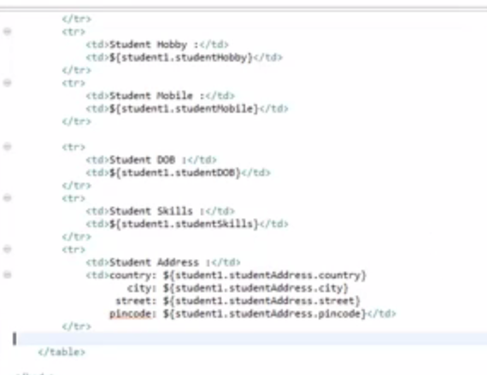
    5. If any errors is present in the errors use the following
    6. 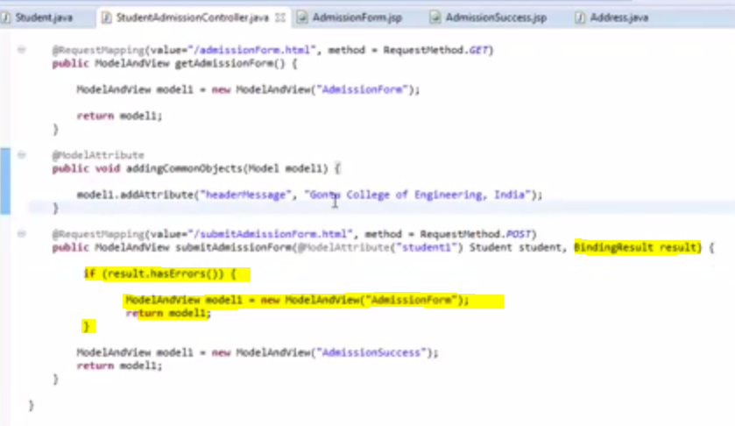
    7. 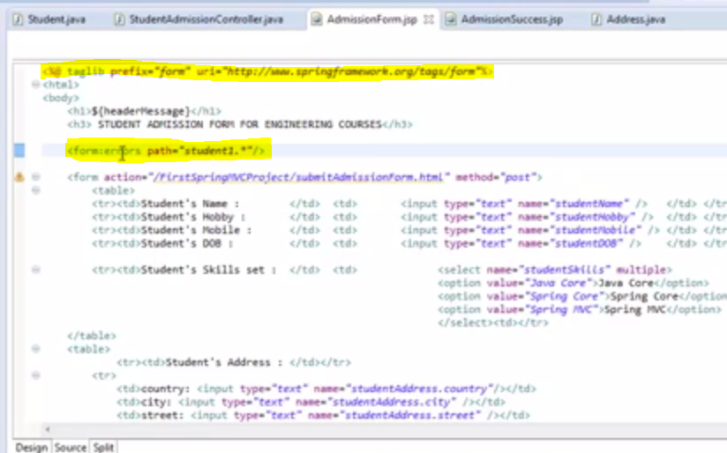
    8. Using this exception itself printed in the page.
15. @InitBinder annotation, WebDataBinder, CustomDateEditor
    1. 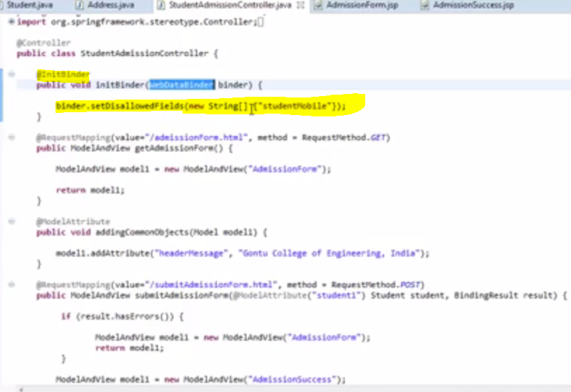
    2. The disallowed filed will be ignored
    3. 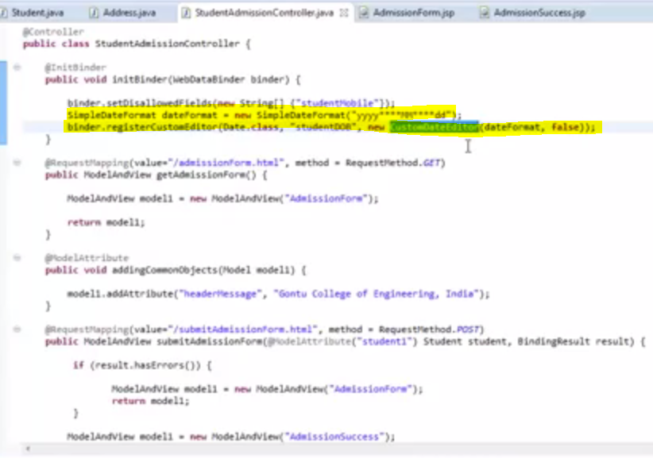
16. Writing your own custom property editor class
    1. Spring has given the following classes for type editor classes
    2. 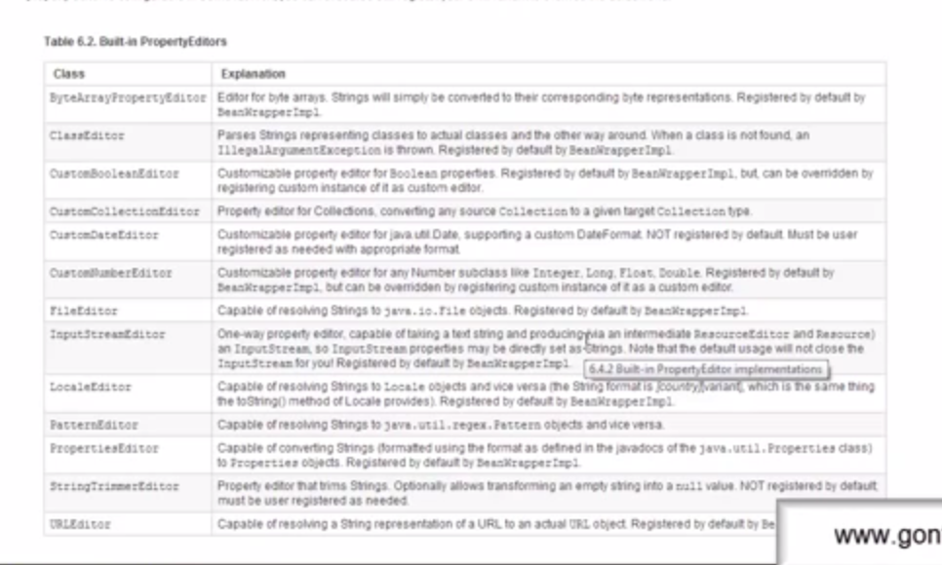
    3. Custom editor for checking the name start with mr of mrs
    4. 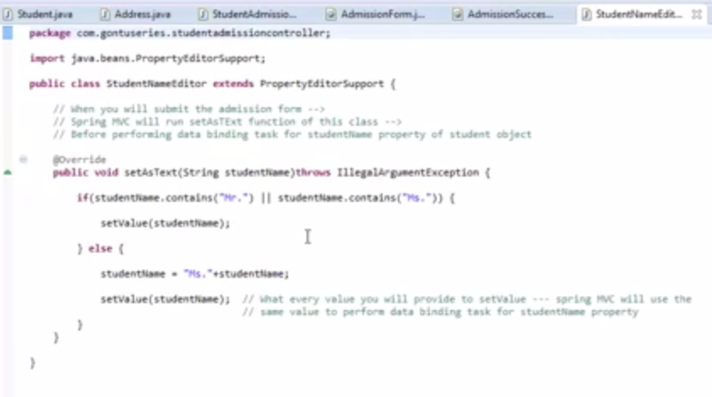
    5. 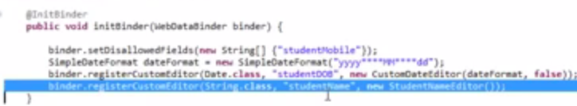
17. Form Validations 01 ( using JSR 303_349 provided annotations )
    1. @Size Attribute is used to set the max and min length of the field
    2. 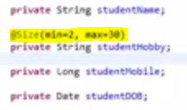
    3. @valid Annotation in the method is used to check the all the form annotated validation for the binding class
    4. 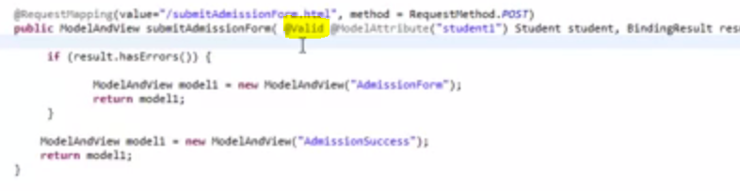
    5. 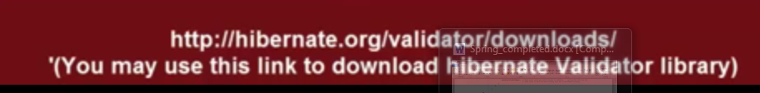
    6. 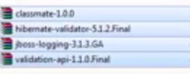
18. Form Validation 02 (customizing error messages using Spring MessageSource)
    1. 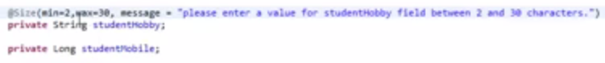
    2. 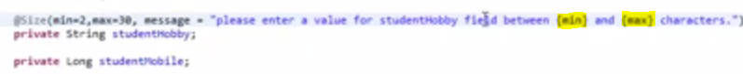
    3. Add the following bean in the Spring.xml to read the messages from a separate file.
    4. 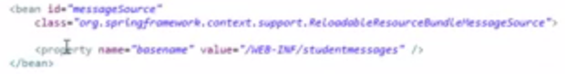
    5. 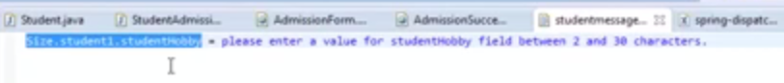
    6. Spring will check for the following pattern in the message resource file
    7. 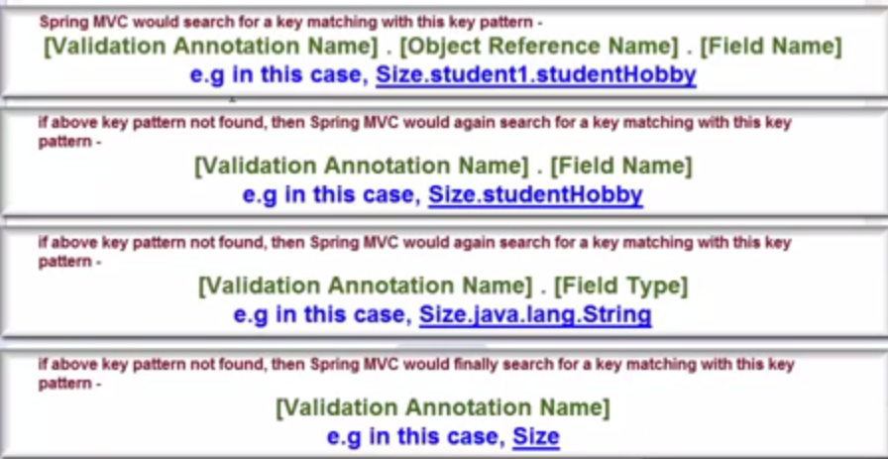
19. Form Validation 03 (more on Spring MessageSource concept...)
    1. 
    2. For dynamic value loading
    3. 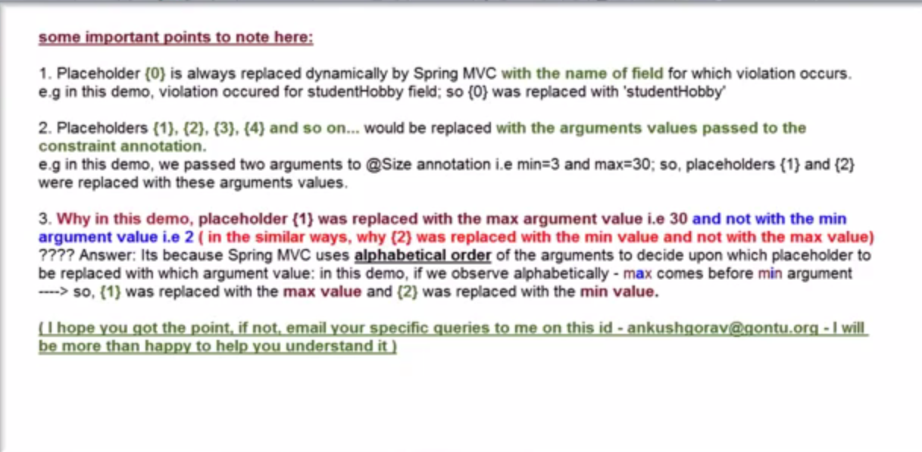
    4. If any changes done in the properties file, then we need to restart the server. To avoid we need to add the following line in the spring.xml
    5. 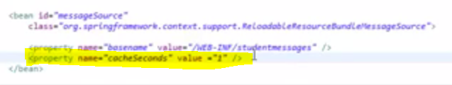
20. Form Validations 04 (@Pattern, @Past, @Max and some more...)
    1. 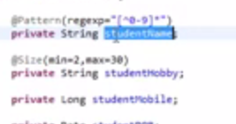
    2. It will throw a error when a name contains a number
    3. @past, @future for date value
    4. @max(val) for maximum value for numbers and @min(val) of numbers
    5. 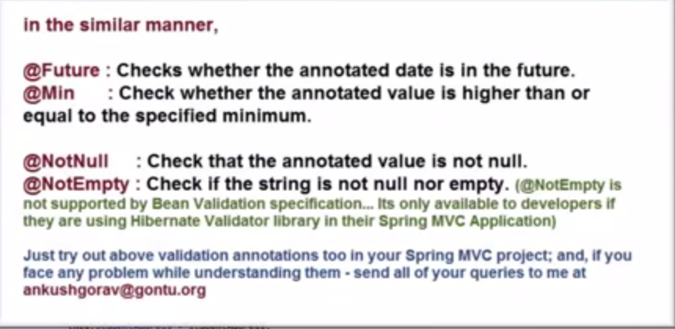
21. Form Validations 05 ( writing a custom Form Validation annotation )
    1. 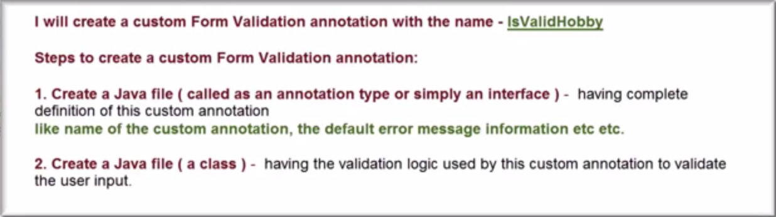
    2. 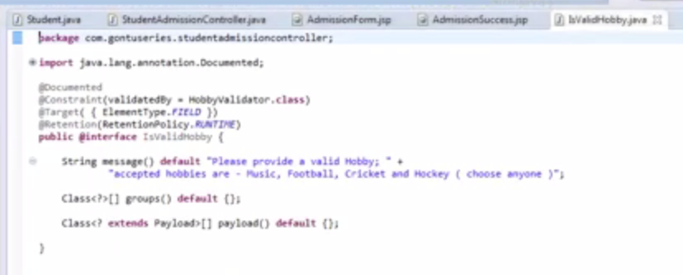
    3. 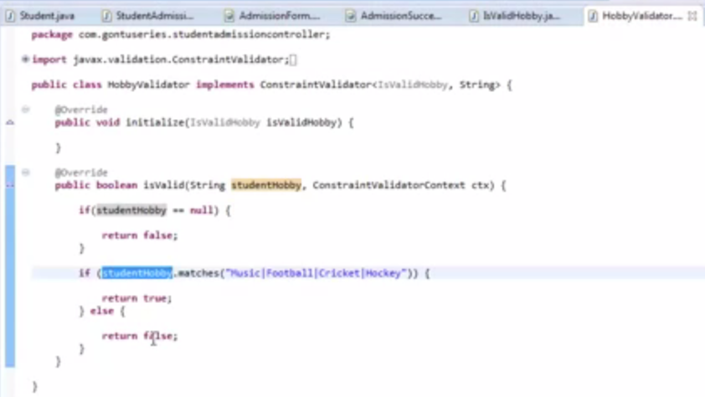
    4. 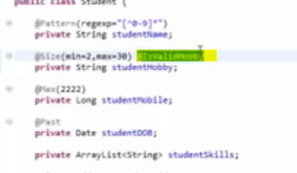
22. Form Validations 06 (More on custom Form Validation annotation...)
    1. 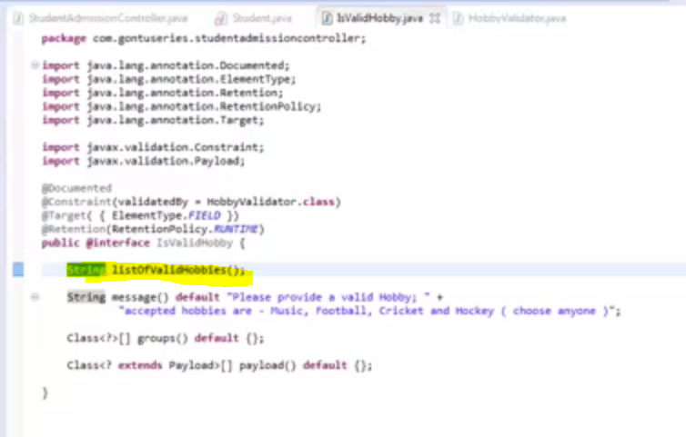
    2. 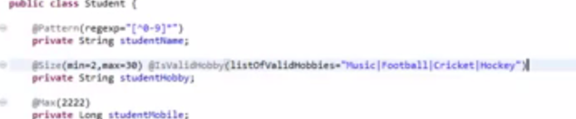
    3. 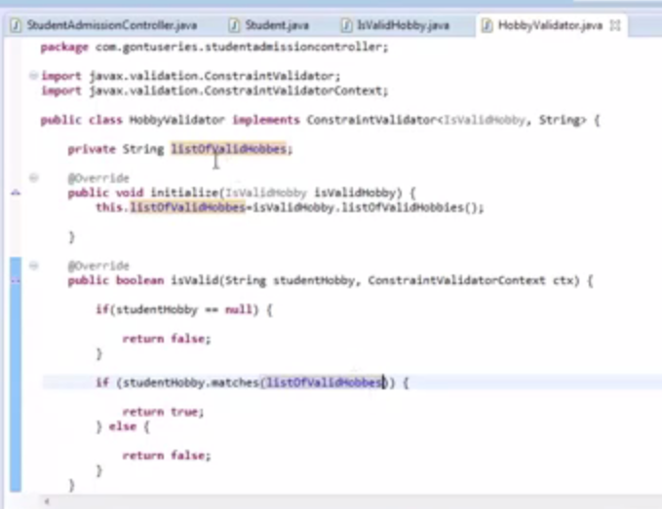
    4. 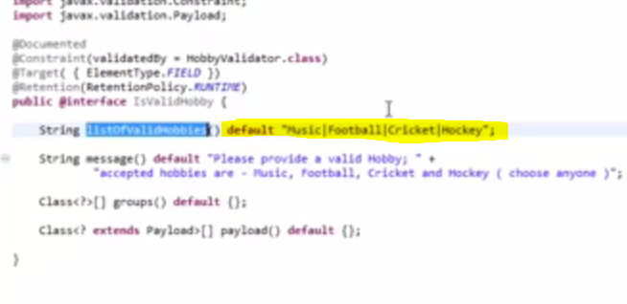
    5. The above highlighted line indicate that the parameter is not a mandatory one and for the user to pass when the annotation is used
23. Interceptor 01 ( Introduction with a hands on session )
    1. Make an application to work only on week days
    2. 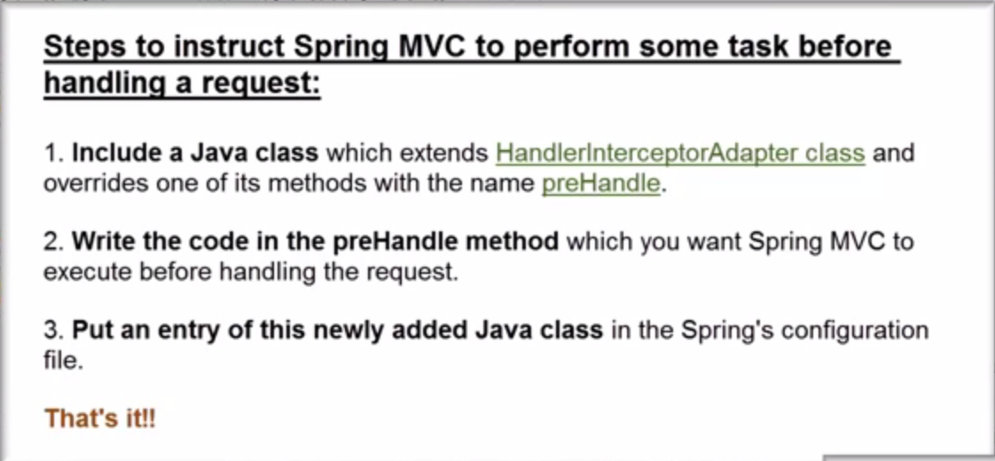
    3. 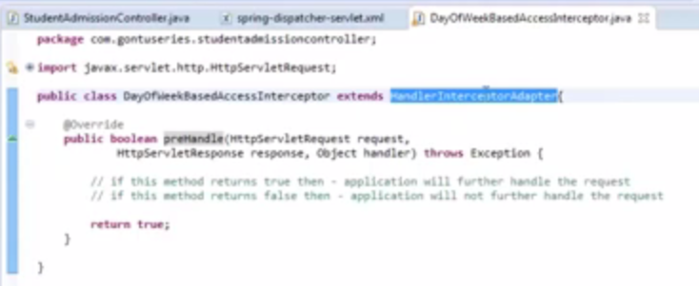
    4. 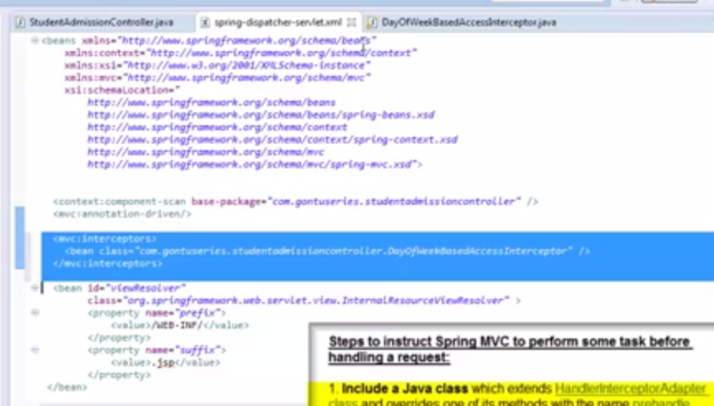
    5. 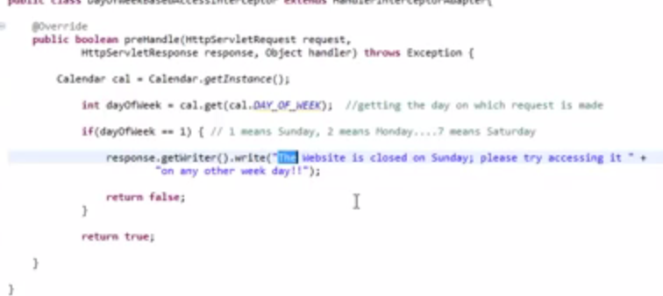
    6. If the above method returns true the application will loads otherwise the application will not be loaded.
24. Interceptor 02 ( more on understanding basics of it...)
    1. 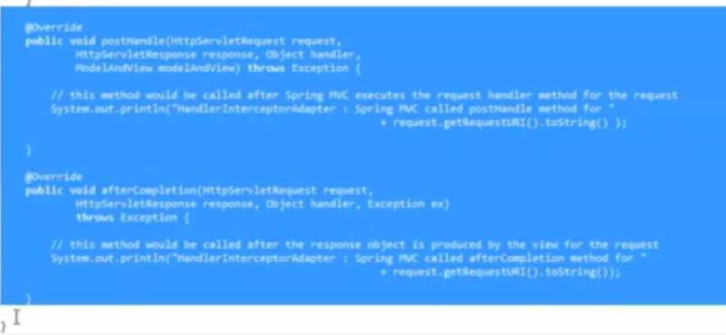
    2. PostHandle and afterCompletion method
    3. PreHandle method will be executed when the application loads and when this method returns true it will execute the controller as per the handler and calls the postHandle method.
    4. The postHandle method will be executed and then the application makes a call to the view form and execute it. Then it call the after Completion method.
    5. To make the interceptor call for certain URL alone we can use this below.
    6. 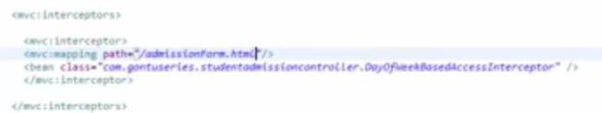

## Spring Services

1. Restful Services
   1. 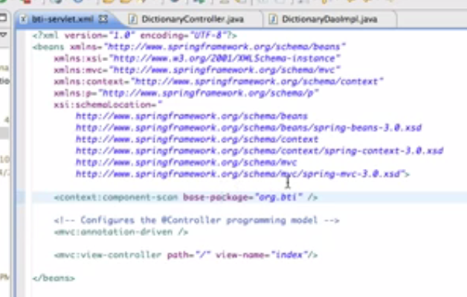
   2. @Controller Annotation – @RequestMappingused to map URL to the services
   3. 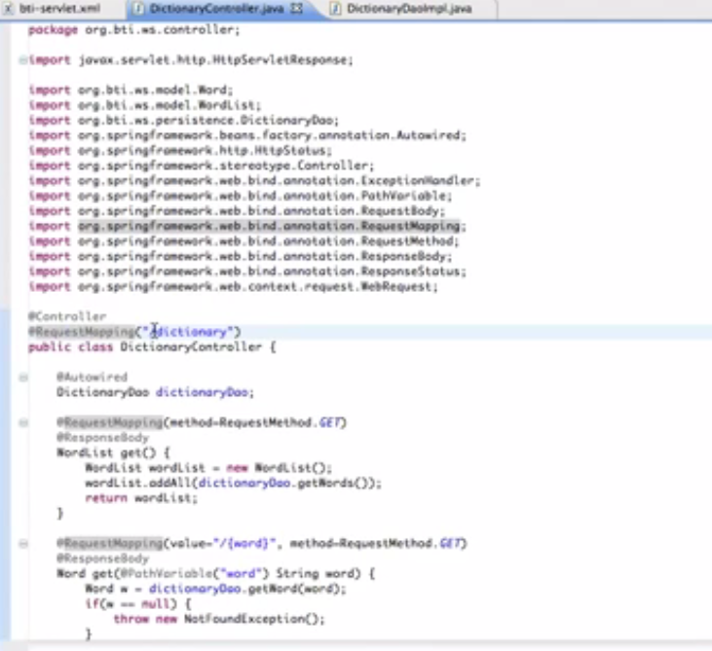
   4. @pathVarible annotation is used to map the values in the URI
   5. 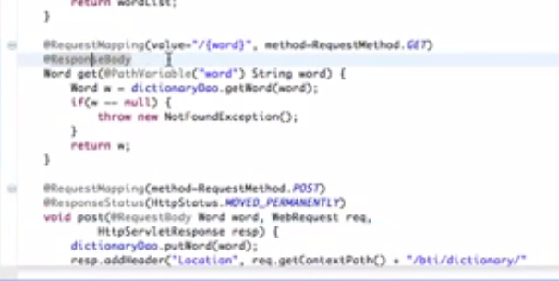
   6. @requestbodyindicate that the parameter will be taken as request.
   7. @responseBody is indicate that whatever this method returned will send as response
   8. 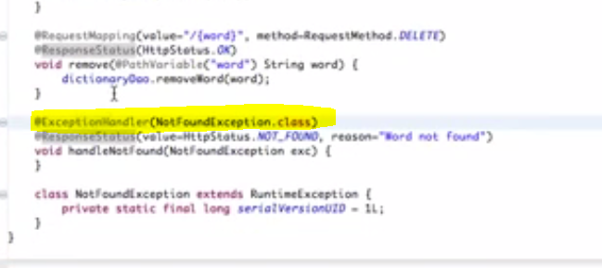
   9. Exception handler is used to indicate which method to handle the right exception
   10. Methods available in services
   11. 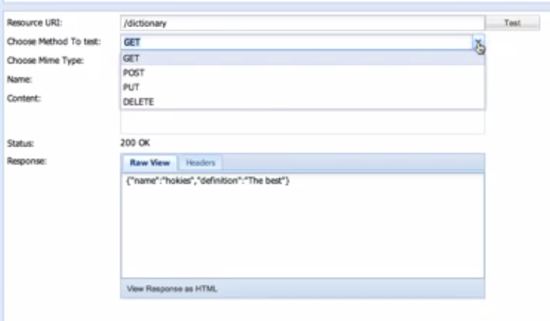

## Spring WS Using JDOM

1. Spring WS is used to develop Contract first web services
2. JDom lib will be used

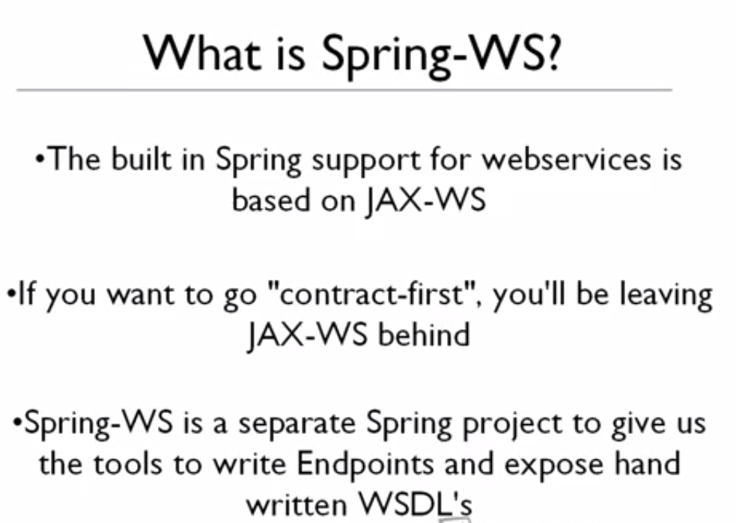

# Spring French Tutorial

1. Spring MVC & Ajax JQuery - Parte 0
2. Spring MVC & Ajax JQuery - Parte 1 (O projeto)
   1. Add a new project in Netbeans
   2. Add a maven web project
   3. Copy dependency in POM.xml
3. Spring MVC & Ajax JQuery - Parte 2 (Entity, DAO, Controller)
   1. Generate a entity class as below
   2. 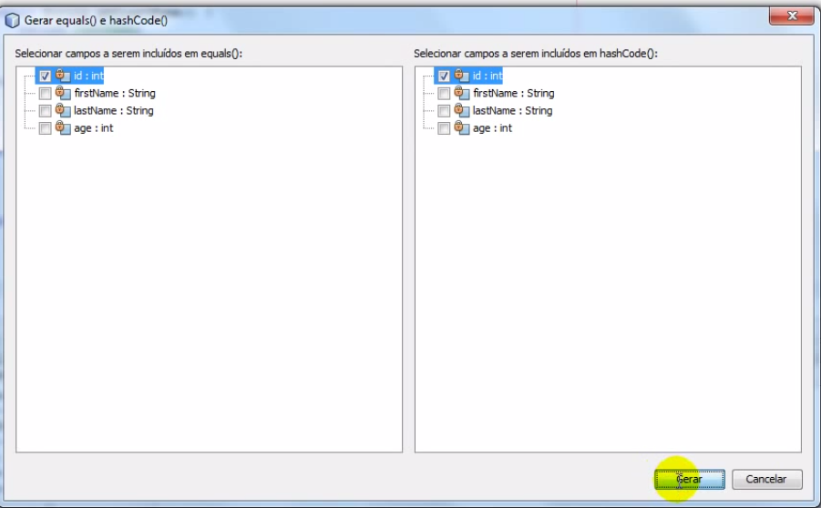
   3. 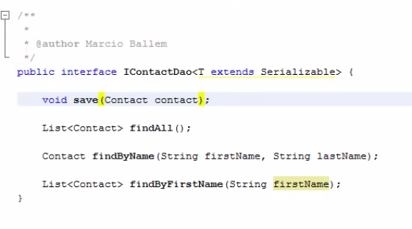
   4. 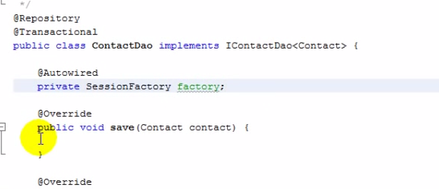
4. Spring MVC & Ajax JQuery - Parte 4 (Evento Save)
   1. 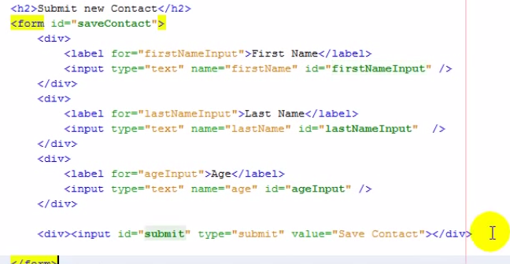
   2. 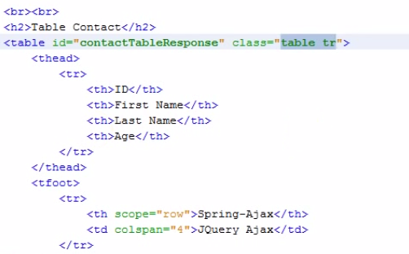
   3. 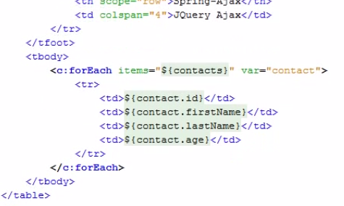
   4. 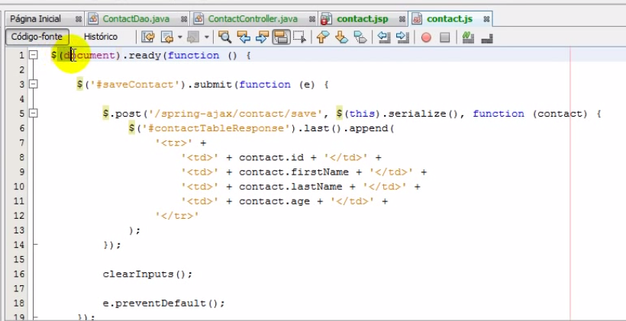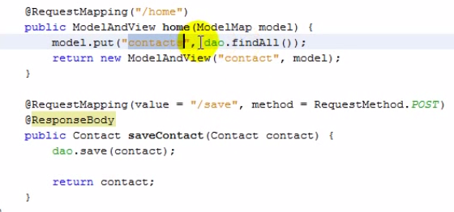
   5. 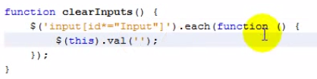
   6. 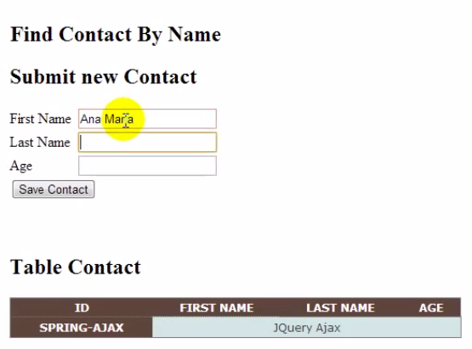
5. Spring MVC & Ajax JQuery - Parte 5 (Evento find)
   1. 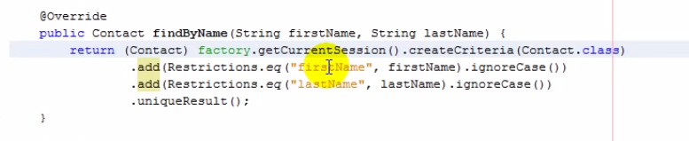
   2. 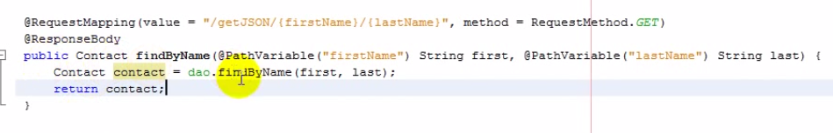
   3. 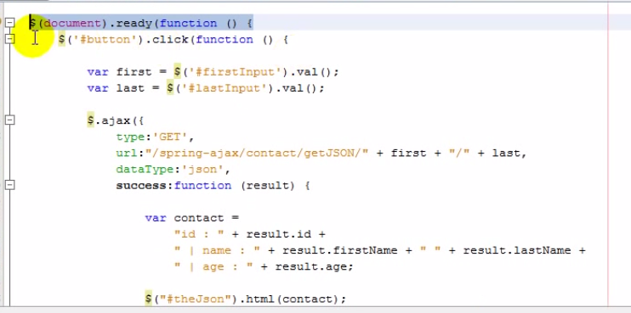
6. Spring MVC & Ajax JQuery - Parte 6 (jQuery load)
   1. 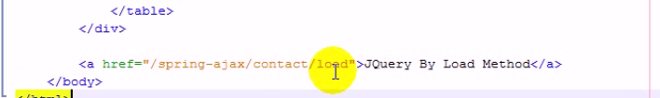
   2. 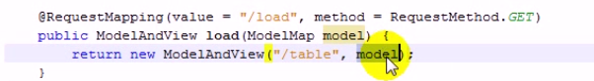
7. Spring MVC & Ajax JQuery - Parte 7
   1. 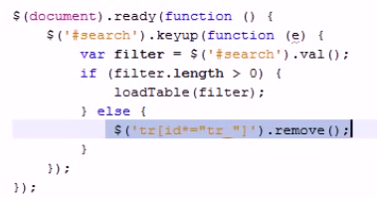
   2. 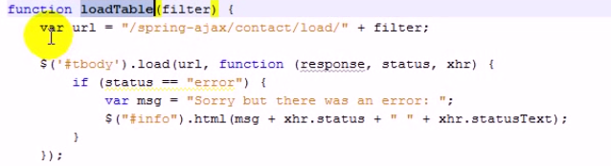
8. 01.SPRING MVC TAMIL TUTORIAL INTRO
   1. 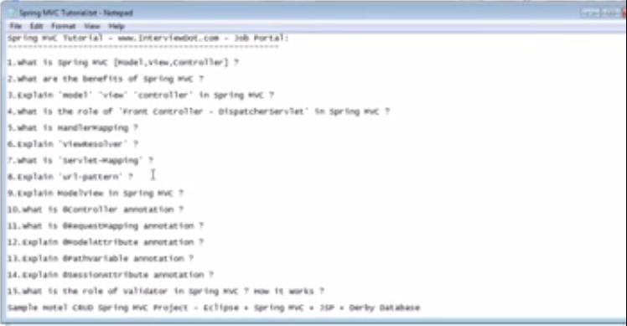
9. 02.HOW SPRING MVC VALIDATOR WORKS TAMIL
   1. 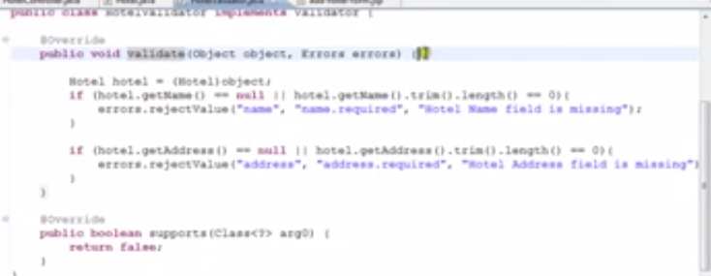
   2. 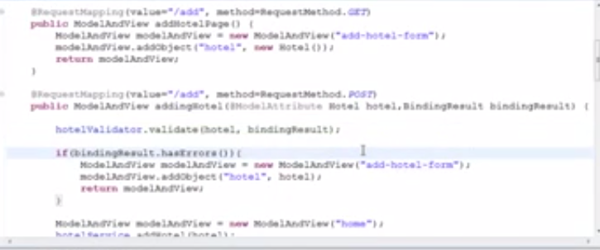
   3. 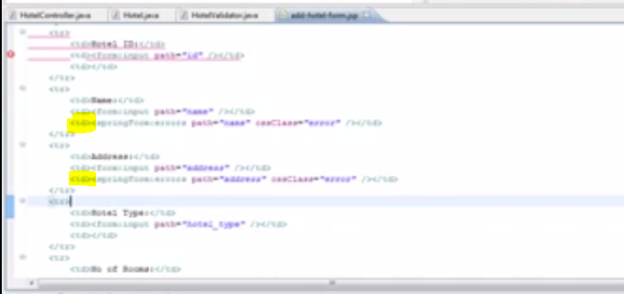
10. 03.BENEFITS OF SPRING MVC TAMIL
    1. 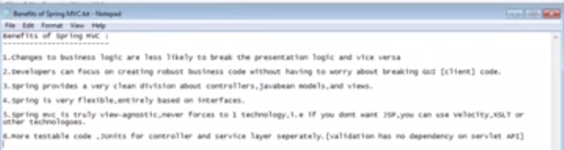
11. 04.WHAT IS MODEL VIEW CONTROLLER IN SPRING MVC TAMIL
    1. 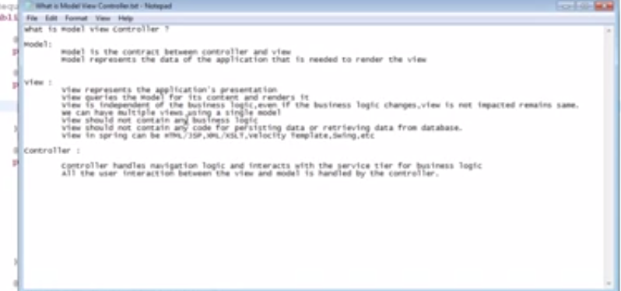
12. 05.WHAT IS DISPATCHER SERVLET IN SPRING MVC TAMIL
    1. This routes the request from the server to controller.
    2. when the servlet container starts the all the @requestMapping in the @controller will be added and will be used during request.
13. 06.WHAT IS HANDLER MAPPING SPRING MVC TAMIL
    1. 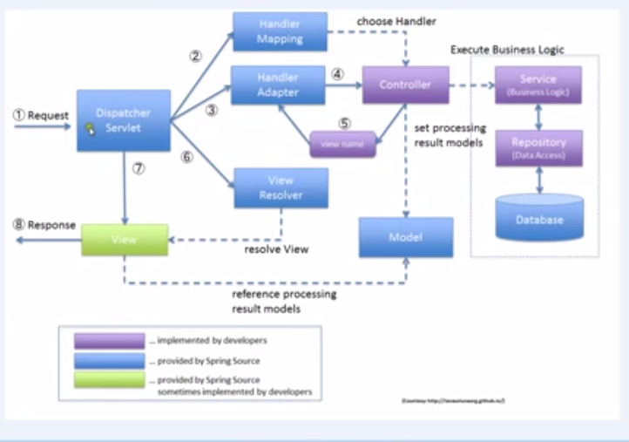
    2. 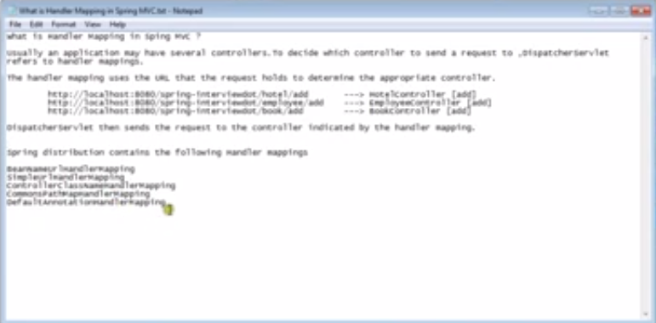
14. 07.WHAT IS VIEW RESOLVER IN SPRING MVC IN TAMIL
    1. 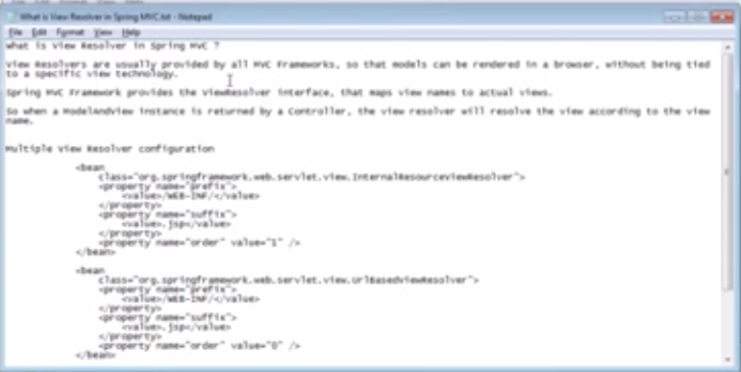
    2. 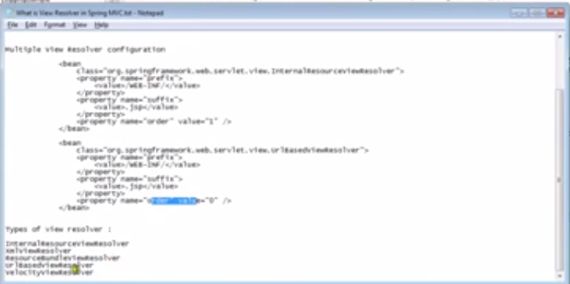
    3. 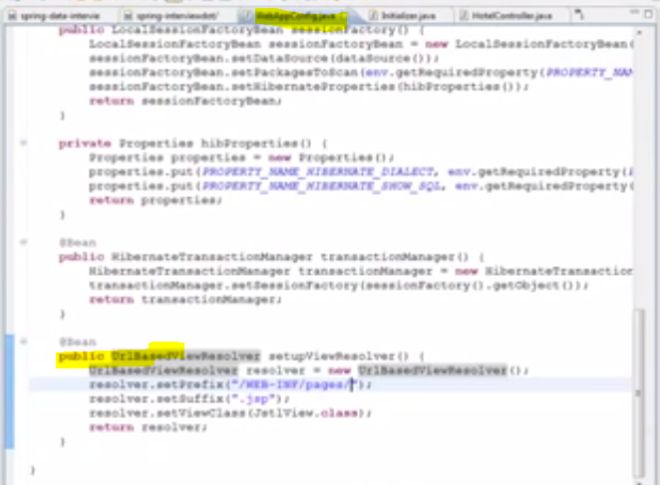
15. 08.WHAT IS SERVLET MAPPING IN SPRING MVC TAMIL
    1. 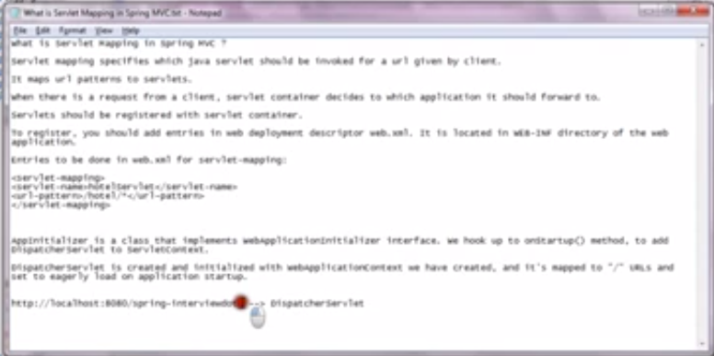
    2. 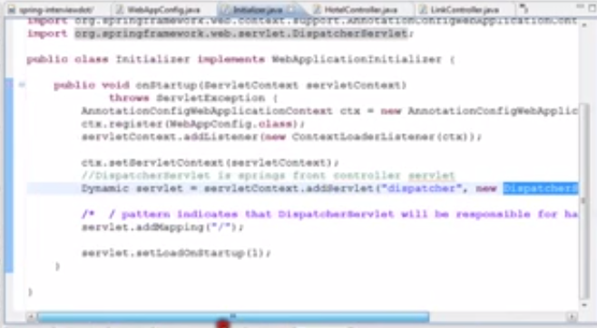
16. 09.WHAT IS URL PATTERN IN SPRING MVC TAMIL
    1. 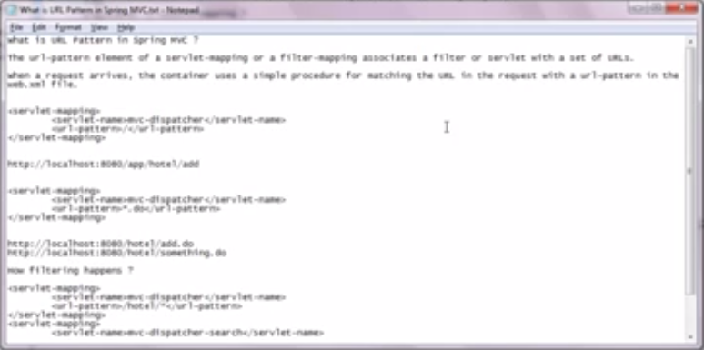
17. 10.WHAT IS MODELVIEW IN SPRING MVC IN TAMIL
    1. 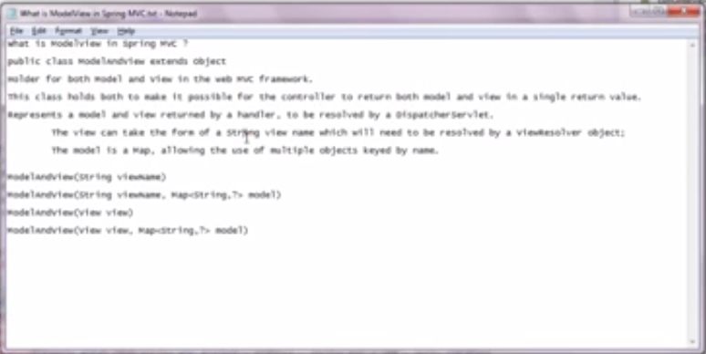
18. 11.WHAT IS @CONTROLLER ANNOTATION IN SPRING MVC TAMIL
    1. 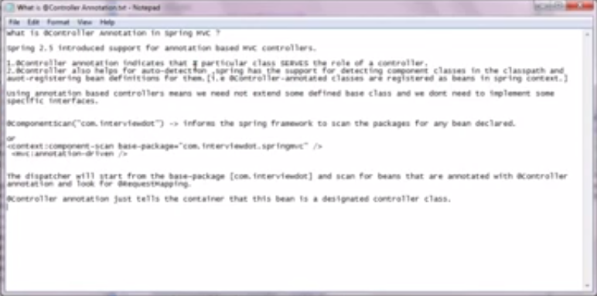
    2. 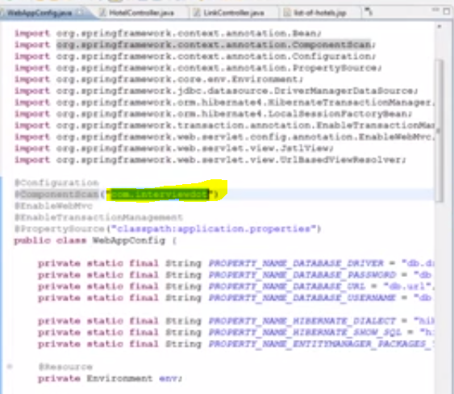
19. 12.WHAT IS @REQUESTMAPPING IN SPRING MVC TAMIL
    1. 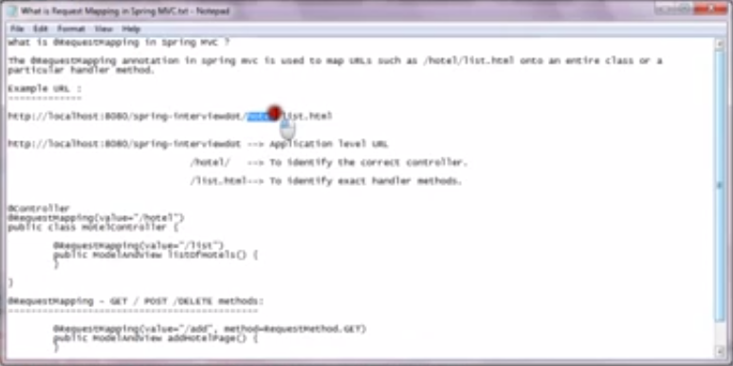
20. 13.@MODELATTRIBUTE IN SPRINGMVC TAMIL
    1. 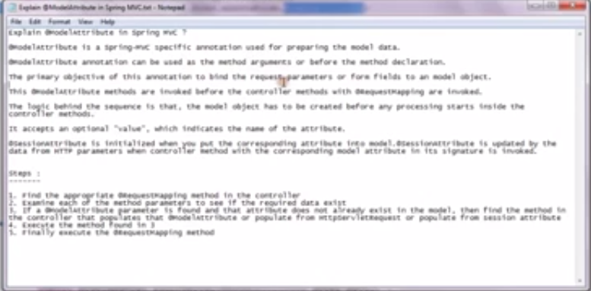
    2. ModelAttribute and sessionAttribute
21. 14.@SESSIONATTRIBUTE IN SPRING MVC TAMIL
    1. 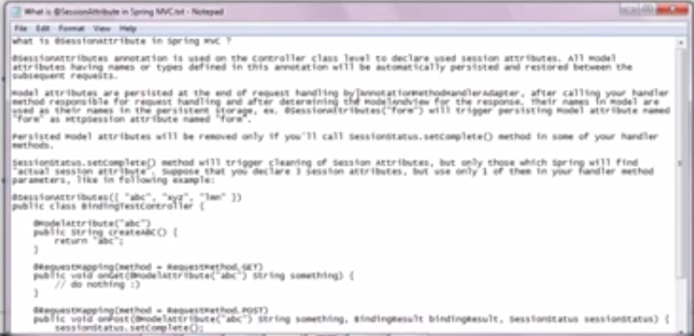
22. 15.@PATHVARIABLE IN SPRING MVC TAMIL
    1. 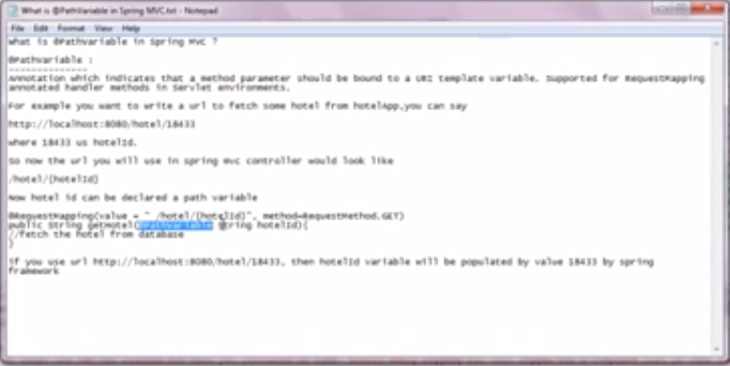
23. 16.SPRING MVC TAMIL TUTORIAL WHAT IS SPRING MVC
    1. 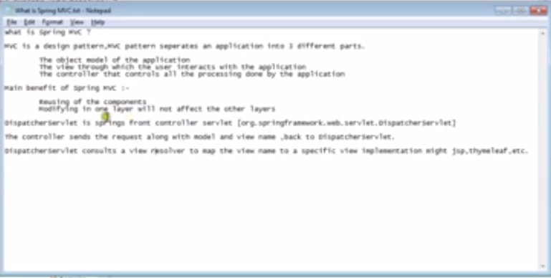
    2. 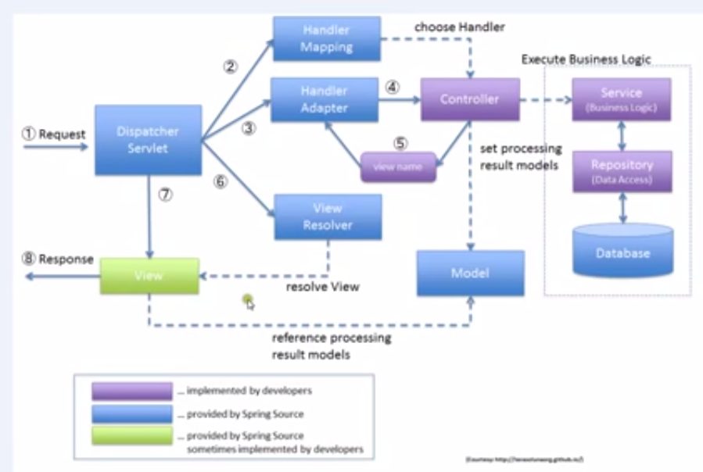

# Spring Real time project

1. Music Store 1 Introduction m4v
   1. Creating a MVC Web project
   2. 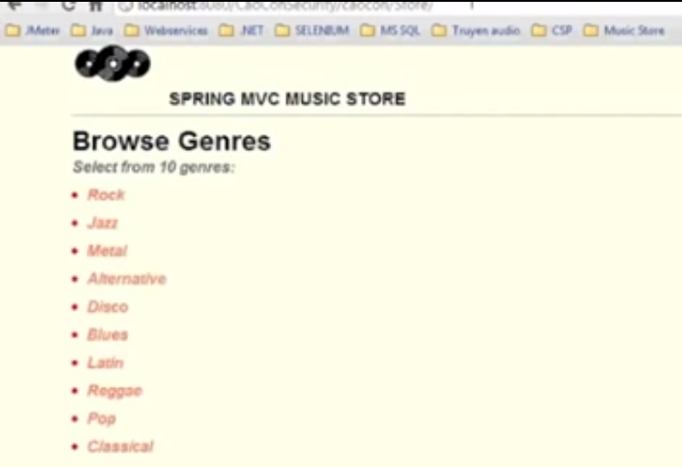
   3. 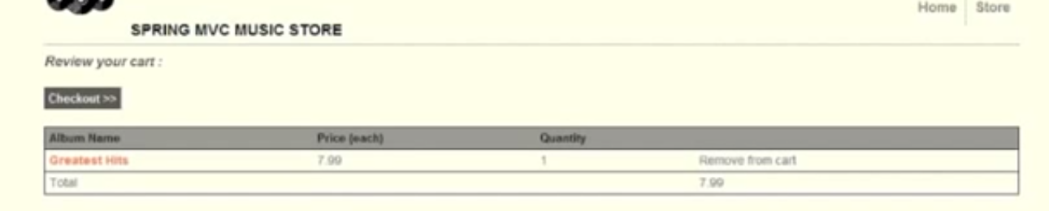
   4. 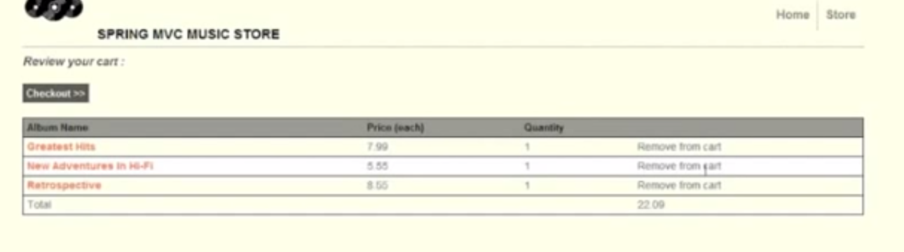
2. Music Store 2 Spring MVC m4v
   1. 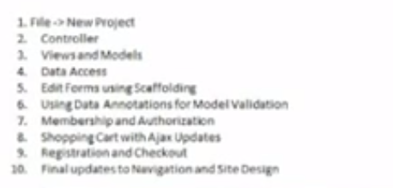
   2. 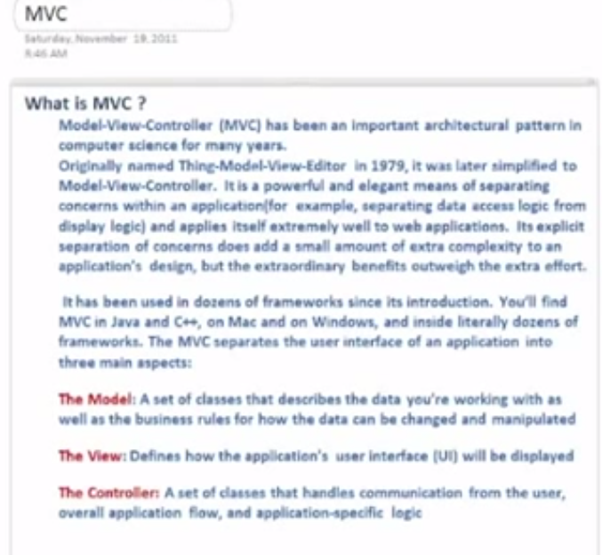
   3. 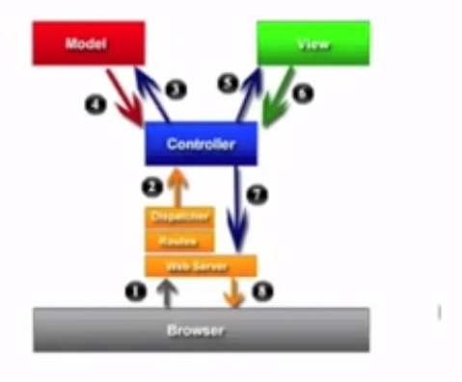
3. Music Store 3 JSP m4v
   1. 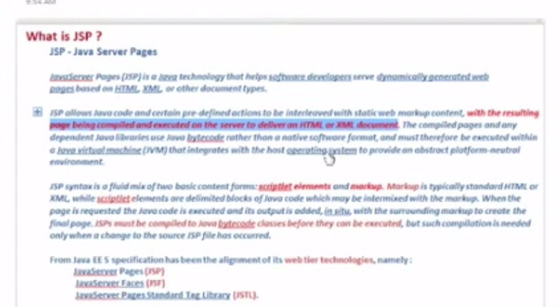
4. Music Store 4 Outline m4v
   1. 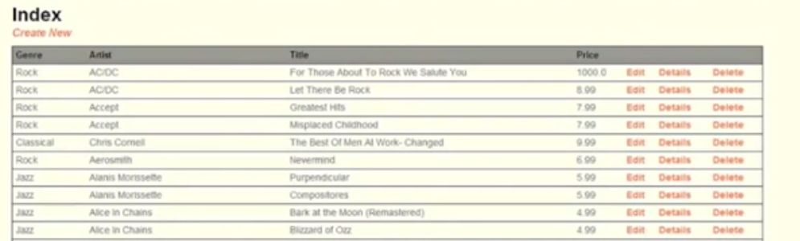
5. Music Store 5 Database And Create Project m4v
   1. 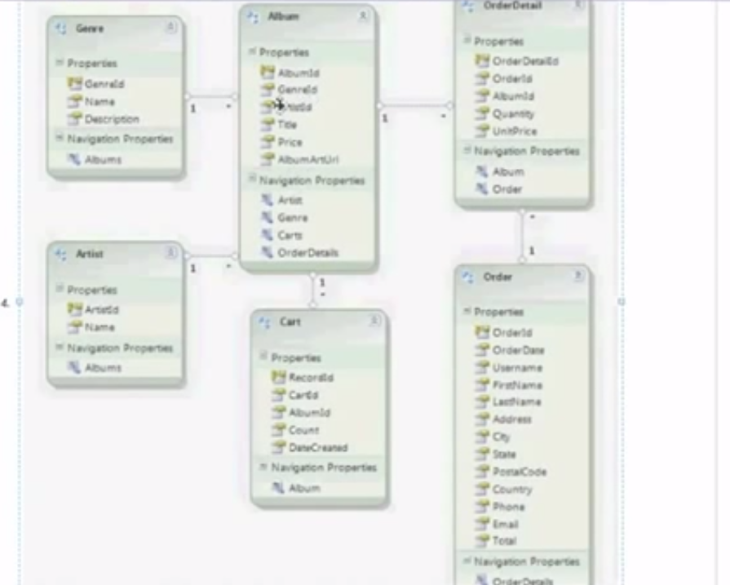
   2. To add maven to eclipse ad the following to Eclipse.
   3. 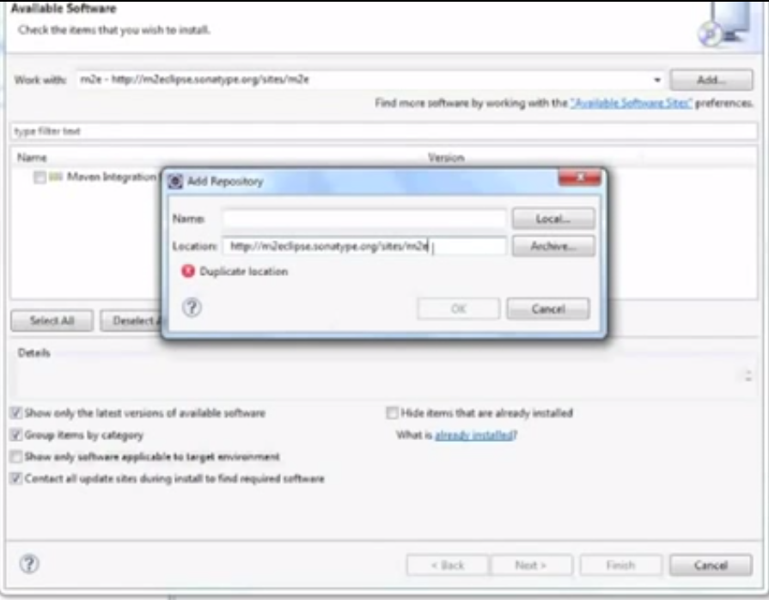
   4. 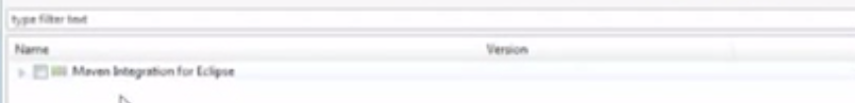
   5. 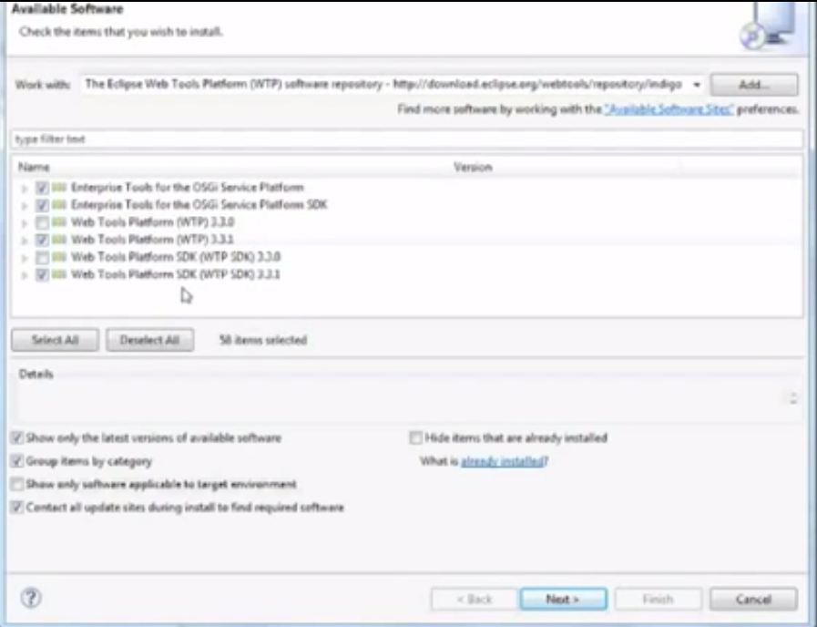
   6. Create a new maven project
   7. 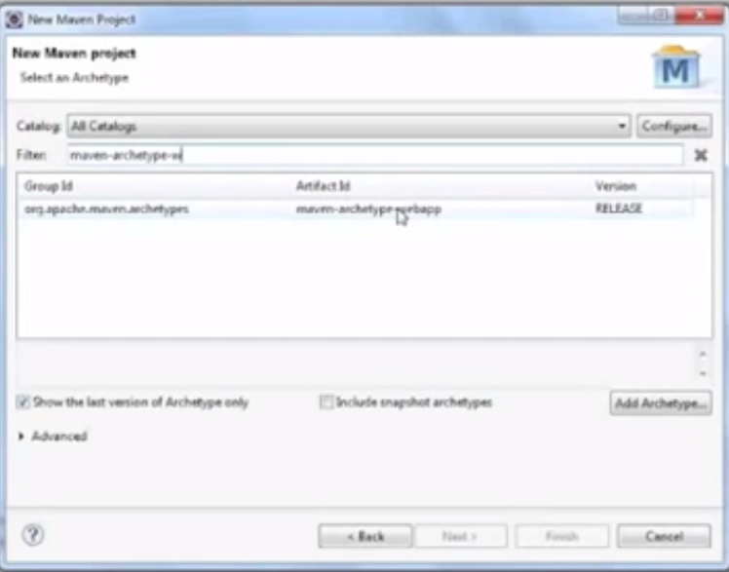
   8. 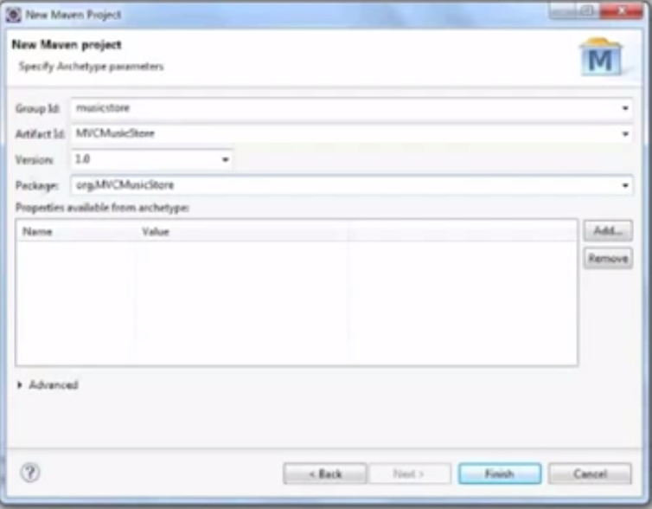
   9. 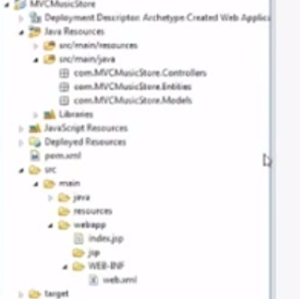
6. Music Store 6 POM m4v
7. Music Store 7 Web Servlet Persistence m4v
   1. 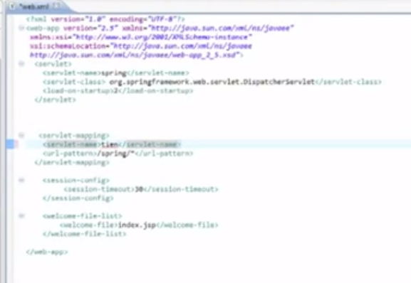
   2. 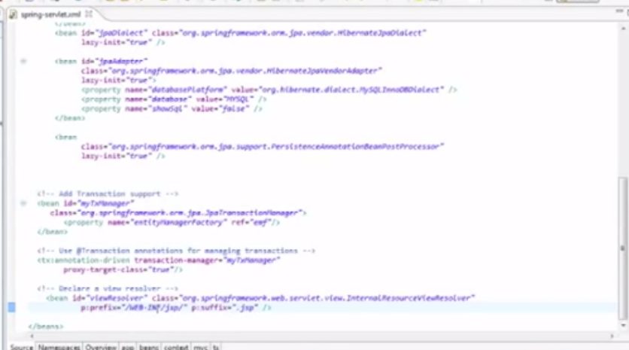
   3. 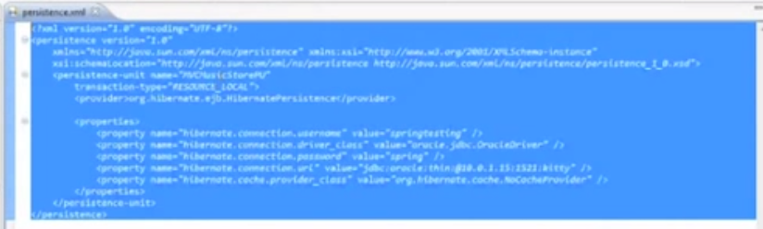
8. Music Store 8 Controllers m4v
   1. 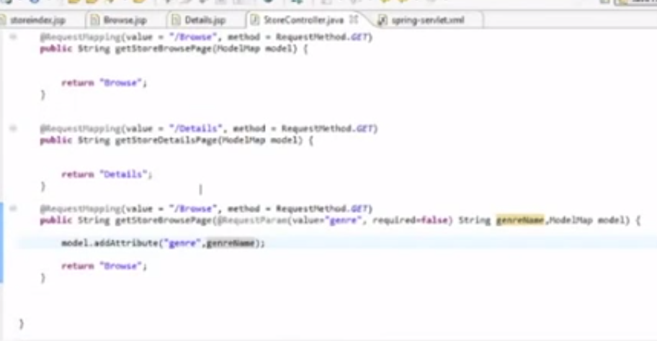
9. Music Store 9 CSS m4v
   1. 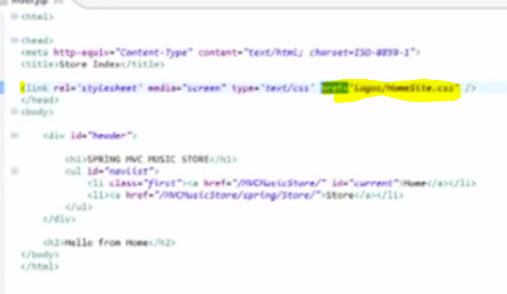
10. Music Store 10 Models And Views m4v
    1. 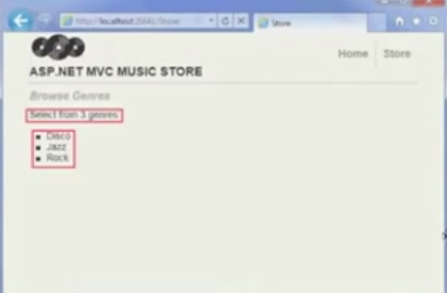
11. Music Store 11 Data Access Deal with Entities m4v
    1. 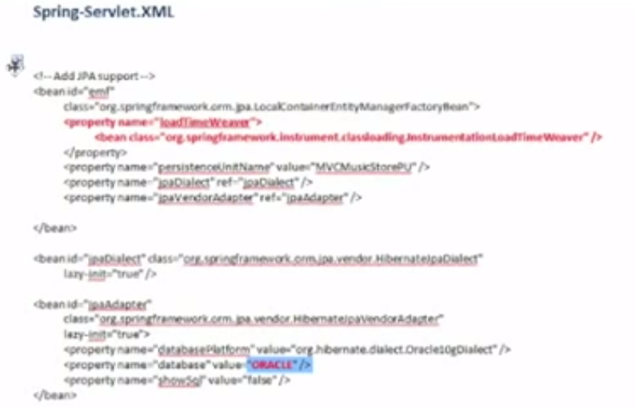
    2. 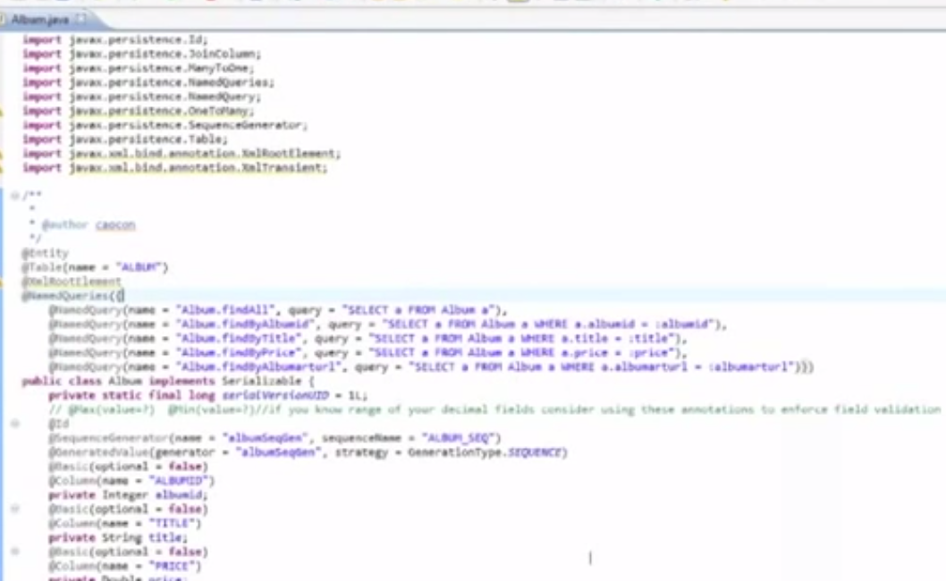
    3. 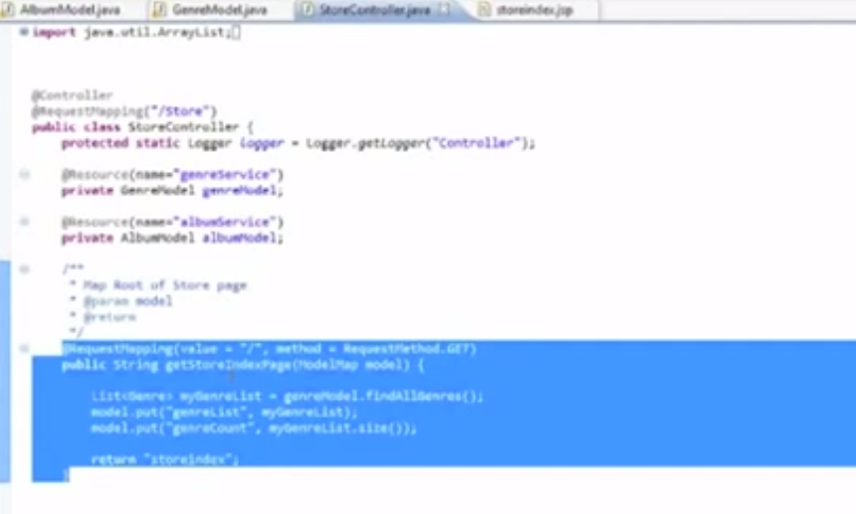
    4. 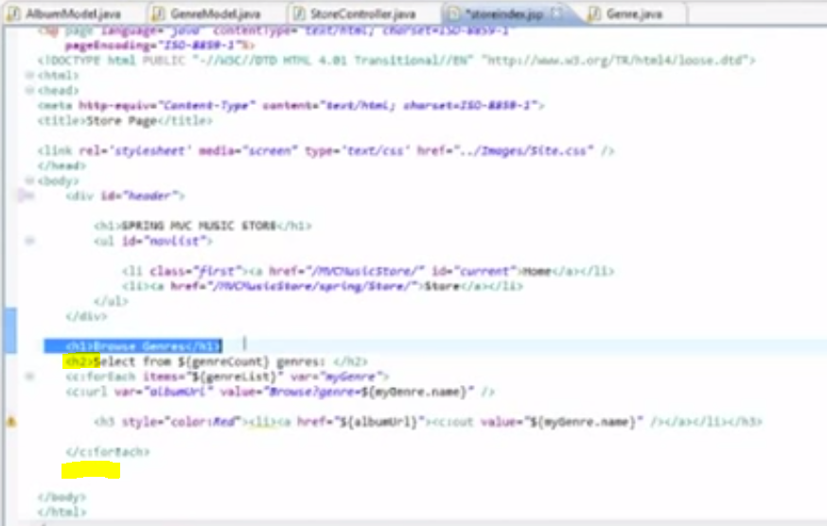
12. Music Store 12 Data Access Store Index Browse Details m4v
    1. 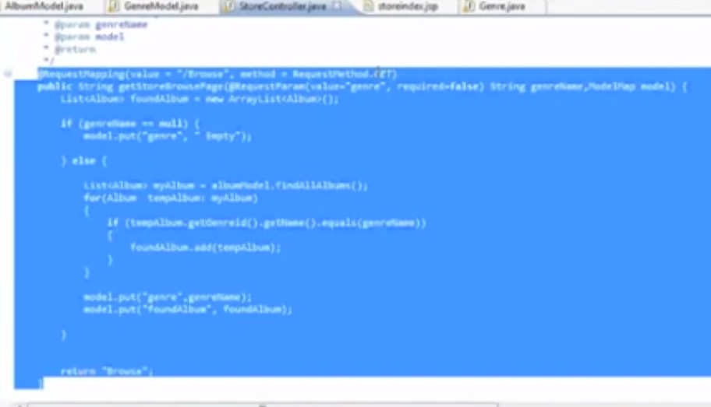
    2. 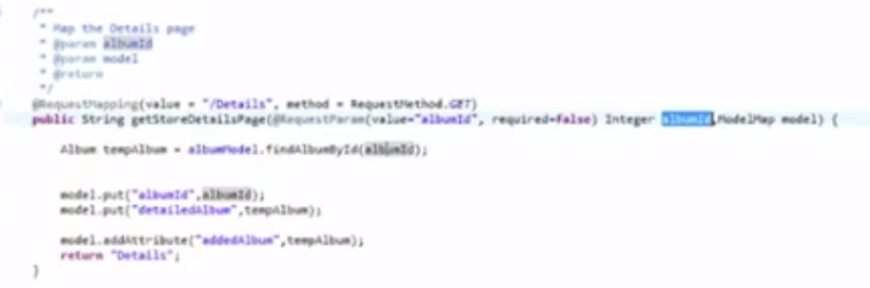
13. Music Store 13 Data Access StoreManager Page m4v
14. Music Store 14 Data Access StoreManager Details m4v
15. Music Store 15 Data Access StoreManager Edit m4v
16. Music Store 16 Data Access StoreManager Create m4v
17. Music Store 17 Data Access StoreManager Delete m4v
18. Music Store 18 Add albums into Shopping cart m4v
19. Music Store 19 Registration and Check out Login page m4v
20. Music Store 20 Registration and Check out Create new User and Shipping m4v
21. Music Store 21 Registration and Check out Persist data m4v
22. Music Store 22 Final updates to Navigation and Site Design m4v

# RealProject 2

1. #1.1 Building Web Applications with Spring Framework [spring MVC]
   1. Setup
   2. Spring Tool Suite
   3. 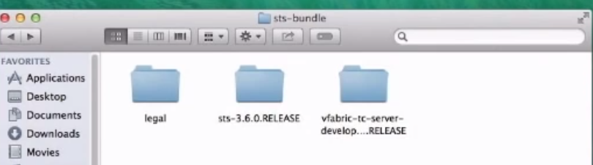
   4. 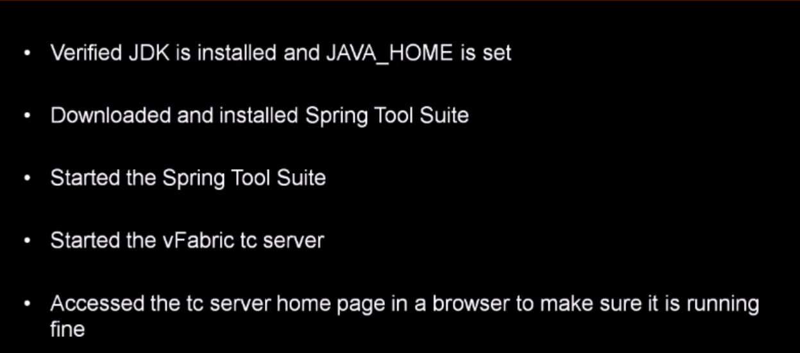
2. #1.2 Writing Our First Spring MVC Application [spring MVC]
   1. 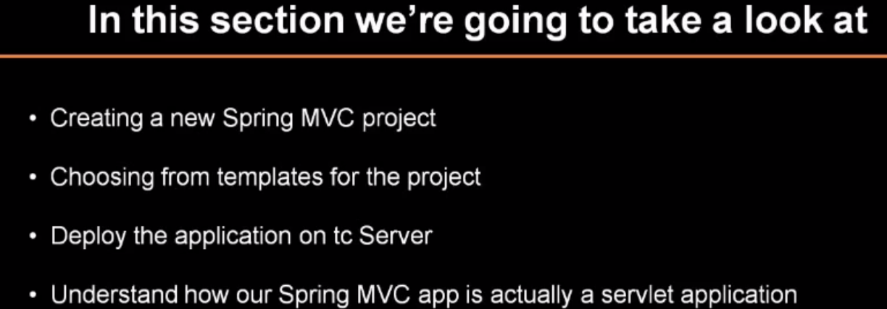
   2. Create a new projects
   3. Run and test the application
3. #1.3 Using the Startup Code [spring MVC]
   1. Sample Application for online chocolates store.
4. #2.1 Understanding the Model [spring MVC]
   1. 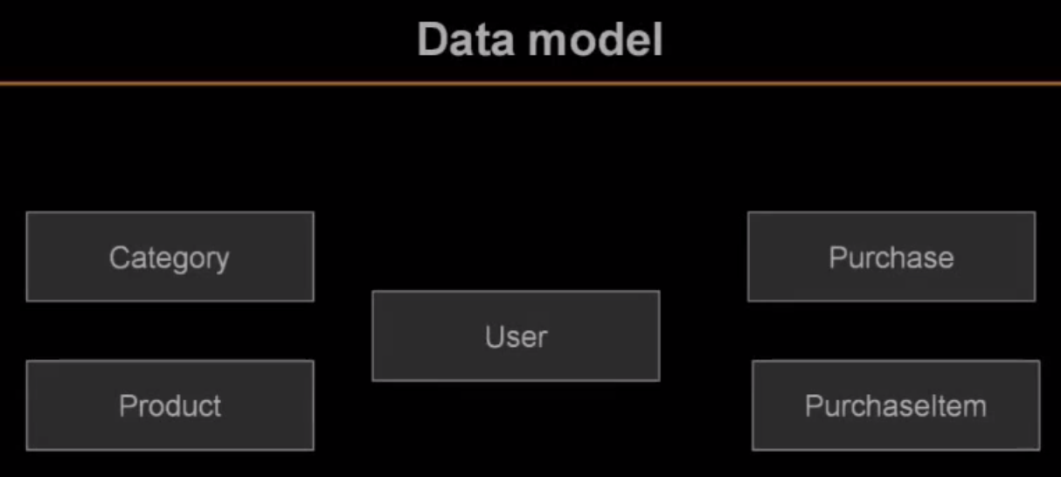
   2. 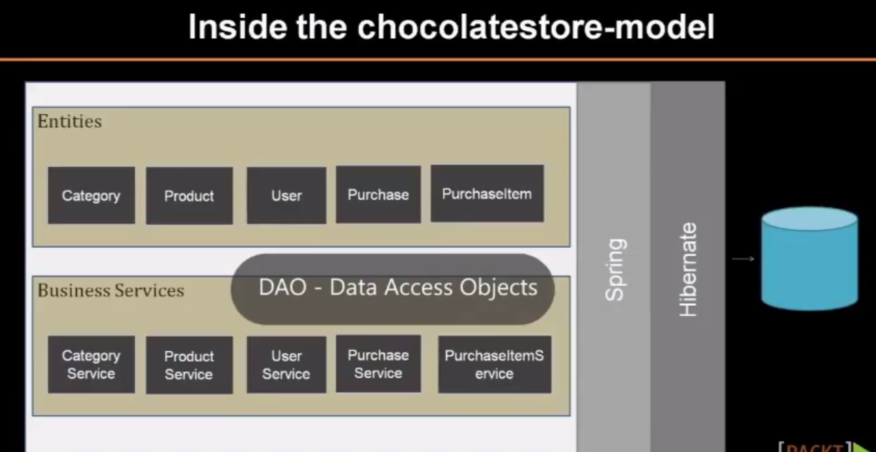
5. #2.2 Calling the Model [spring MVC]
   1. 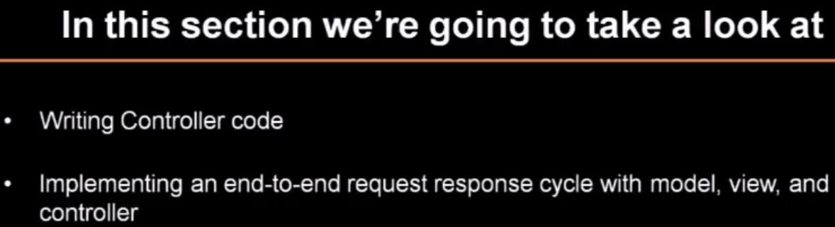
   2. 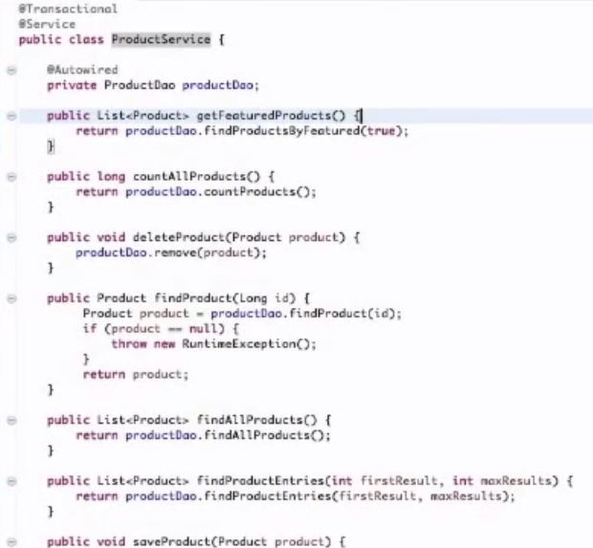
   3. 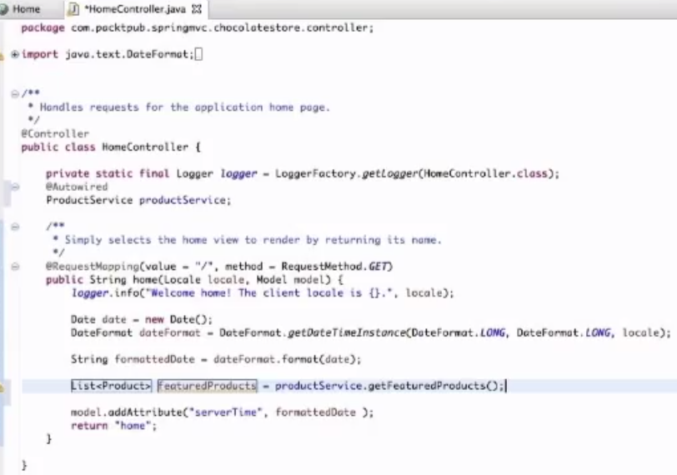
   4. 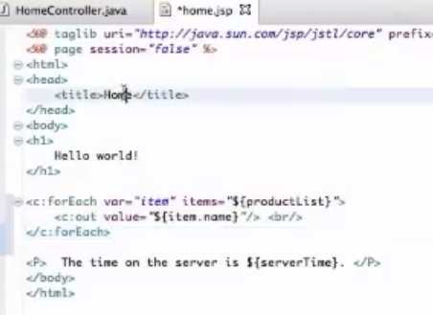
   5. 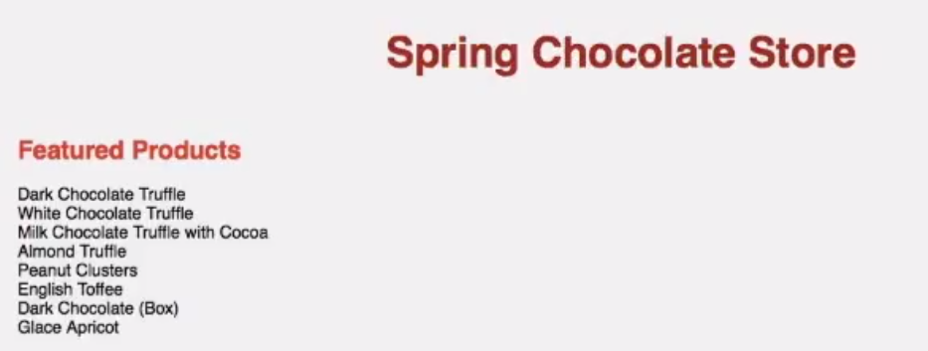
6. #2.3 Writing a Controller [spring MVC]
   1. 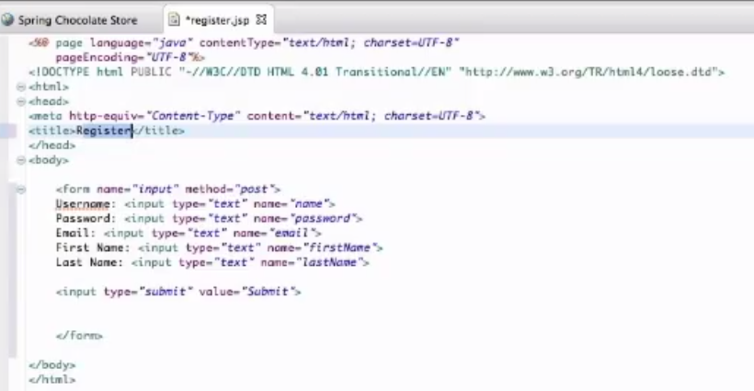
   2. 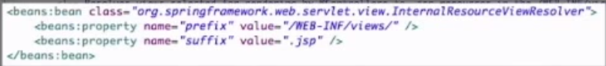
   3. 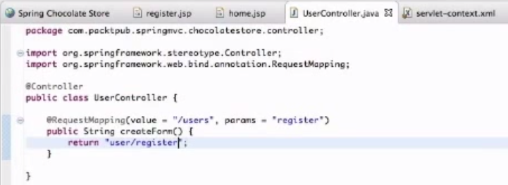
   4. 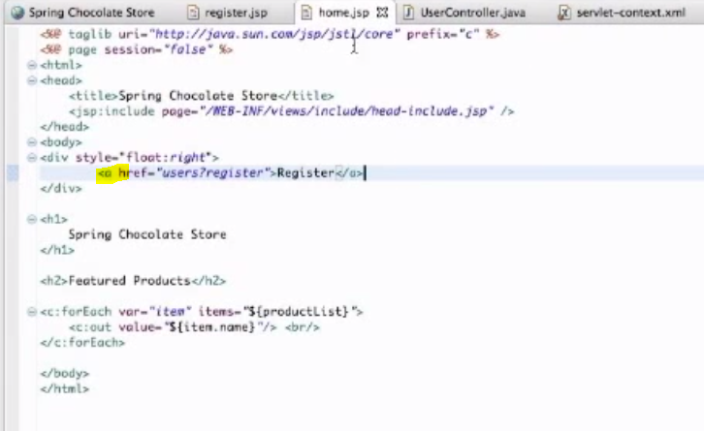
7. #3.1 Getting the User Input [spring MVC]
   1. 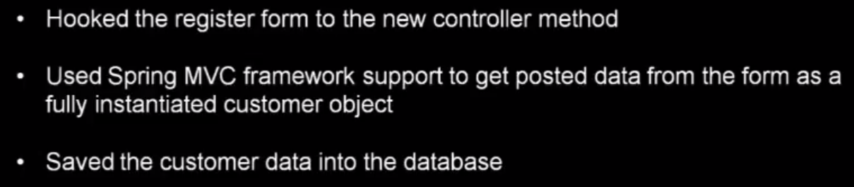
8. #3.2 Using Path Variables and Redirects [spring MVC]
   1. 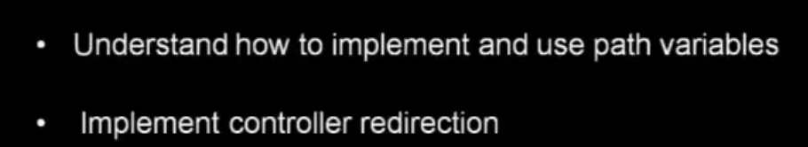
   2. 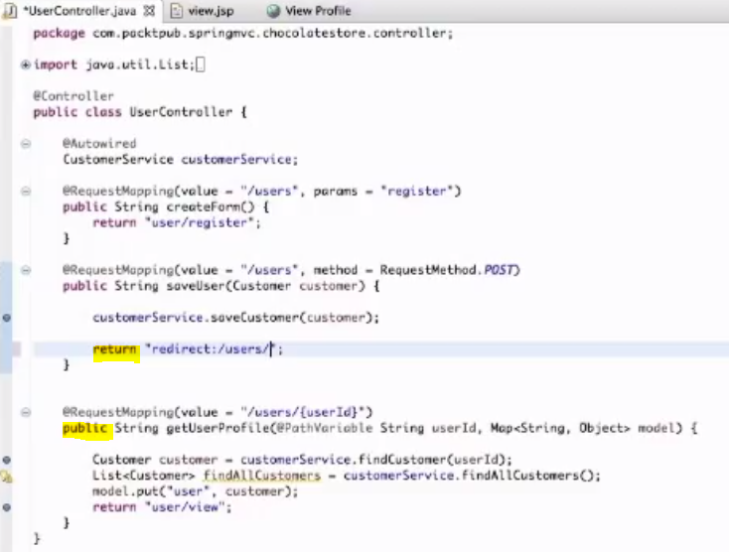
   3. 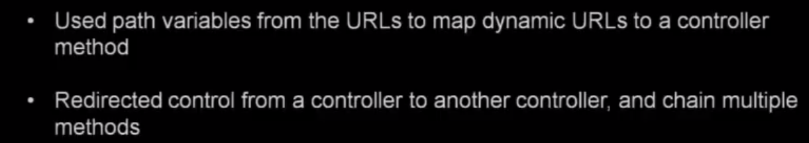
9. #3.3 Implementing Validation [spring MVC]
   1. 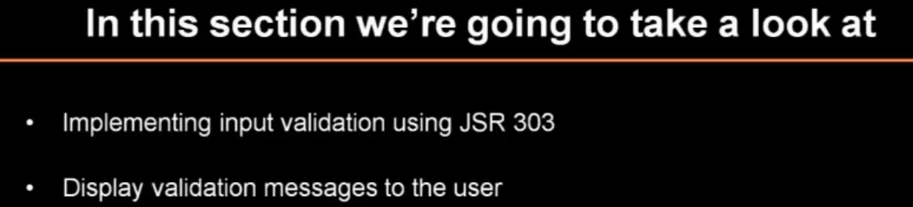
   2. 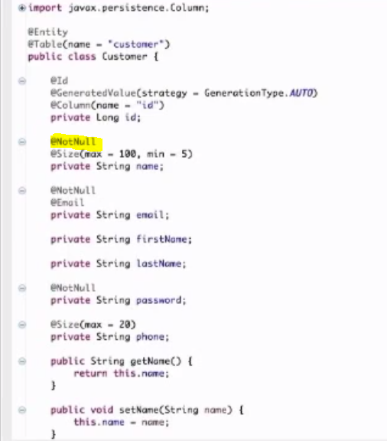
   3. 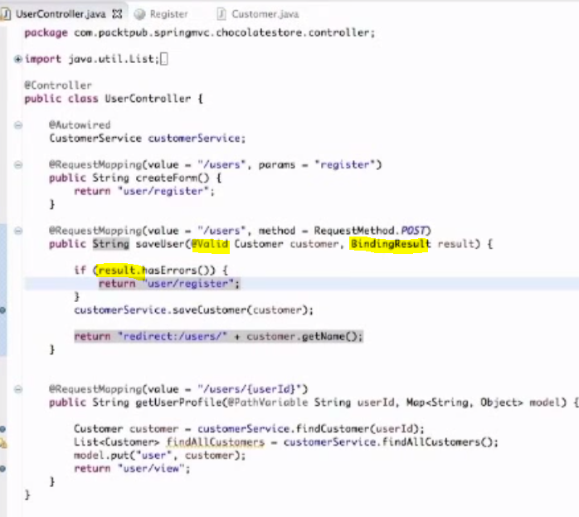
   4. 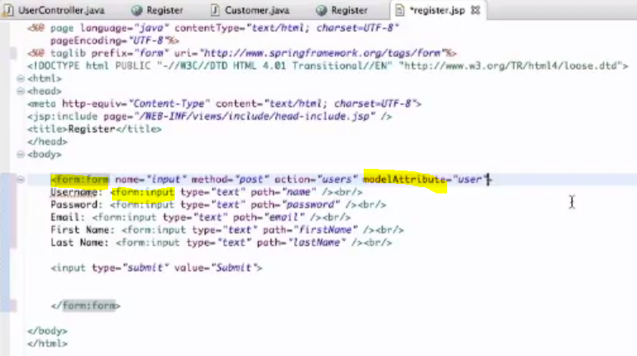
   5. 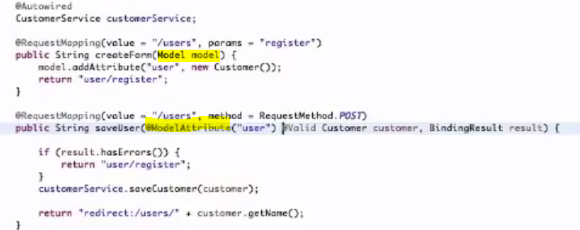
   6. 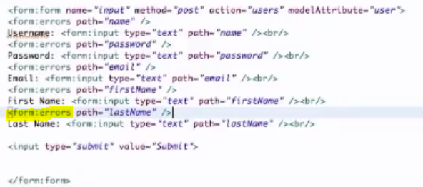
   7. 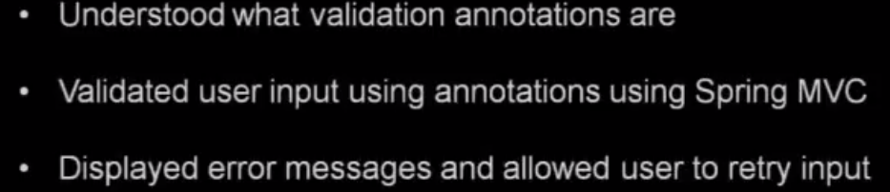
10. #3.4 Adding the Update Functionality [spring MVC]
    1. 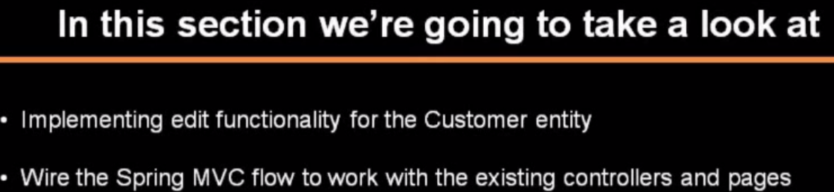
    2. 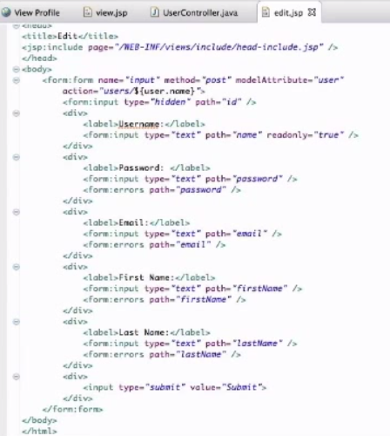
    3. 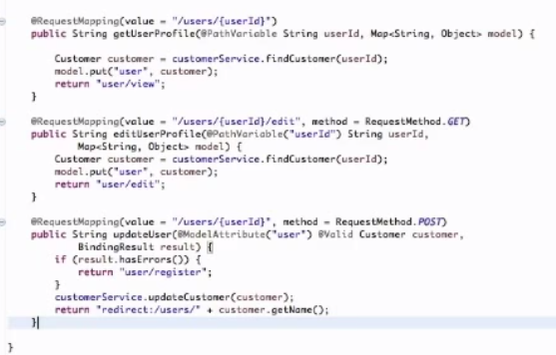
11. #4.1 Working with Multiple Entities [spring MVC]
    1. 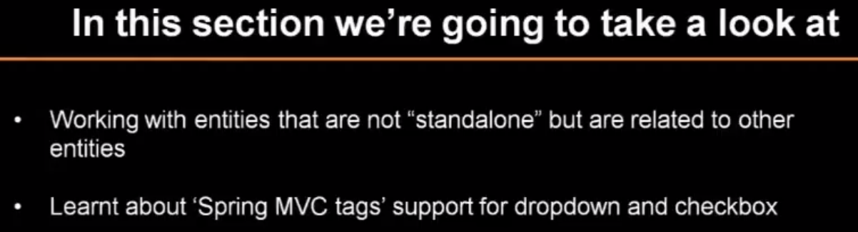
    2. 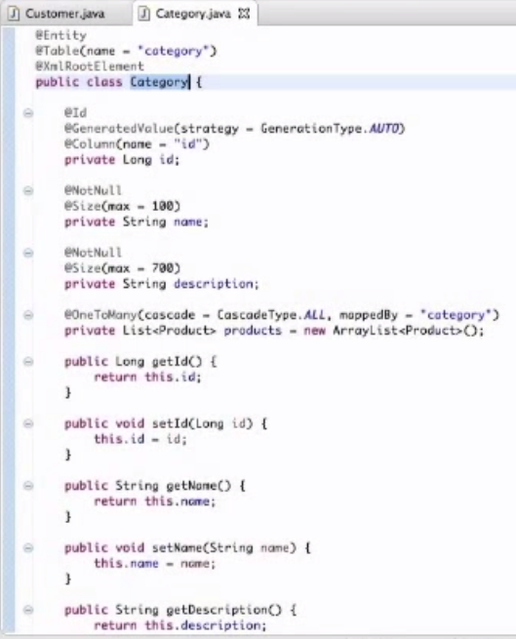
    3. 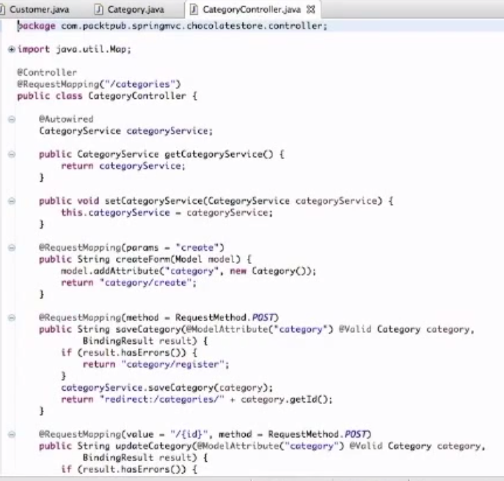
    4. 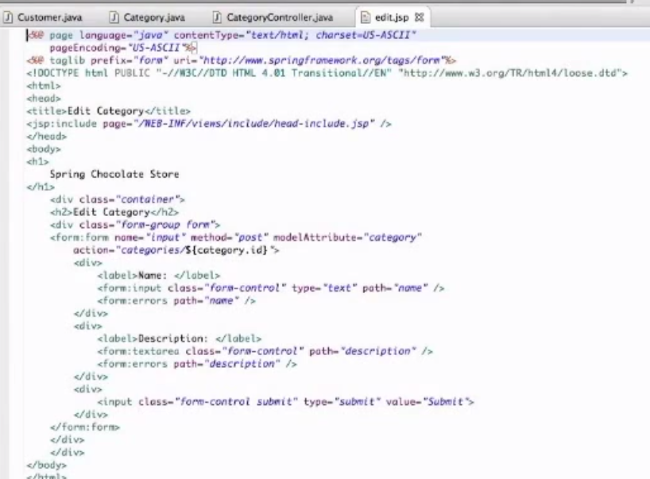
    5. Do the same for Product
    6. 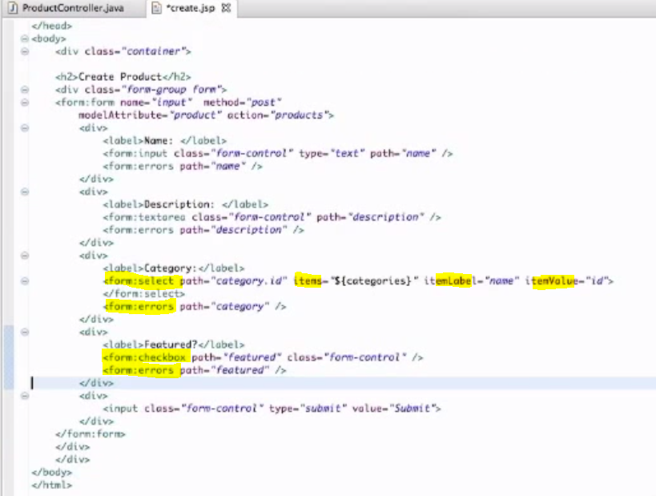
    7. 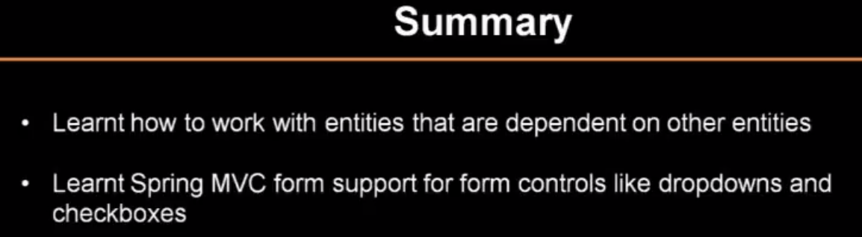
12. #4.2 Implementing Themes [spring MVC]
    1. 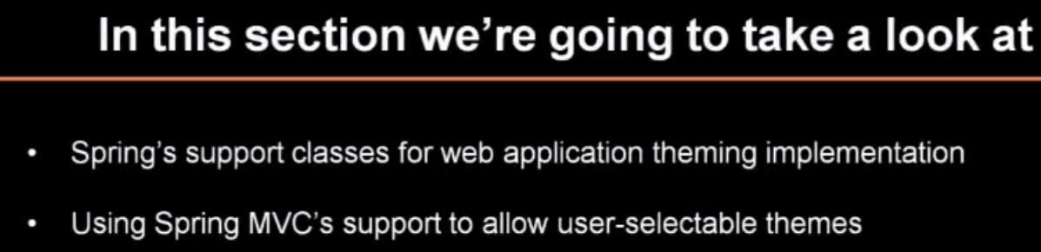
    2. 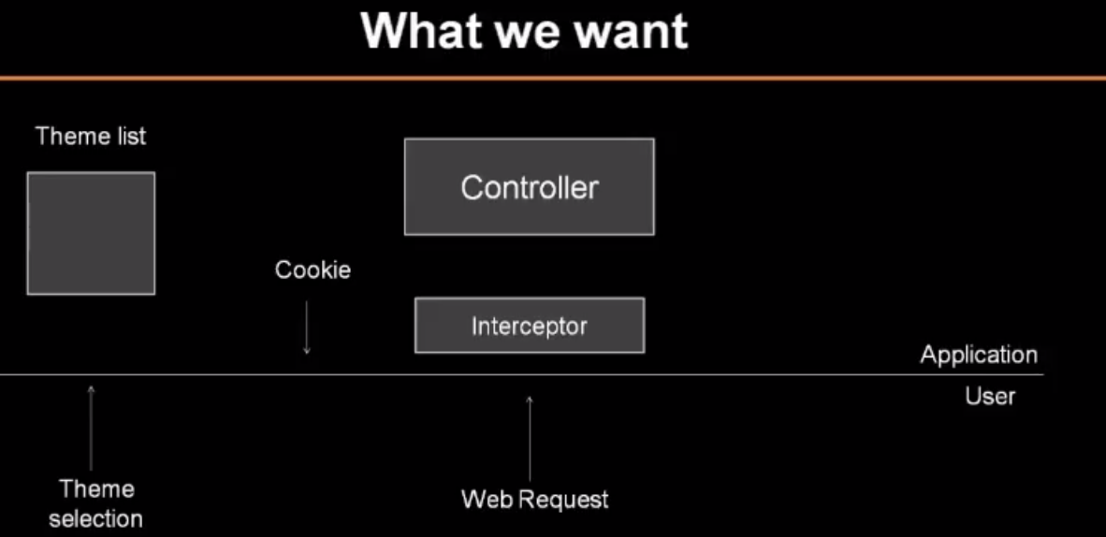
    3. 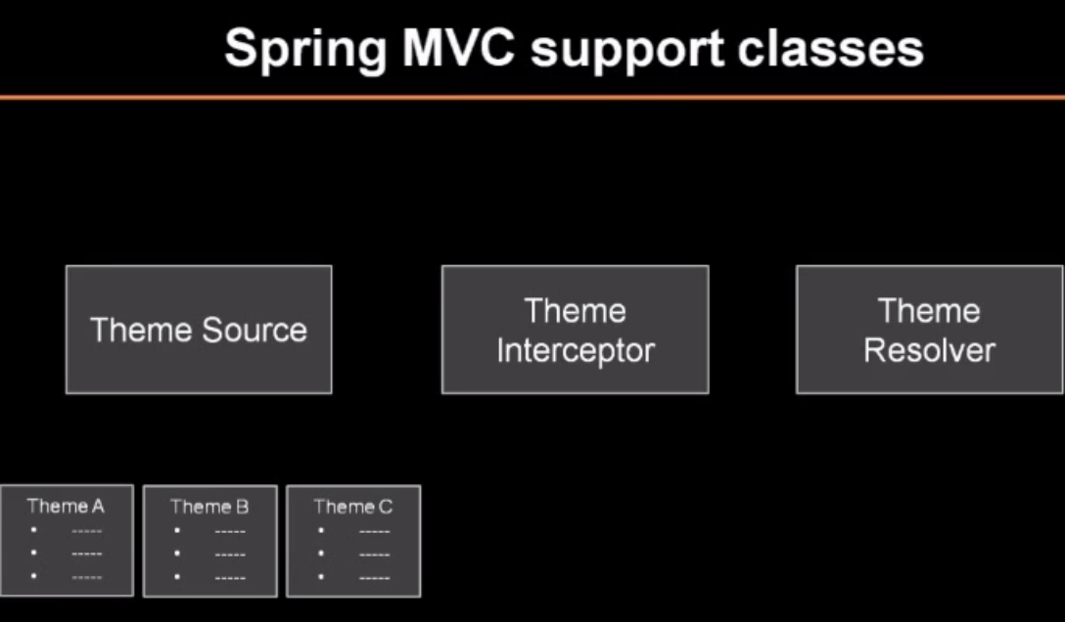
    4. 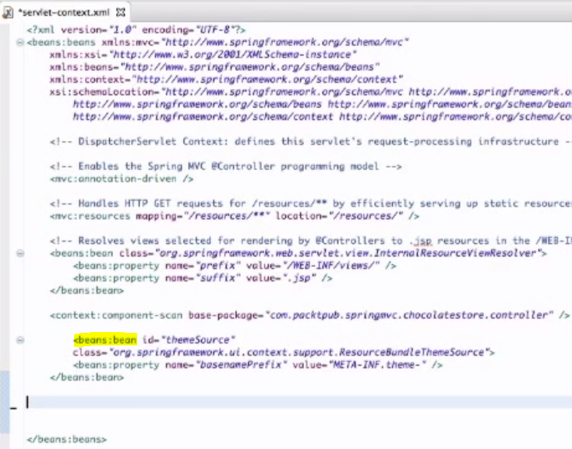
    5. 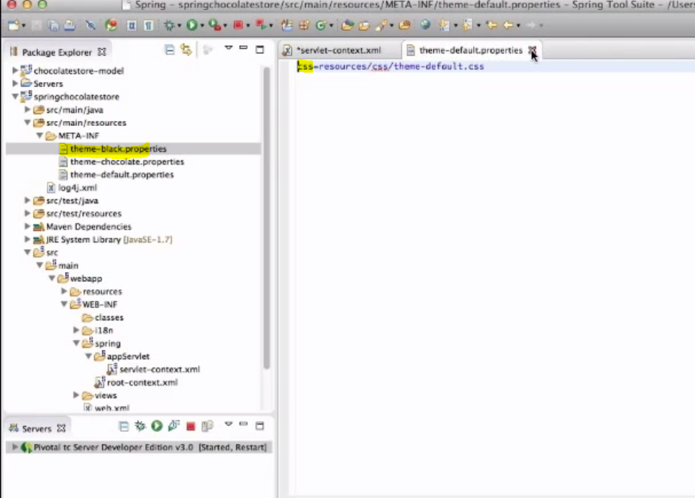
    6. 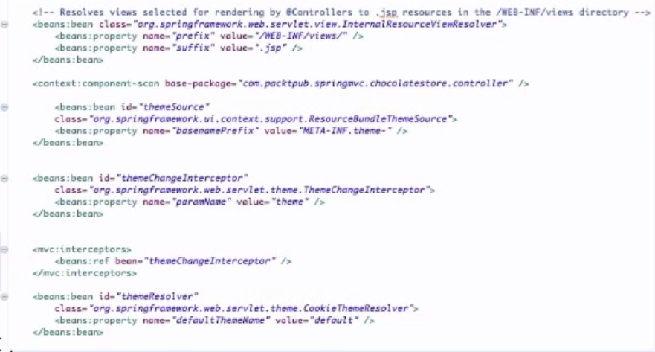
    7. 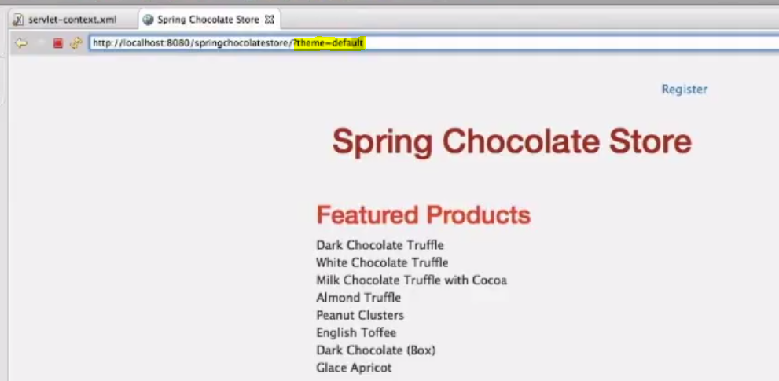
    8. 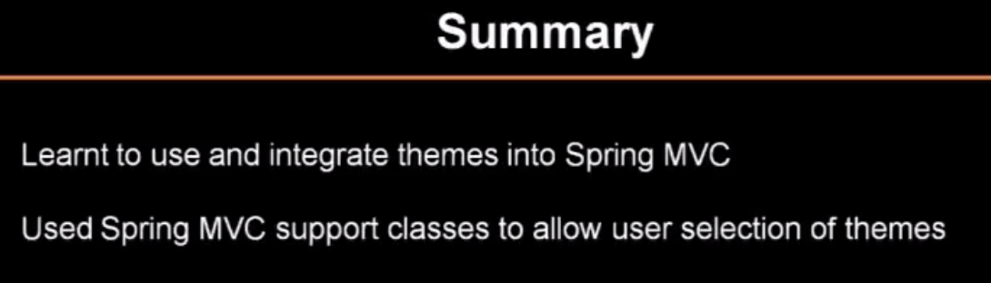
13. #4.3 Implementing Internationalization [spring MVC]
    1. Internalization - Same application in different languages
    2. Localization - Detect the language to render
    3. Static and Dynamic text
    4. 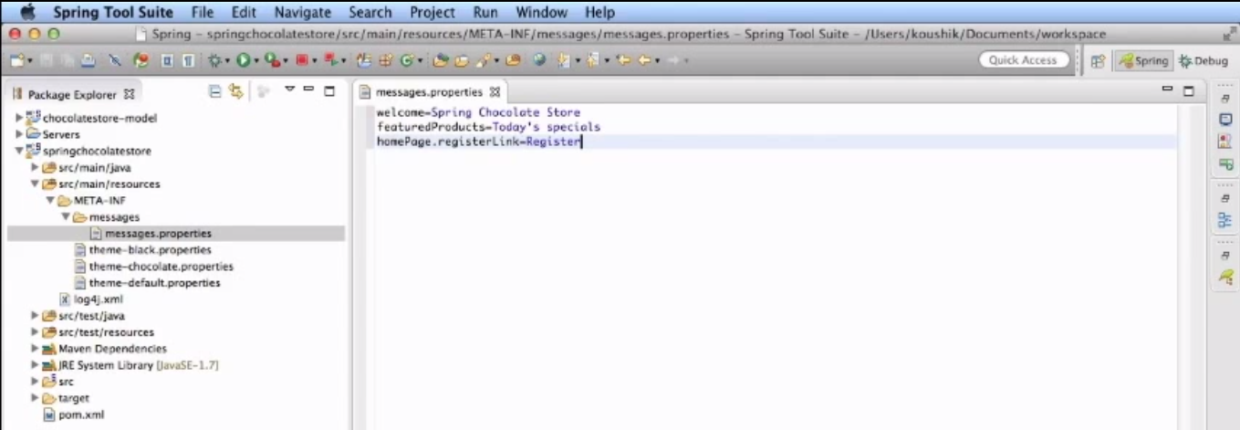
    5. 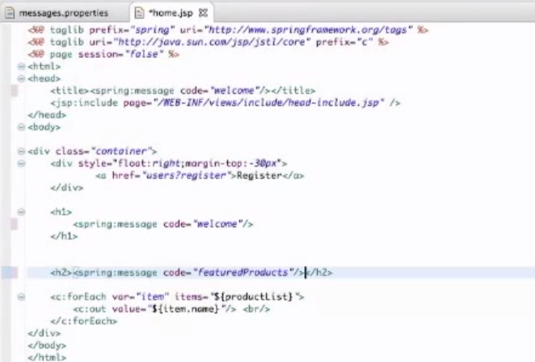
    6. 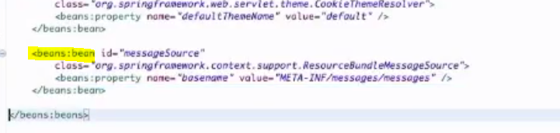
    7. 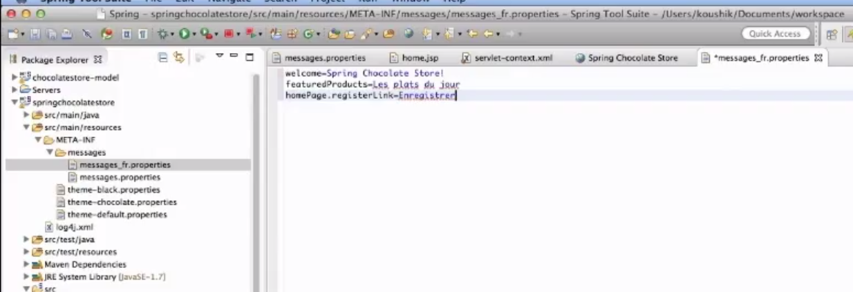
    8. 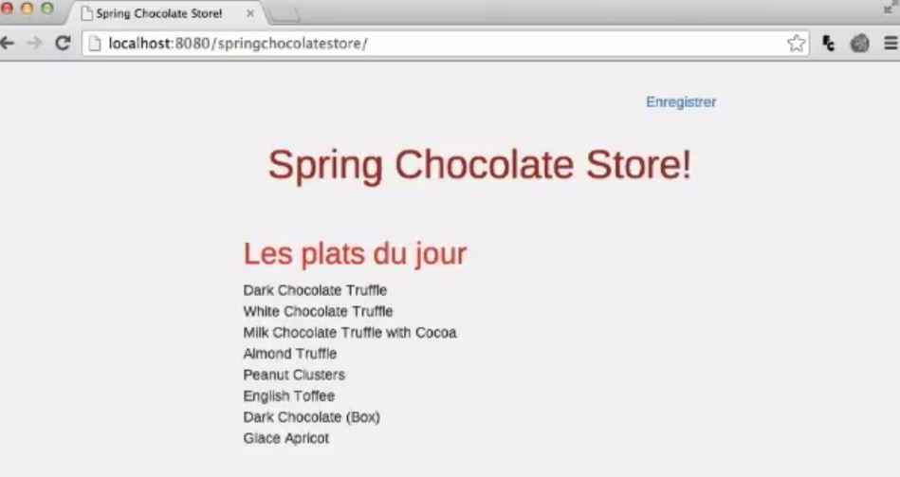
    9. 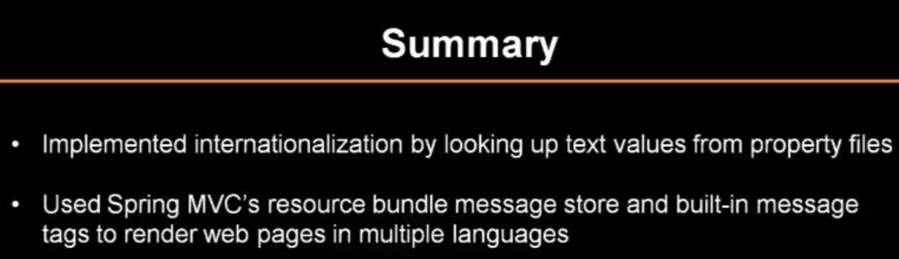
14. #5.2 Understanding Data Binding [spring MVC]
    1. 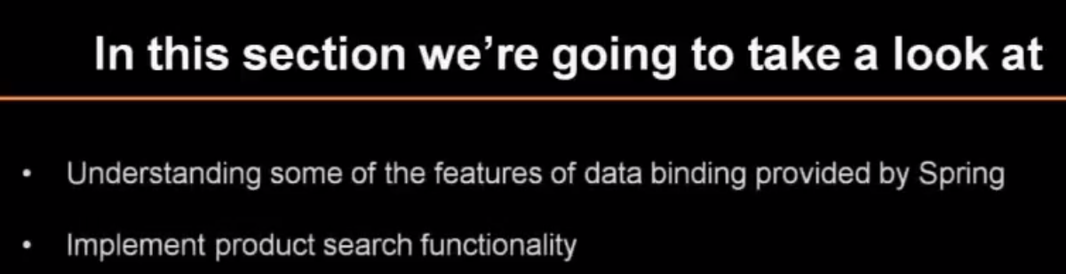
    2. Create a searchController
    3. 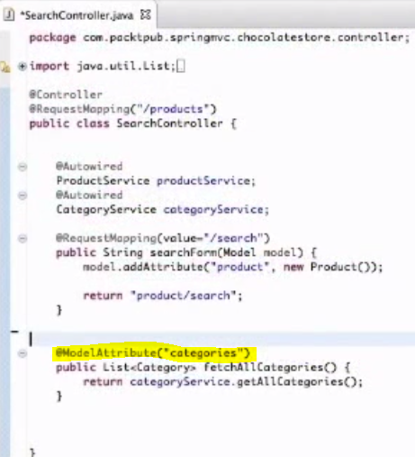
    4. 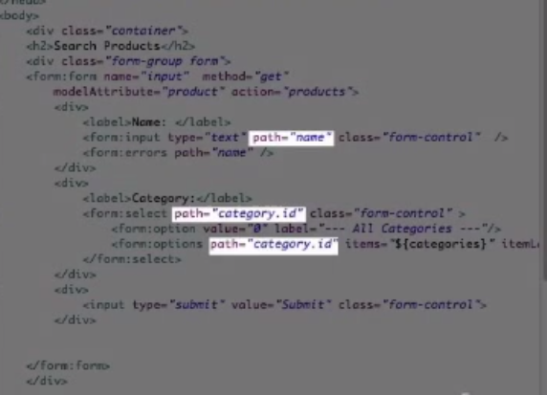
    5. 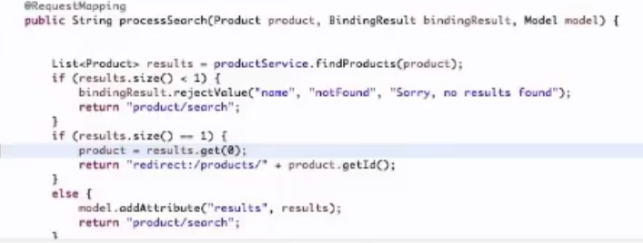
    6. 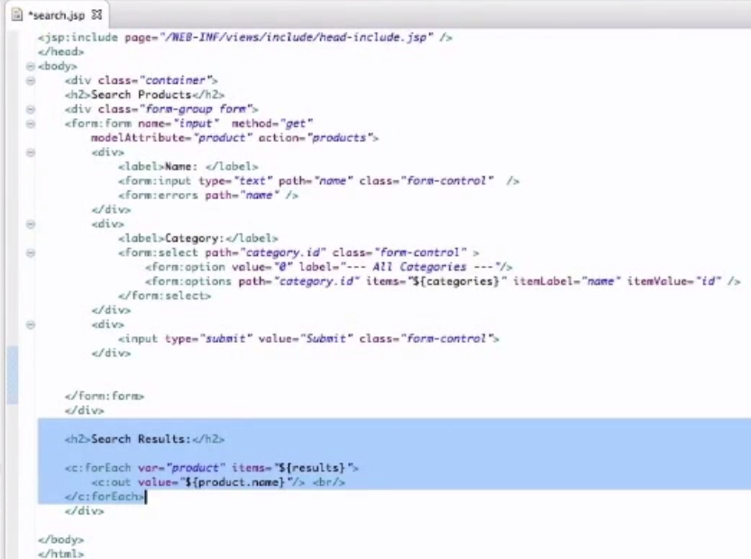
15. #5.3 Writing Custom Validators [spring MVC]
    1. 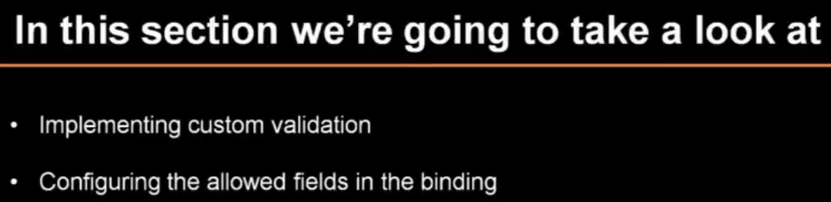
    2. 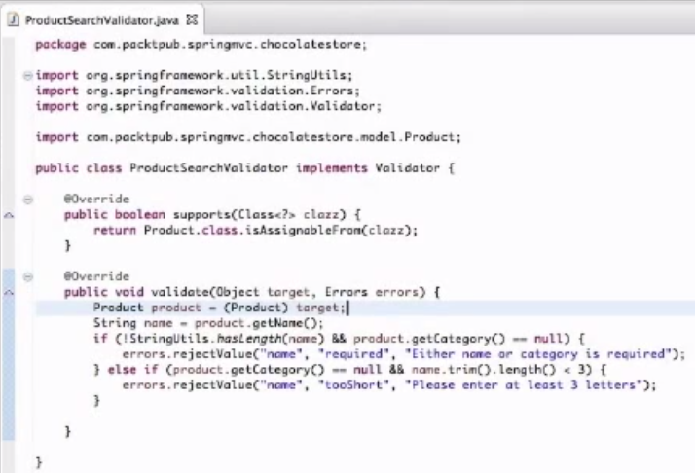
    3. To bind the validator we need to create method initBinder as shown below
    4. 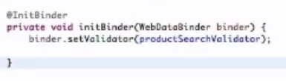
16. #5.4 Handling Exceptions [spring MVC]
    1. 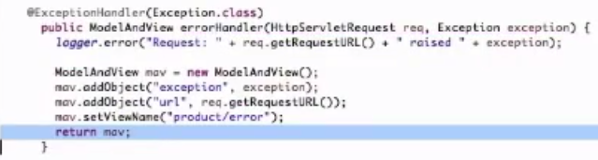
17. #6.1 Implementing the Login Functionality [spring MVC]
    1. 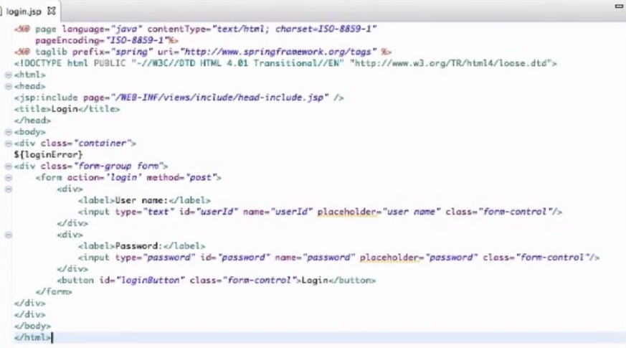
    2. 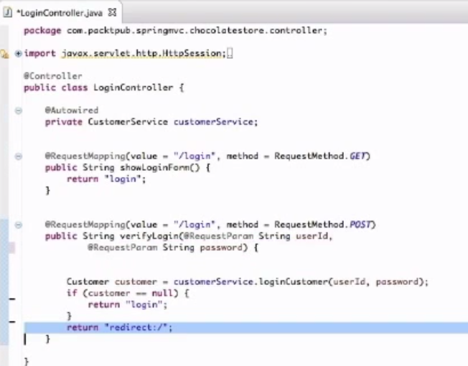
    3. 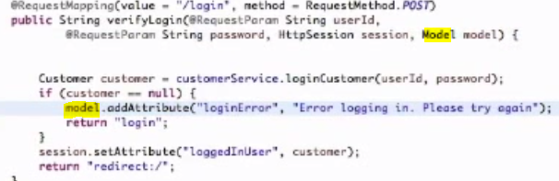
    4. 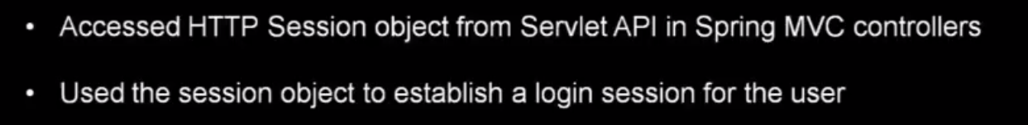
18. #6.2 Implementing the Shopping Cart Functionality [spring MVC]
    1. 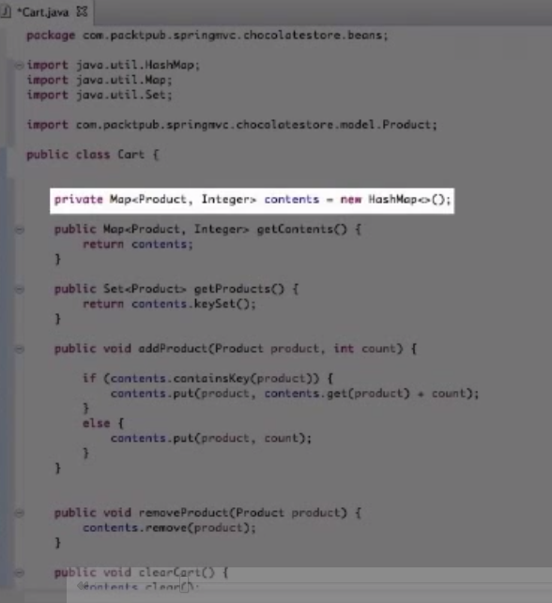
    2. This class add the all the products to the cart that the user selects
    3. 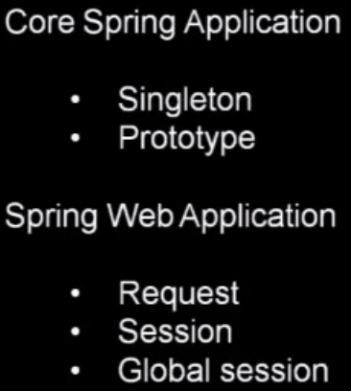
    4. 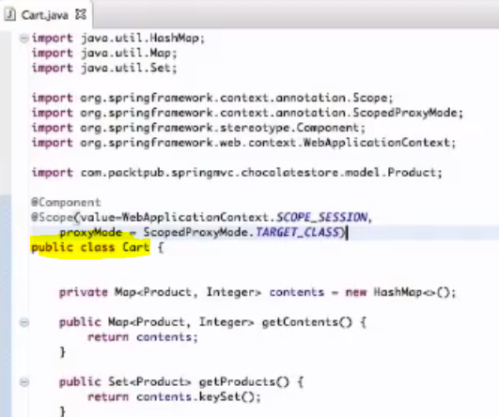
    5. 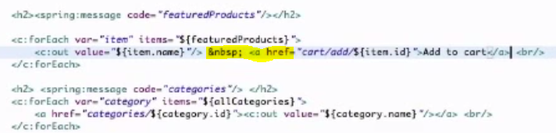
    6. 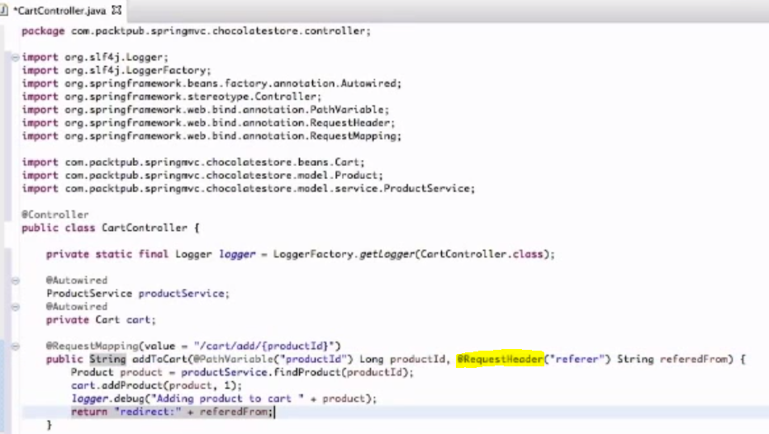
    7. @requestHeader is used to get the header information. The Key "referer" parameter will get the current page from where the request is refered.
    8. 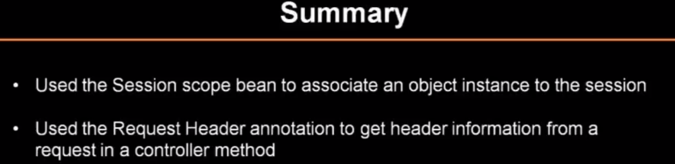
19. #6.3 Implementing the Ordering Functionality [spring MVC]
    1. 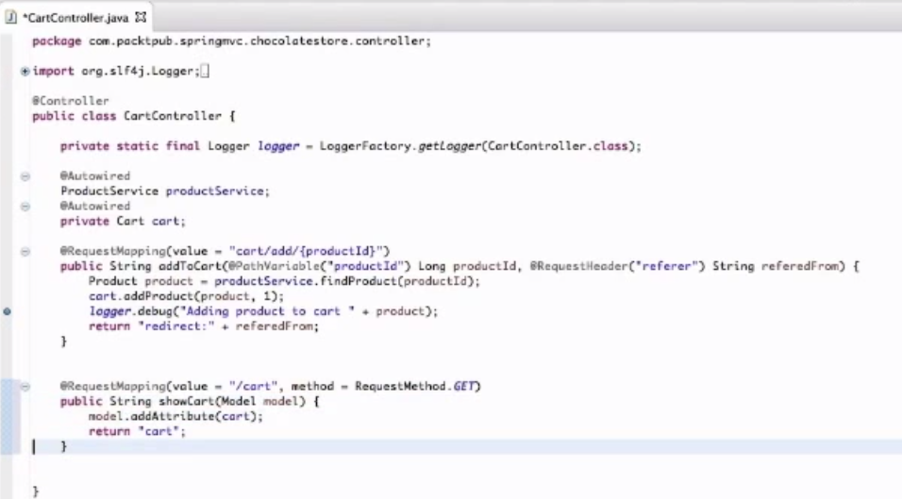
    2. 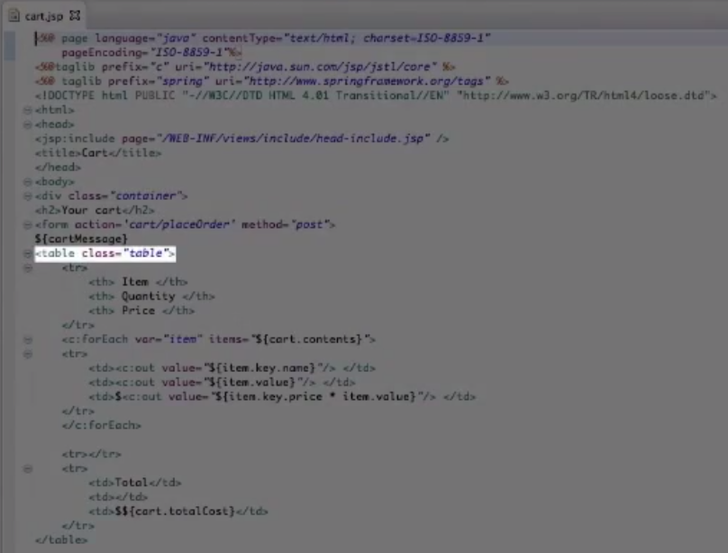
    3. 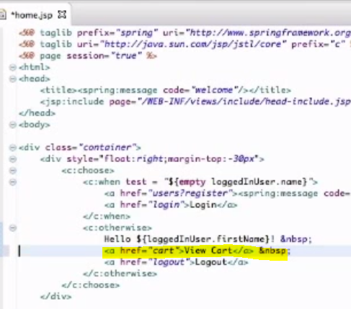
    4. 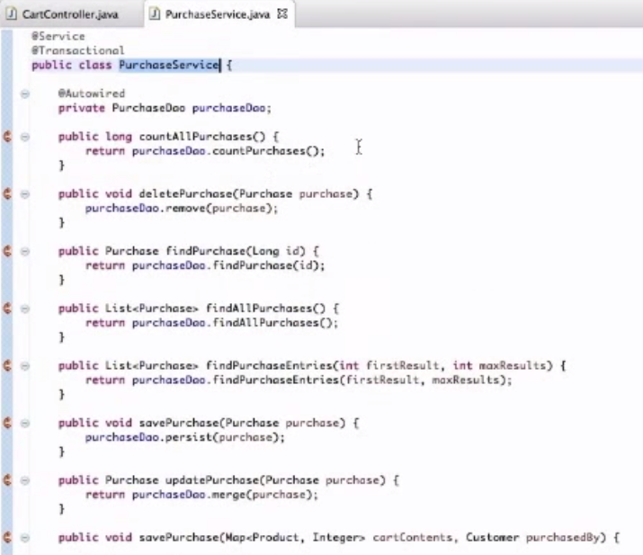
    5. 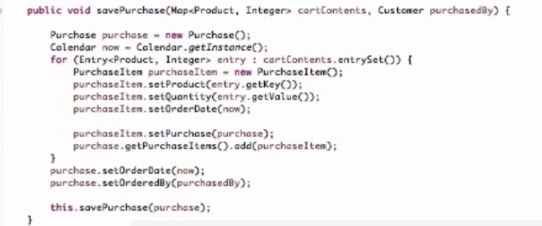
    6. 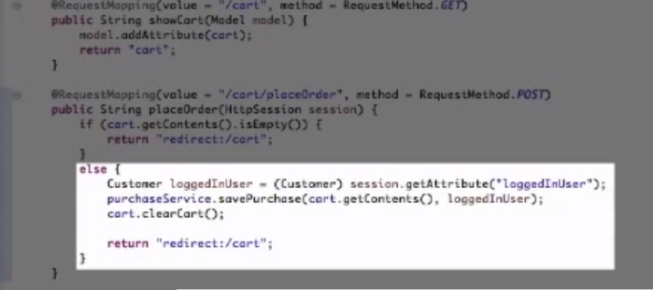
    7. 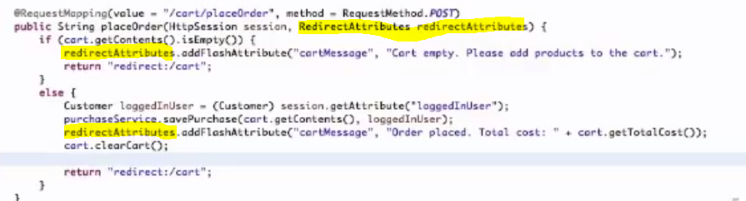
    8. 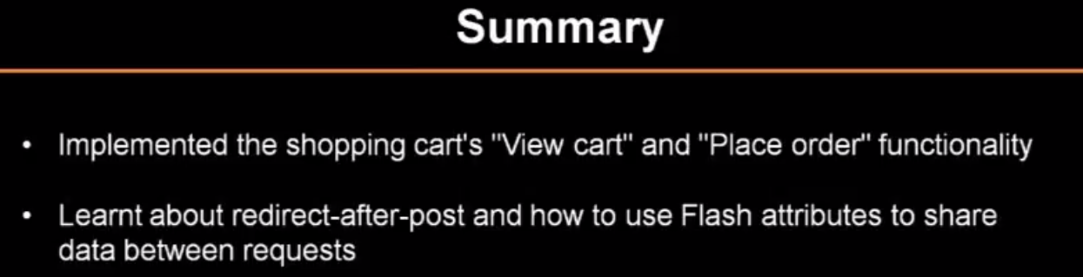
20. #6.4 Writing Custom Interceptors [spring MVC]
    1. 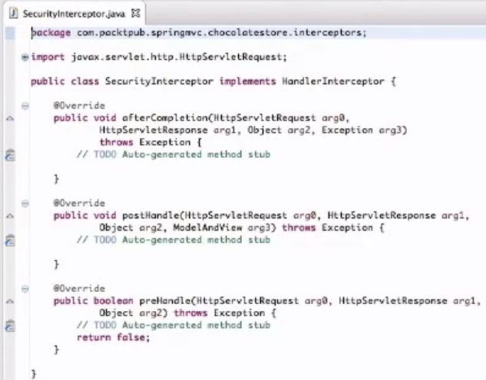
    2. 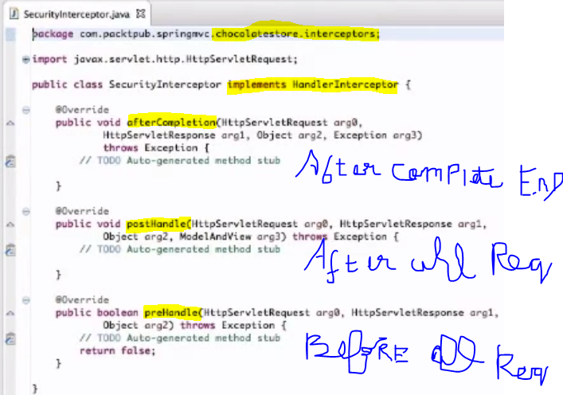
    3. After logging
    4. 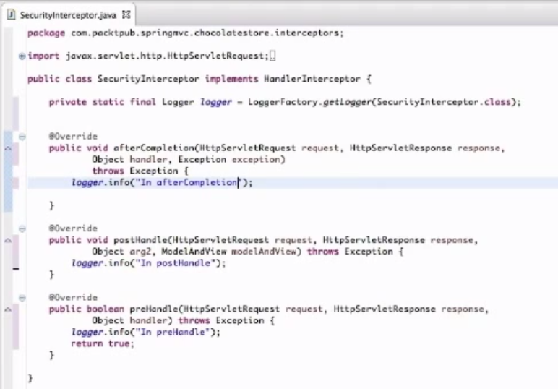
    5. 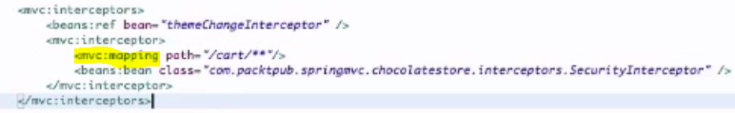
    6. The path is used to restrict the interceptor to the class only.
    7. 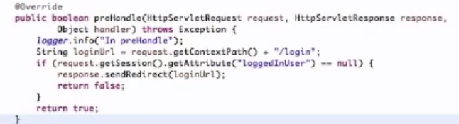
21. #7.1 Integrating with Freemarker [spring MVC]
    1. View resolver for FreeMarker
    2. 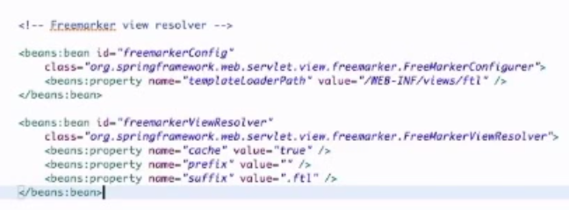
    3. 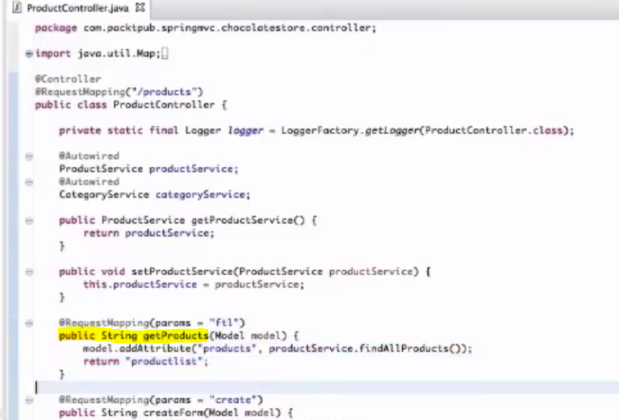
    4. 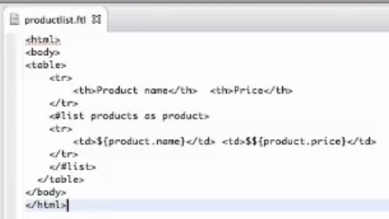
    5. Add the required jar to POM.xml as below
    6. 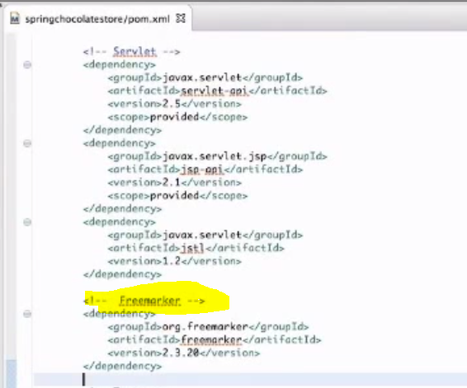
    7. Multi View Resolver
    8. 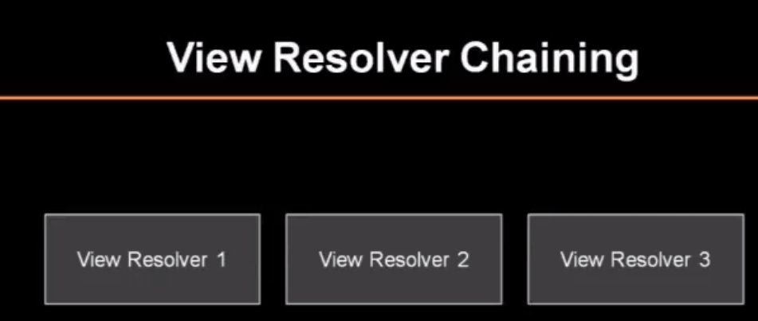
    9. User Order property to set which to check first.
    10. 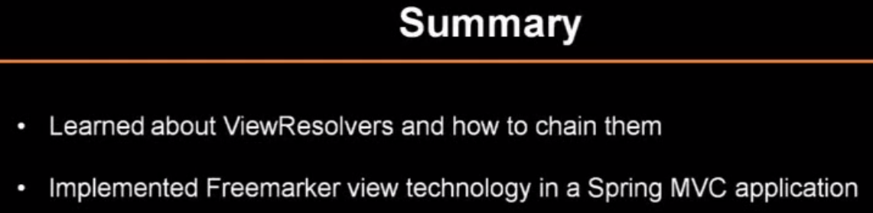
22. #7.2 Integrating with Apache Tiles [spring MVC]
    1. This allow to break the pages into tiles.
    2. 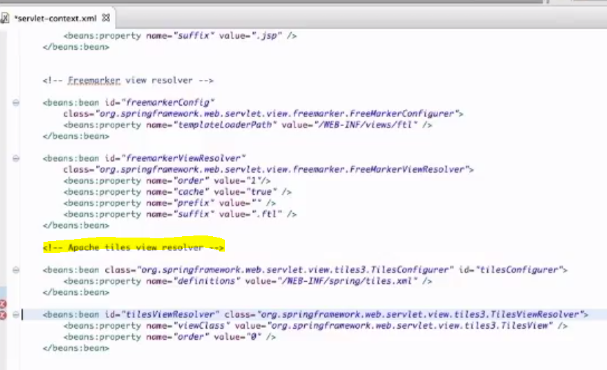
    3. 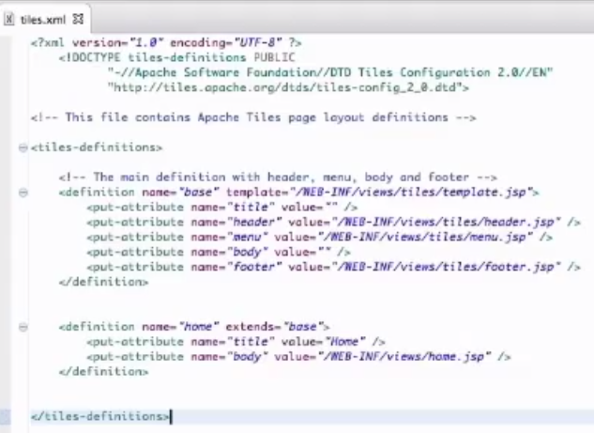
    4. 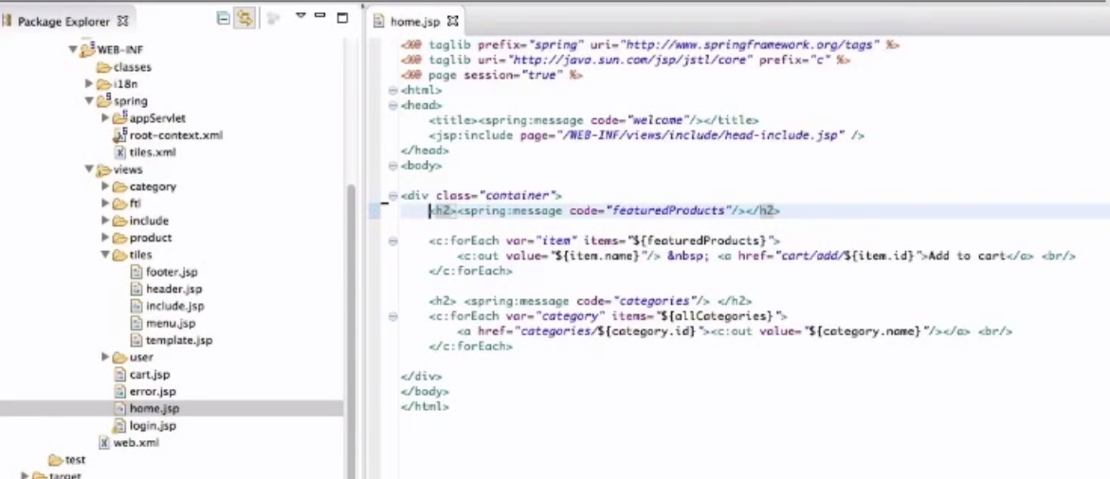
    5. 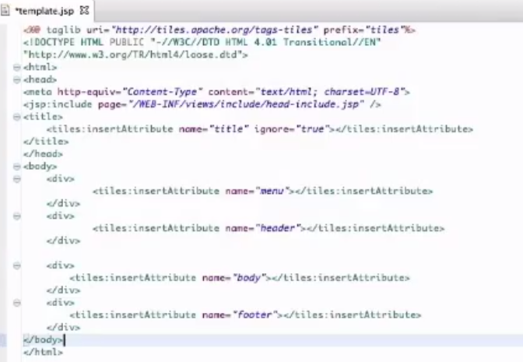
    6. Add tiles libraries
    7. 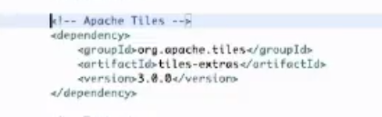
    8. 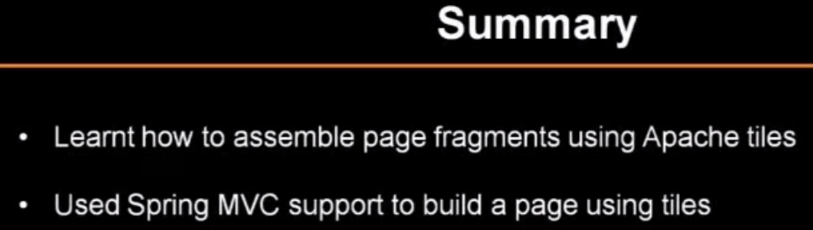
23. #7.3 Working with Multiple Content Types [spring MVC]
    1. 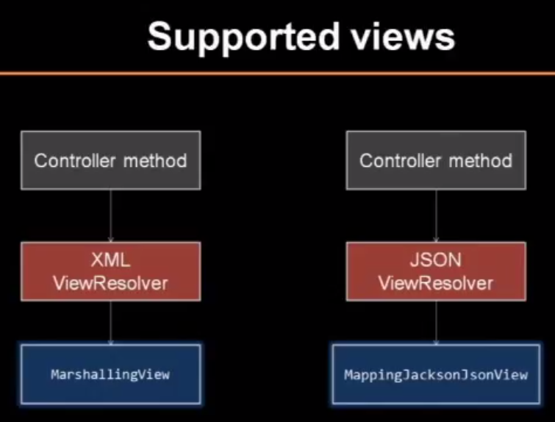
    2. 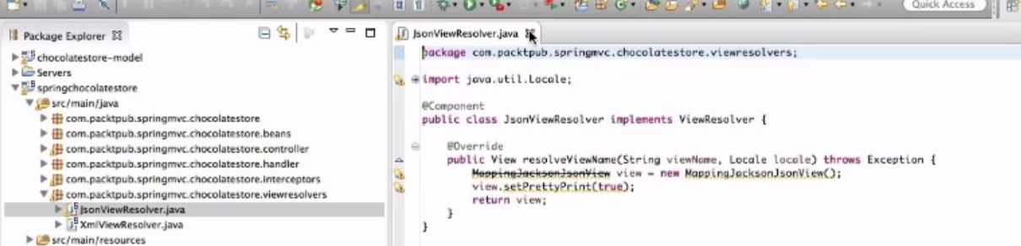
    3. 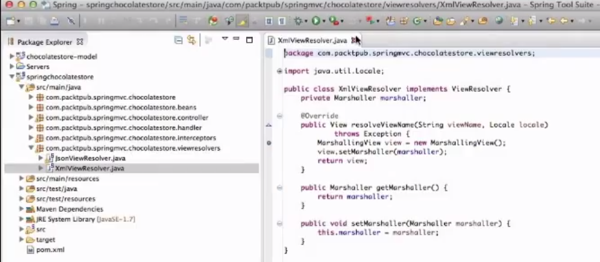
    4. 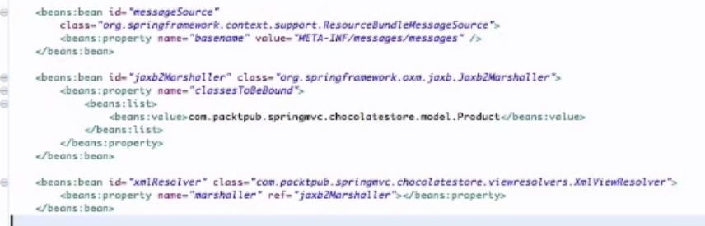
    5. 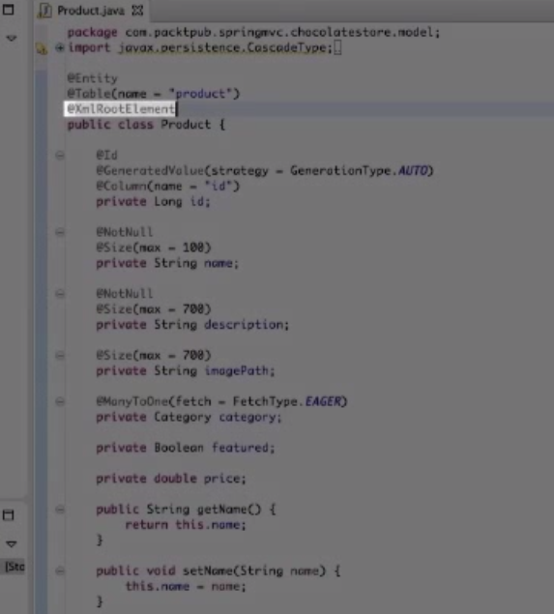
    6. 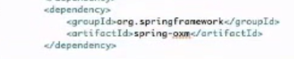
    7. 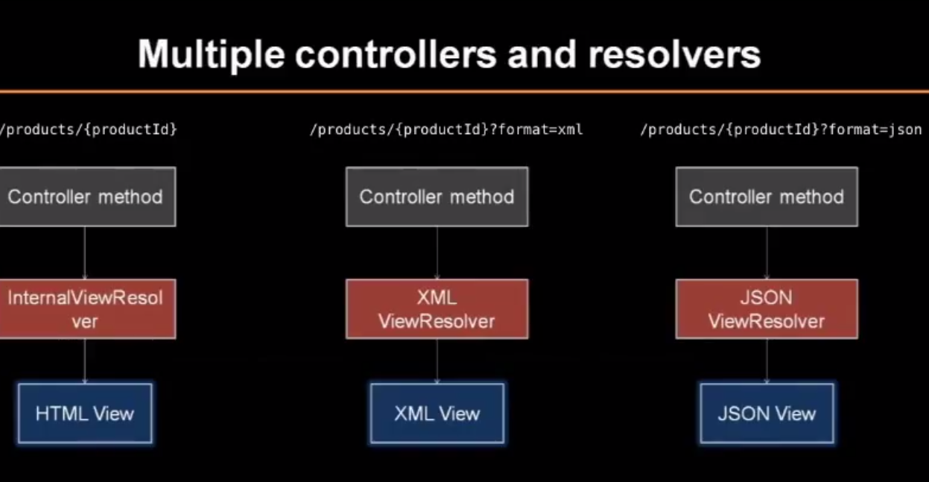
    8. Refer the video for further.
24. #8.1 Understanding RESTful Web Services [spring MVC]
    1. 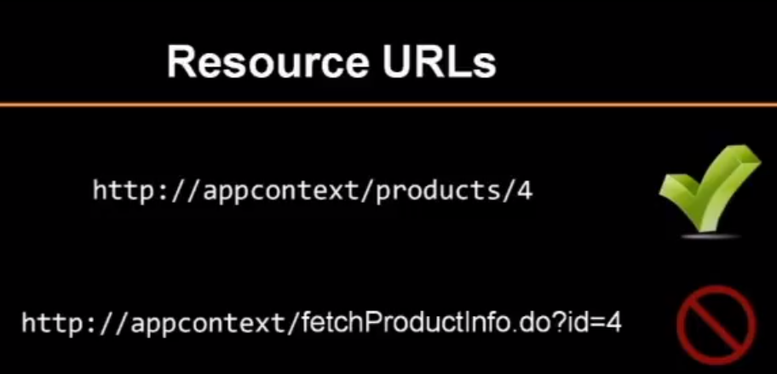
    2. 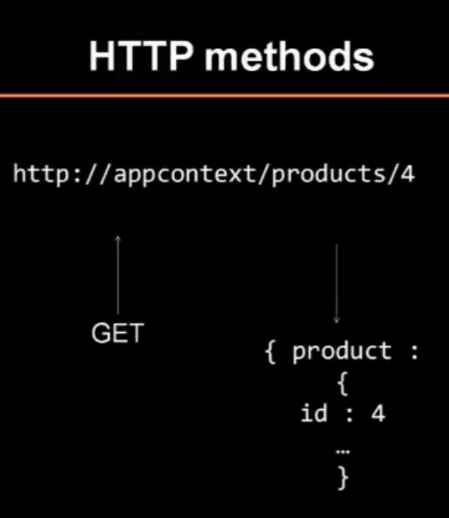
    3. 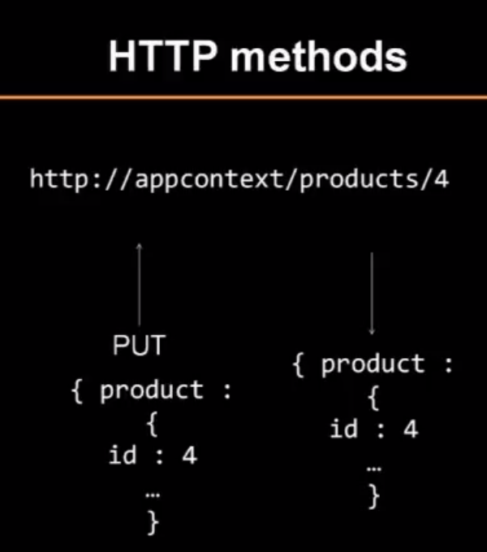
    4. 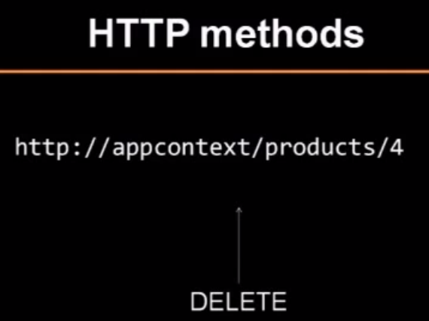
    5. 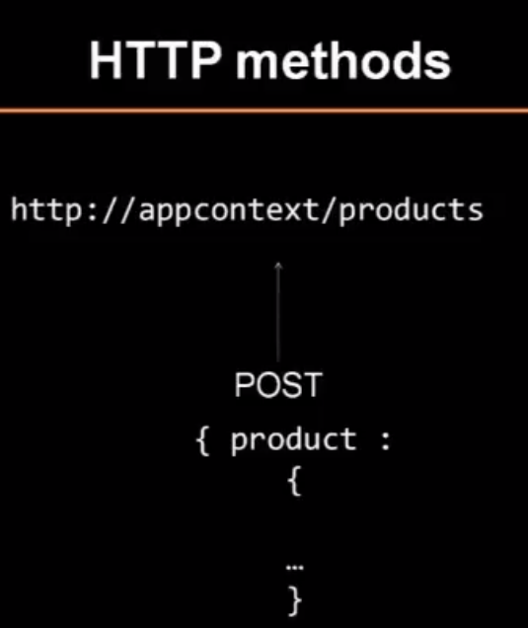
    6. 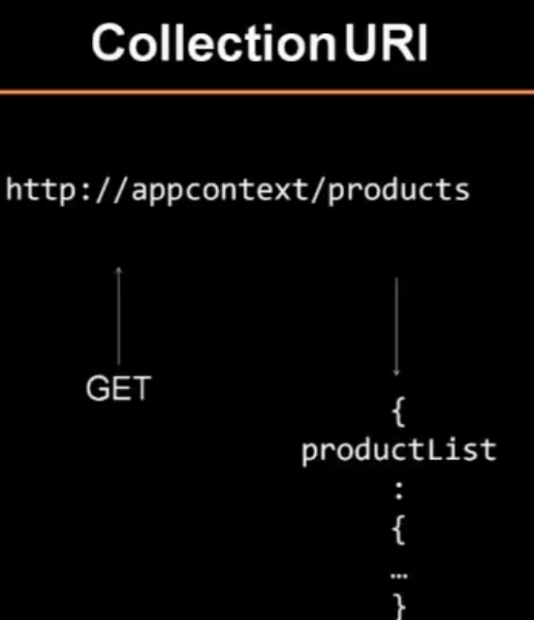
    7. 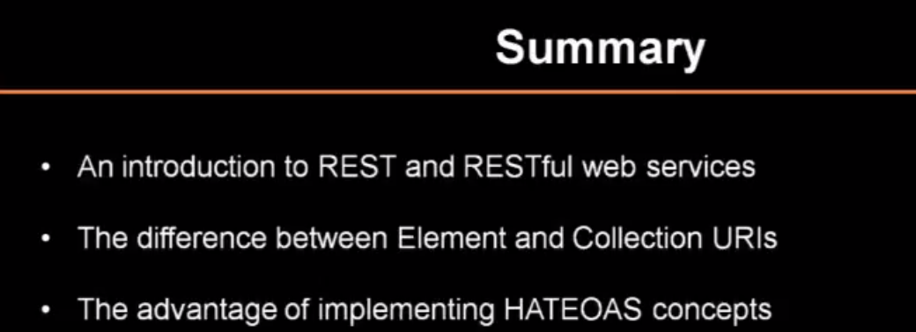
25. #8.2 Implementing Your First REST Endpoint [spring MVC]
    1. 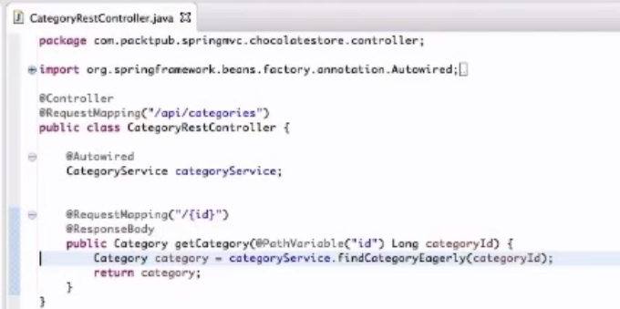
    2. 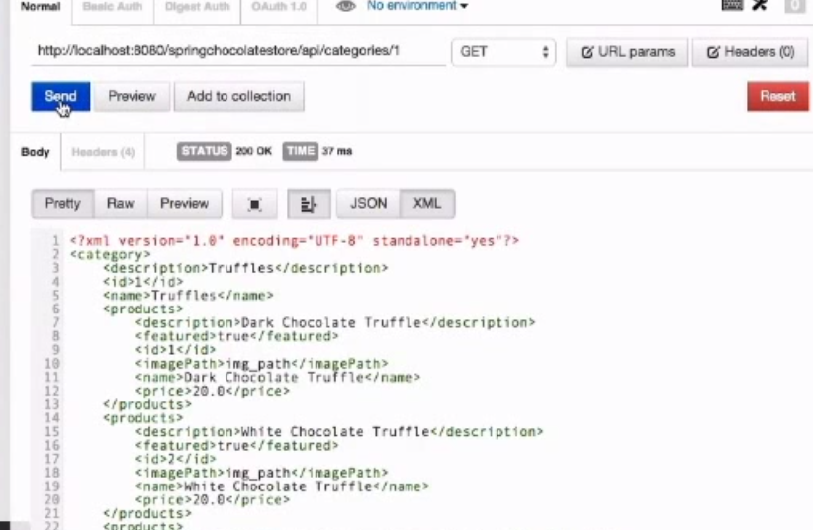
    3. 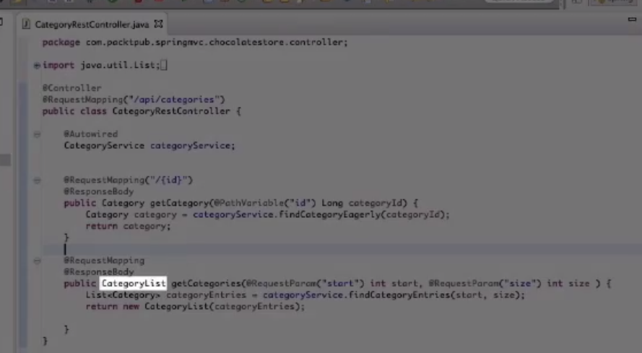
    4. 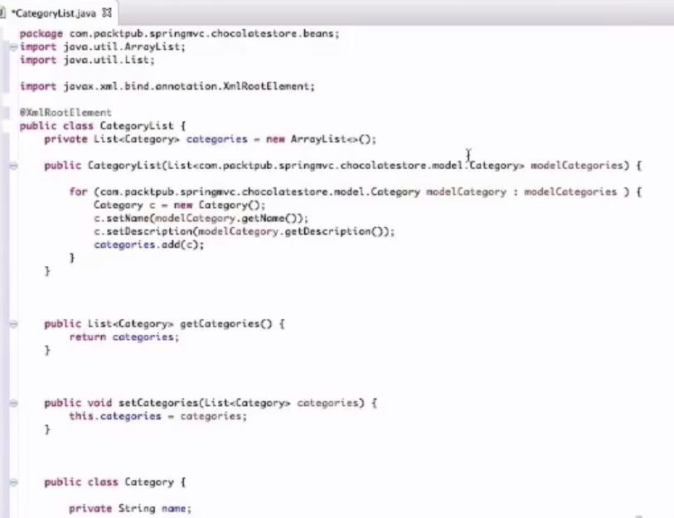
    5. 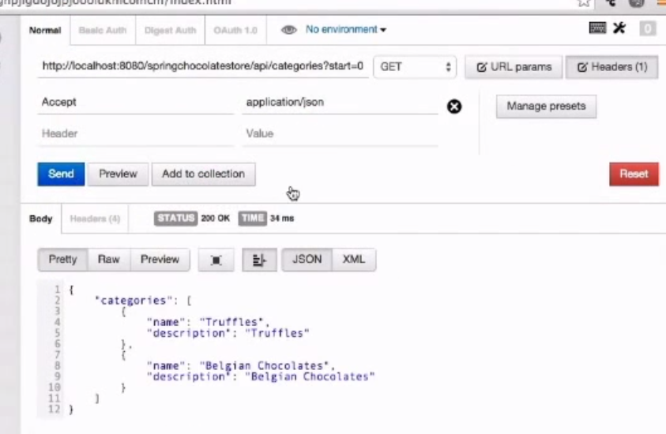
    6. 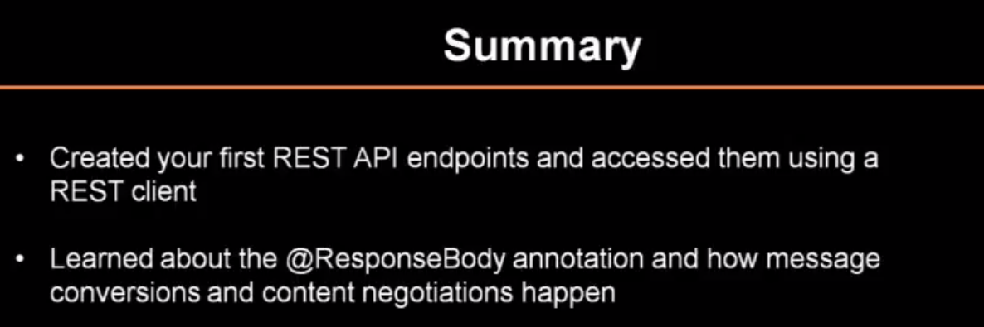
26. #8.3 Implementing CRUD APIs [spring MVC]
    1. 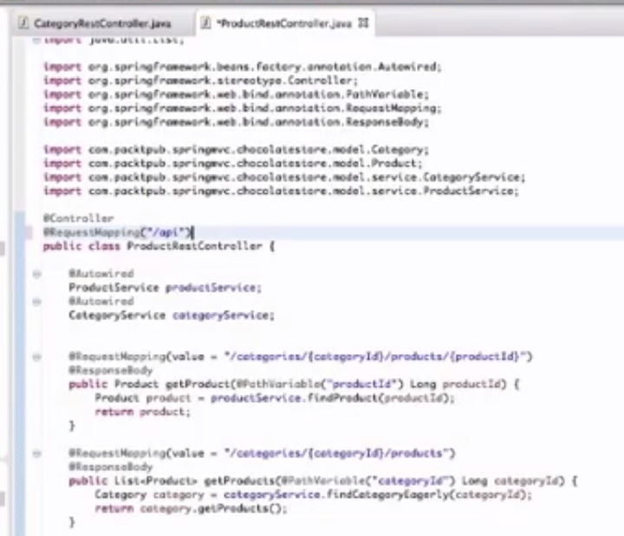
    2. 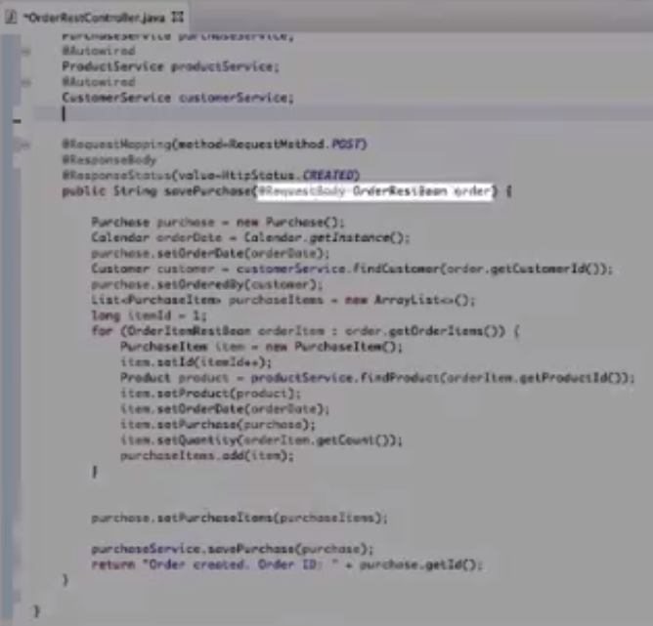
    3. 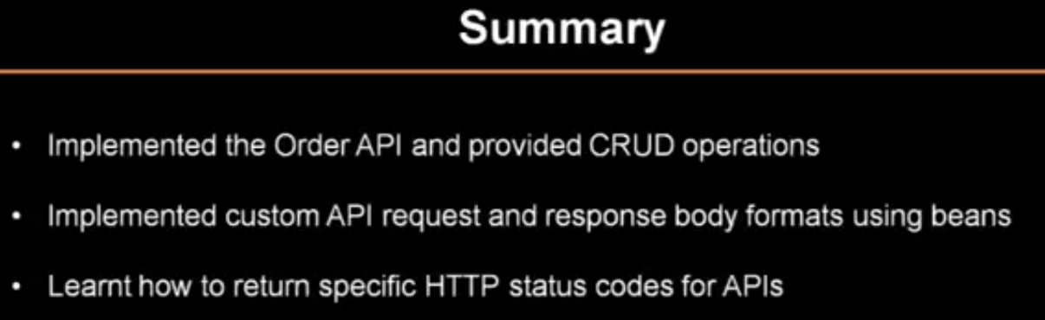
27. #8.4 Implementing Exception Handling and HATEOAS [spring MVC]
    1. @ExceptionHandler
    2. 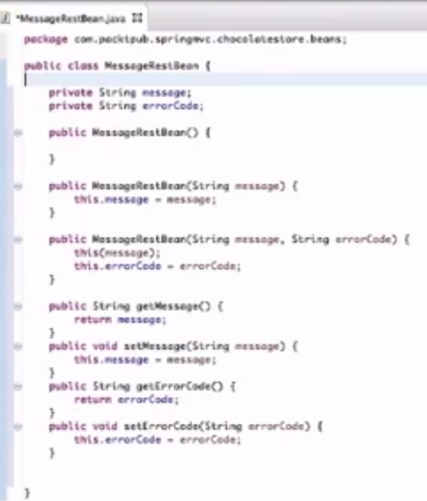
    3. 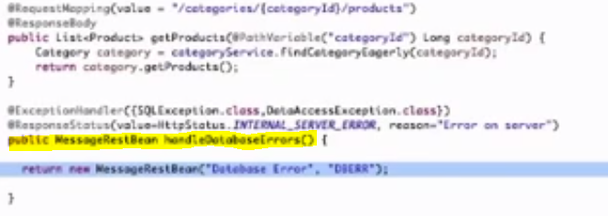
    4. 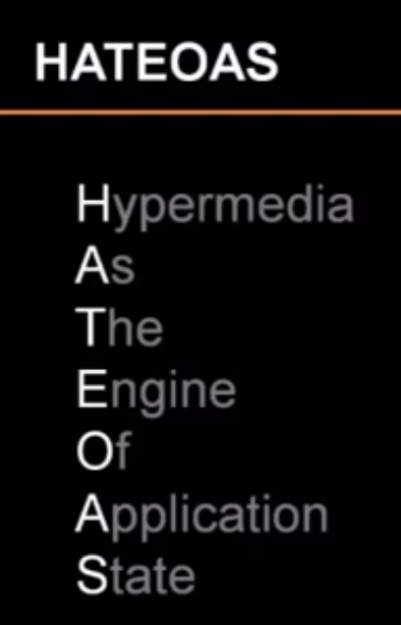
    5. 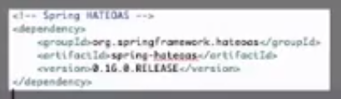
    6. 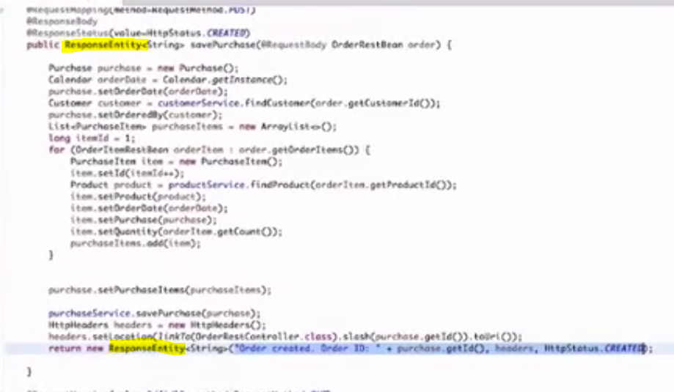
    7. 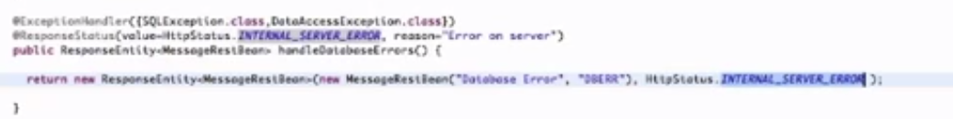
    8. 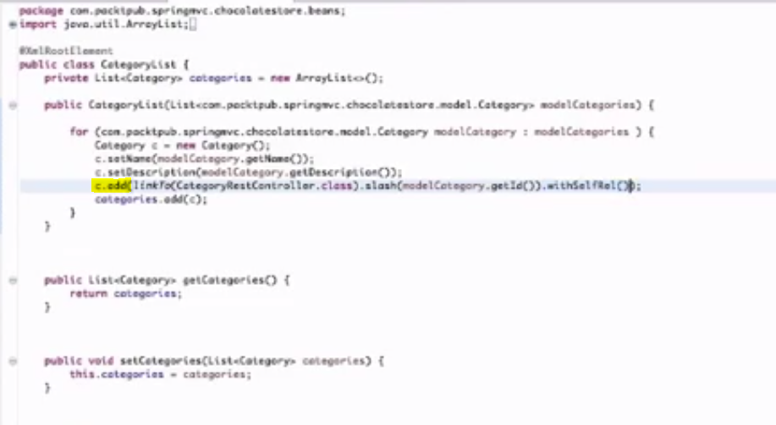
    9. 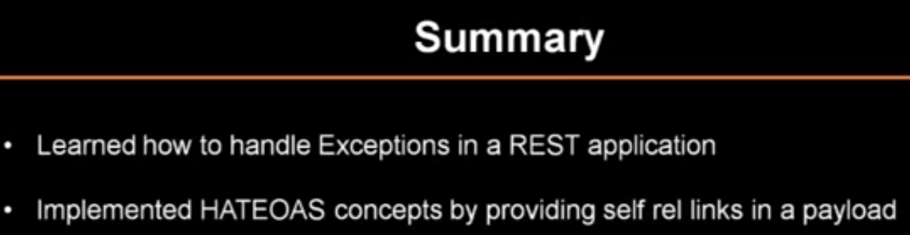

# JAVA Project Implementation - Mr Naveen

1. 01.JAVA Project Implementation - Waterfall Model by Mr Naveen
   1. 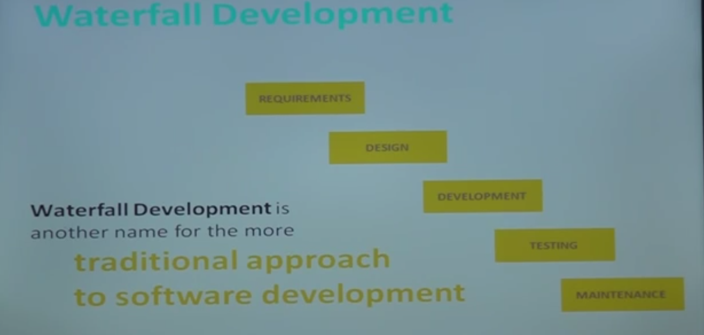
   2. 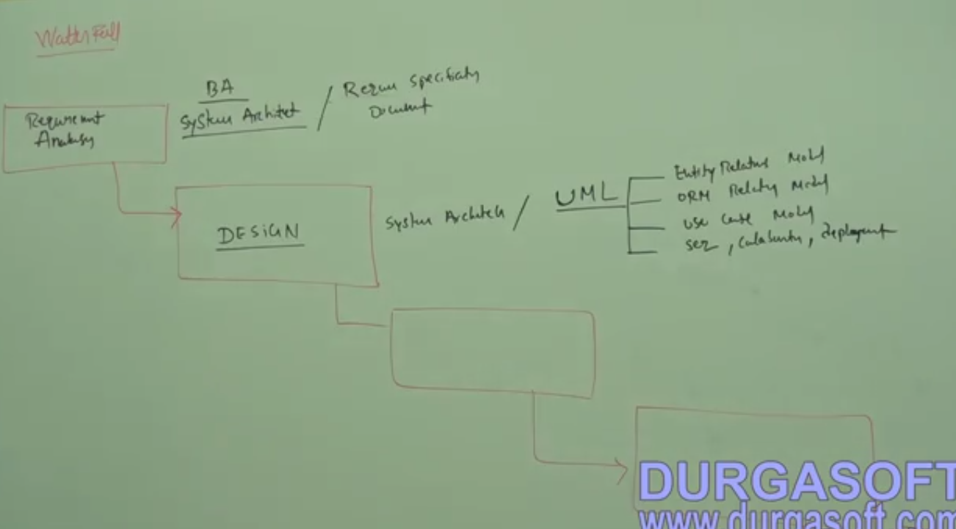
   3. 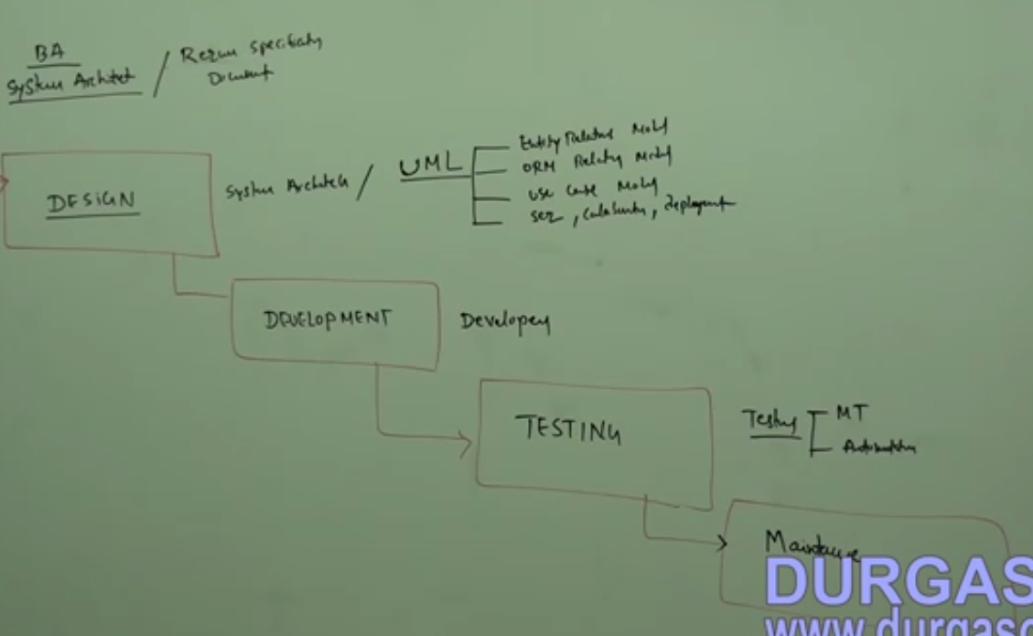
   4. Not recommended for large scale application
   5. 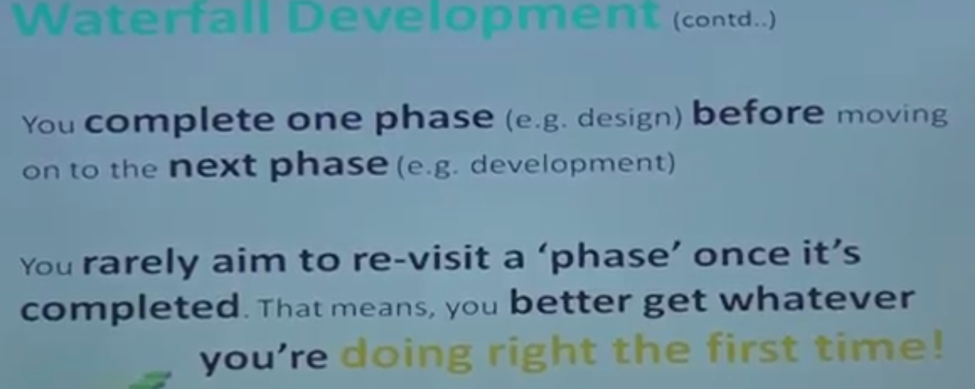
   6. 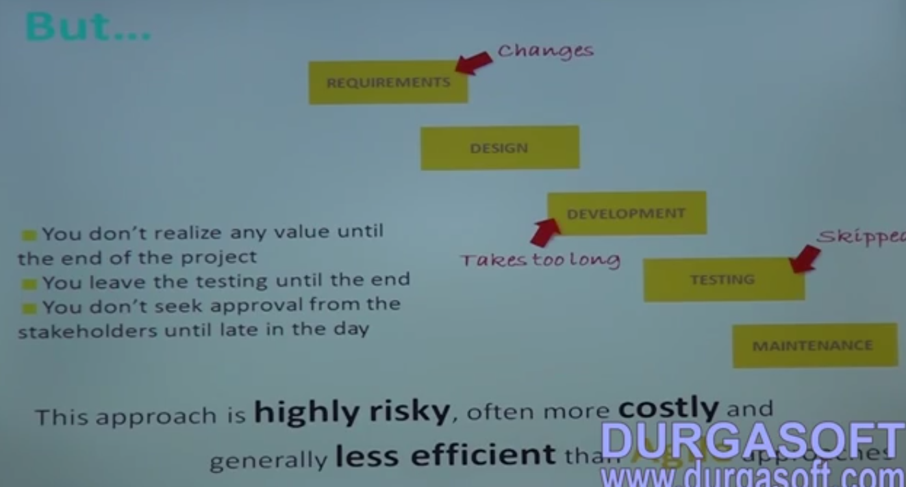
2. 02.JAVA Project Implementation - agile Model by Mr Naveen
   1. Task will be divided into sub task which is called **Scrums.**
   2. For each task we need to provide a life cycle and each task should be independent.
   3. 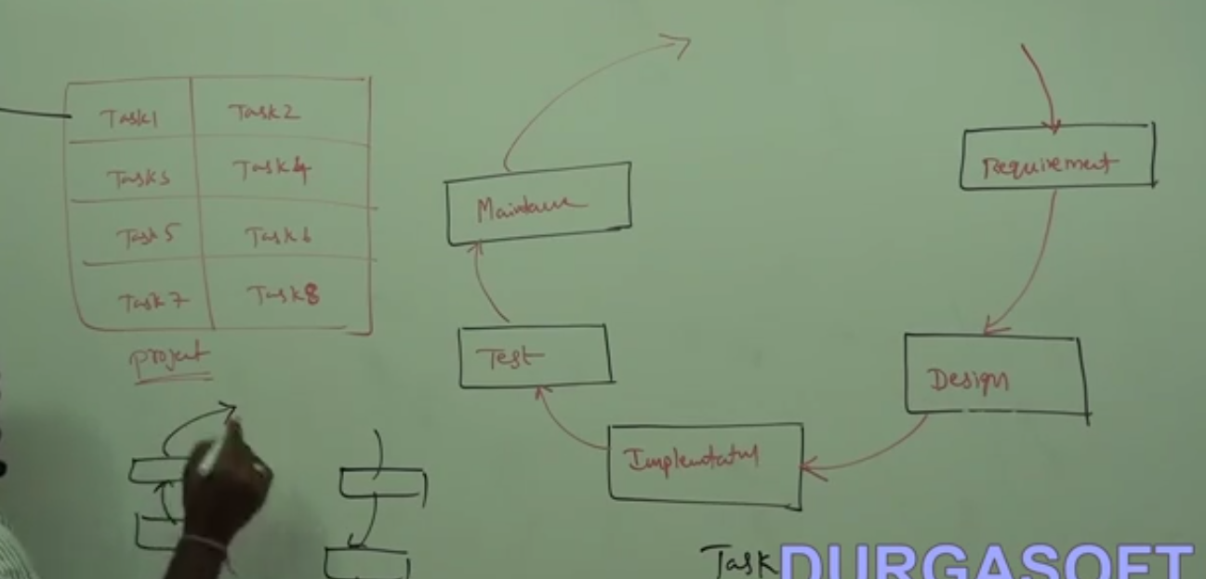
   4. Scrum Meetings every week/day
   5. Design scrums in independent manner
3. 03.JAVA Project Implementation (SRS) Software Requirements Specification (Part -1) by Mr Naveen
   1. Online car cab services
   2. User need to select car type, model and etc
   3. book a car for day/hour/monthly basis
   4. charges based on different criteria.
   5. Pickup location and drop location
   6. Insurance policy
   7. Confirming registration
   8. payment modes
   9. Cancelation support
   10. Driver req/not
   11. Cancelation warning using mails and sms
   12. Coupons support for discount
   13. Support for user module
4. 04.JAVA Project Implementation - system architecture by Mr Naveen
   1. Fuel and KM reading
   2. report generation
5. 05.JAVA Project Implementation (SRS) Software Requirements Specification (Part - 2) by Mr Naveen
   1. Travel Limit
   2. Waiting Charges
   3. Manager roles and client roles
   4. Reports
   5. User tracking(GPS system)
6. 06.JAVA Project Implementation - Entity relationship diagrams (Part - 1) by Mr Naveen
   1. Design of Tables User, Address, And roles
7. 07.JAVA Project Implementation - Entity relationship diagrams (Part - 2) by Mr Naveen
   1. Transactions
   2. Booking Records
8. 08.JAVA Project Implementation - Entity relationship diagrams (Part - 3) by Mr Naveen
   1. CarforSale, Carselling records, TravelLimit, Time Sheet, Cancellation records, Confirmation records.
   2. 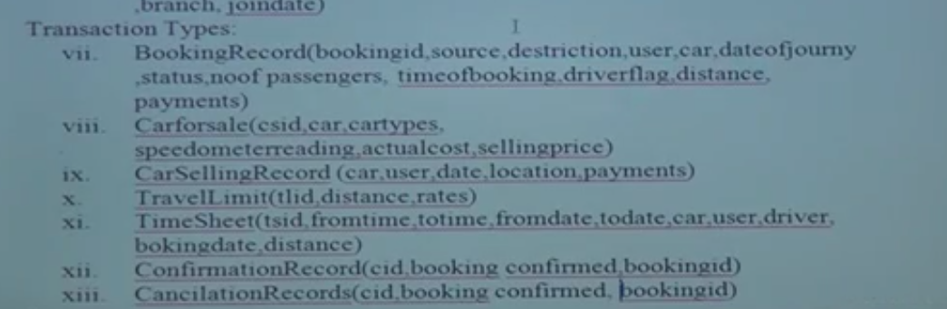
9. 09.JAVA Project Implementation - Entity relationship diagrams (Part - 4) by Mr Naveen
   1. 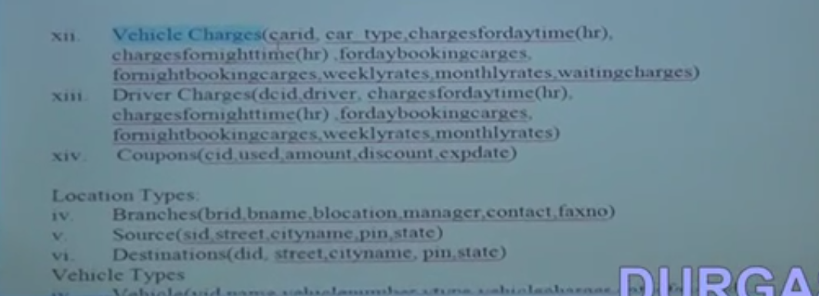
10. 10.JAVA Project Implementation - Entity relationship diagrams (Part - 5) by Mr Naveen
    1. 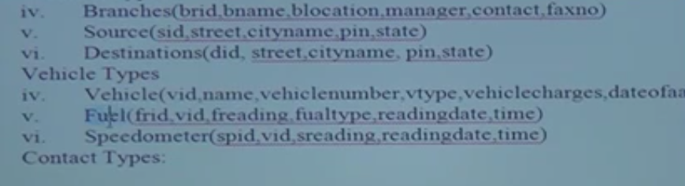
11. 11.JAVA Project Implementation - Entity relationship diagrams (Part - 6) by Mr Naveen
12. 12.JAVA Project Implementation Entity relationship diagrams Part 7 by Mr Naveen
13. 13.JAVA Project Implementation - Entity relationship diagrams (Part - 8) by Mr Naveen
14. 14.JAVA Project Implementation - Entity relationship diagrams (Part - 9) by Mr Naveen
15. 15.JAVA Project Implementation - Entity relationship diagrams (Part - 10) by Mr Naveen
16. 16.JAVA Project Implementation - Entity relationship diagrams (Part - 11) by Mr Naveen
17. 26.JAVA Project Implementation - Object relational mapping (ORM) - (Part - 2 ) by Mr Naveen
18. 27.JAVA Project Implementation - Object relational mapping (ORM) (Part - 3) by Mr Naveen
19. 28.JAVA Project Implementation - Use case diagram ( Part - 1 ) by Mr Naveen
    1. 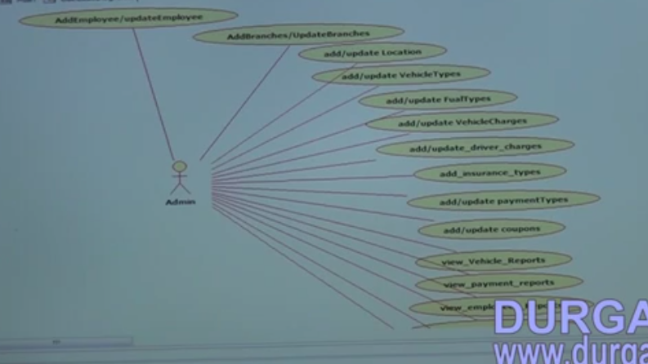
20. 29..JAVA Project Implementation - Use case diagram (Part - 2) by Mr Naveen
21. 30.JAVA Project Implementation - Use case diagram (Part - 3) by Mr Naveen
22. 31.JAVA Project Implementation - Use case diagram (Part - 4) by Mr Naveen
23. 32.JAVA Project Implementation - system architecture by Mr Naveen
24. 33.JAVA Project Implementation - Object relational mapping (ORM) Part - 1 by Mr Naveen
25. 34.JAVA Project Implementation - Object relational mapping (ORM) - (Part - 2 ) by Mr Naveen
26. 35.JAVA Project Implementation - Object relational mapping (ORM) (Part - 3) by Mr Naveen

# Spring Security

1. 